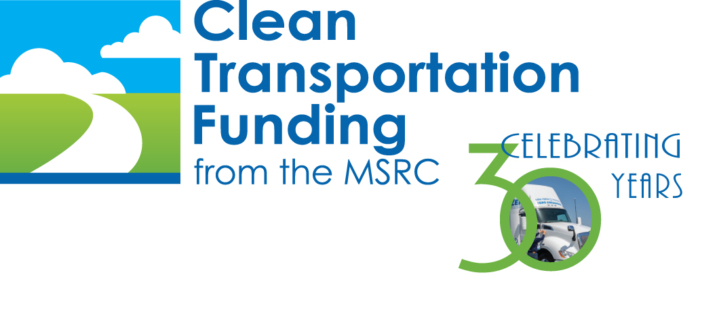

Request for Proposals

For

Zero & Near-Zero Emission Trucking to Warehouse, Distribution, & Intermodal Facilities in Riverside & San Bernardino Counties

Financial Assistance to Transition to Zero & Near-Zero Emission Goods Movement Operations

P2021-07

November 6, 2020

SECTION 1: INTRODUCTION

The ability to move goods efficiently across the South Coast basin is crucial to the economic vitality of Southern California. In Los Angeles County alone, goods movement dependent industries generate one third of the county’s economy and support one third of all employment. Our region is also home to the largest container port complex in the United States. Forty percent (40%) of all containerized goods imported into the United States enter through the Ports of Long Beach and Los Angeles, known as the San Pedro Bay Ports.

However, the movement of goods does not stop at the maritime ports. Approximately 70% of the containerized cargo that moves through the San Pedro Bay Ports travels by heavy-duty diesel trucks through the South Coast basin, where 40% of it ends up at a vast network of warehouses, distribution centers, and logistics facilities located in Riverside and San Bernardino counties.
Each warehouse and logistics facility is – in and of itself – a small scale port. There are over 400 of these facilities currently within Riverside and San Bernardino counties (Inland Empire). Goods are delivered, trans-loaded, and depart each facility primarily by heavy-duty diesel trucks. While individually smaller in scale, when viewed collectively the hundreds of warehouses, distribution centers, and logistics facilities in the Inland Empire generate air pollutant emissions that endanger the health of the communities they are located in and adversely impact the entire South Coast region.

SECTION 2: PURPOSE OF THIS REQUEST FOR PROPOSALS

To reduce air pollutant emissions generated by heavy-duty diesel trucks that transport goods to the “Inland Ports”, the MSRC Clean Transportation Funding™ Program is seeking to partner with trucking fleet owners to begin their transition to zero or near-zero emission goods movement.

Specifically, this Request for Proposals (RFP) seeks proposals from qualified businesses who frequently transport containerized or bulk goods to warehouses, distribution centers, logistics facilities, or intermodal freight transportation hubs located in Riverside or San Bernardino counties. MSRC Clean Transportation Funding™ is available to partially offset the cost of acquiring zero or near-zero emission heavy-duty trucks and associated refueling infrastructure and/or electric vehicle supply equipment (EVSE), as applicable.

A total of $14 million in MSRC funding is available under this RFP. The following Sections outline the eligibility requirements, conditions, and other relevant information to assist fleets in developing a proposal.
SECTION 3: PROGRAM ELIGIBILITY REQUIREMENTS

3.1 Eligible Respondents to this RFP – the MSRC is seeking proposals from entities who, as a part of their business enterprise, frequently transport goods to warehouse and distribution facilities located in the Inland Empire using heavy-duty Class 7 or 8 trucks.

Eligible entities include licensed motor carriers, third party logistics companies, freight forwarding companies, truck leasing companies, and private businesses who own or lease trucks to transport goods to freight facilities located in San Bernardino and Riverside counties.

3.2 Minimum Operation within the South Coast AQMD Jurisdiction & Inland Empire – heavy-duty trucks that will be used in conjunction with a project submitted under this RFP must, at a minimum:
- Accrue at least 85 percent of their annual mileage within the geographical boundaries of the South Coast Air Quality Management District; and
- Demonstrate that at least 70 percent of annual trips include destinations within Riverside and/or San Bernardino County.

3.3 Eligible Project Elements – This RFP seeks proposals for the acquisition of heavy-duty zero or near-zero emission trucks and supporting infrastructure primarily used to transport goods within the South Coast AQMD region with destinations in the Inland Empire. The following are project elements eligible to receive MSRC Clean Transportation Funding™:

- Acquisition of Zero-Emission or Near-Zero Emission (Z/NZE) Heavy-Duty On-Road Trucks
  - Purchase or lease and deploy into revenue service new on-road heavy-duty Class 7 or Class 8 trucks (gross vehicle weight rating greater than 26,000 pounds) that are zero-emission (e.g., battery or fuel cell) or equipped with a “near-zero” emission natural gas engine. Under this RFP, “zero emission” is defined as having no tailpipe emissions and includes battery electric and hydrogen fuel cell technologies. “Near-zero” includes engines certified to the CARB Optional Low-NO_{x} standard of 0.02 grams per brake horsepower-hour or cleaner.
- Electrification to Support Zero Emission Trucks
  - Design and install Electric Vehicle Support Equipment (EVSE, i.e., chargers) to allow onsite recharging of battery electric on-road trucks. For the purpose of this RFP, “EVSE” includes vehicle chargers, solar canopies, charge management system hardware, and energy storage system hardware.
- Development of Onsite Renewable Natural Gas Refueling Infrastructure
  - Design and install natural gas refueling infrastructure to allow onsite fueling of near-zero emission natural gas on-road heavy-duty trucks.
- Development of Onsite Hydrogen Refueling infrastructure
  - Design and install hydrogen refueling infrastructure to allow fueling of hydrogen fuel cell heavy-duty on-road trucks.
IMPORTANT! Transportation companies seeking MSRC funding to buy down the capital cost of leased vehicles must partner with the truck leasing company and submit a joint proposal. Any Contract resulting from an MSRC funding award will require the Truck Leasing Company to act as the prime contractor and contract signatory.

IMPORTANT! A proposal may request funding for Infrastructure-Only, either EVSE, renewable natural gas refueling equipment, or hydrogen refueling equipment. However, the proposer must demonstrate that qualifying on-road vehicles intended to utilize the MSRC-funded infrastructure have or are in the process of being acquired. Documentation will be required to confirm vehicle acquisition has been initiated prior to execution by the MSRC of an Infrastructure-Only funding award.

IMPORTANT! Vehicles and infrastructure receiving MSRC funds are required to be retained by the awardee for a minimum of five (5) years from the date MSRC co-funded vehicles or infrastructure enters revenue service.

SECTION 4: FUNDING AVAILABLITY

The total amount of MSRC Clean Transportation Funding™ allocated for this Program is $14M. Funding will be awarded on a competitive basis in accordance with the proposal evaluation and scoring procedures outlined in Section 9 of this RFP.
The MSRC reserves the right to increase the amount of total funding available. Additionally, if total funding requests are less than the amount currently allocated, or if proposals are deemed non-meritorious, the MSRC reserves the right to reduce the total funding available and reallocate funds to other Work Program categories.
4.1 Maximum Funding Award – The maximum funding award to any entity under this RFP shall not exceed 50% of the total available funding, or a current maximum award amount of $7M. This maximum funding restriction can be waived by the MSRC in the event the MSRC does not receive meritorious proposals from other bidders or if the MSRC allocates additional funds to the program.
4.2 Funding Restrictions – The following funding restrictions have been imposed by the MSRC:
- MSRC funds must be applied towards the capital purchase/lease and installation costs of qualifying zero-near-zero heavy-duty vehicles and infrastructure.
- MSRC funds cannot be used to purchase real property, fuel, including electricity, or used to offset vehicle operations or maintenance costs.
- MSRC funds cannot be used to offset recurring fees associated with the operation and maintenance of EVSE charge management systems.
4.3 Earliest Date for an MSRC-Funded Project to Commence – The release date of this RFP, November 6, 2020, is the earliest date work on a project can commence and be potentially eligible for MSRC funding. Any expenditures made in anticipation of an award and prior to execution of a contract are solely at the proposer’s risk. If no contract is executed, neither the MSRC nor South Coast AQMD is liable for payment of any funds expended in anticipation of a contract. Please note that in the event a contract is executed, reimbursement for any costs incurred by the proposer in anticipation of the contract is at the discretion of the MSRC and South Coast AQMD.
4.4 Additional Conditions on MSRC Funding
- MSRC funds will be distributed on a reimbursement basis only upon completion of approved project tasks and submission of all required reports and invoices;
- MSRC funds are not intended to fund staff salaries or administrative costs;
- Funding provided under this RFP opportunity cannot be comingled with funds from any other MSRC Program, i.e., no “double dipping”;
- Finally, in accordance with state law, all projects awarded MSRC Clean Transportation Funding™ are subject to audit. The provisions of the audit are discussed in the Sample Contract, attached to this RFP. It is highly recommended that bidders employ Generally Accepted Accounting Principles (GAAP) when administering their MSRC co-funded project.

SECTION 5 - SCHEDULE OF EVENTS
This RFP will be administered in accordance with the timeline shown below in Table 6-1. Proposals may be submitted anytime during the period commencing November 6, 2020 and ending January 15, 2021.

Table 6-1 - Key Inland Port Program Dates
Program Event | Date
RFP Release  Online Bidders’ Conference | November 6, 2020  November 18, 2020
Latest Date/Time to Submit a Proposal | January 15, 2021 @ 11:59 pm

IMPORTANT! Proposals must be submitted to the MSRC website no later than 11:59 pm on January 15, 2021. Late proposals cannot be accepted for any reason. Please refer to Section 7, below, for instructions on how to submit a proposal.

5.1 Online Bidders’ Conference – this Zoom Webinar will further explain the goals and requirements of this RFP and provide an opportunity for participants to ask questions. Participation in the online bidders’ conference is voluntary. The webinar will take place on Wednesday, November 18th at 10:00 am and can be accessed using the following link:

When: Wednesday, November 18, 2020 10:00 AM-11:00 AM (UTC-08:00) Pacific Time (US & Canada).
Join from a PC, Mac, iPad, iPhone or Android device:
Please click this URL to join. https://scaqmd.zoom.us/j/93533914127
Or join by phone:
Dial(for higher quality, dial a number based on your current location):
US: +1 669 900 6833 or +1 346 248 7799 or +1 253 215 8782 or +1 312 626 6799 or +1 929 436 2866 or +1 301 715 8592
Webinar ID: 935 3391 4127
International numbers available: https://scaqmd.zoom.us/u/abYPVgID0c

In addition, proposers seeking clarification to this RFP can contact the MSRC staff at any time – see Section 8, below, for a MSRC staff member contact information.

SECTION 6 PROPOSAL Preparation INSTRUCTIONS

The following instructions are intended to assist bidders in preparing a proposal for funding consideration under this RFP. Proposals should be concisely written, but include all necessary technical and financial detail requested in the following Subsections.

IMPORTANT! The MSRC seeks proposals that offer a “Complete Project” – meaning that the entire project scope - zero or near-zero vehicles to be demonstrated, essential infrastructure, coordination with project partners, including utilities, and necessary co-funding - are all considered and discussed within the proposal narrative.
Questions regarding proposal preparation and submittal should be directed to the appropriate MSRC staff representative listed in Section 8 of this RFP.

6.1 Cover Letter – A cover letter should accompany the proposal, referencing RFP number P2021-07, specify contact person(s) for technical and contractual matters, and be signed by the person(s) authorized to contractually bind the bidding entity.

6.2 Project Partner Letters of Support, MOA, or MOU – The proposal must include a letter of support, Memorandum of Agreement (MOA), or Memorandum of Understanding (MOU) from all participating entities of a joint proposal acknowledging their participation in the proposed project.

6.3 Proposal Team Contact Information – Proposers may use the template provided (Attachment A to this RFP) or provide the requested information in another format.

6.4 Project Technical Description – The proposal should include a concise yet thorough description of the overall project scope. While the format is left to the discretion of the proposer, the technical description should include, to the extent currently known and applicable, the following key elements:
6.4.1 Zero & Near-Zero Emission Heavy-Duty Truck Project Component
- Host Fleet – the name and characteristics of the fleet that will be operating the vehicles associated with the proposed project, including the proposed vehicle and infrastructure domicile address. Links to existing websites that describe the host fleet may be included to augment information provided in the proposal;
- Zero/Near-Zero Emission Technical Specifications – to the extent available, include information on the vehicles associated with the proposed project. This may include, but is not limited to, technical specifications, manufacturer publications, etc. Links to existing websites that describe the vehicle characteristics may be included to augment the proposal;
- Vehicle Duty Cycle – the zero or near-zero vehicles associated with the project, provide information as it relates to average daily or weekly miles traveled per vehicle, anticipated route or destination location(s), total average annual miles per vehicle, and the percentage of truck trips that service freight facilities in the Inland Empire. To the extent feasible, identify specific Inland Empire facilities that the trucks are expected to frequent.

6.4.2 Infrastructure Components
Provide an overview and technical description of the infrastructure elements associated with the proposed project, including but not limited to the following:
- Technical Description & Specifications for the Proposed Infrastructure – This element of the proposal should include, to the extent available, technical specifications, equipment lists, preliminary designs, site plans, etc., as available;
- Infrastructure Accessibility – Discuss the near-term and future plans for infrastructure accessibility, i.e., whether the infrastructure will be private access only or offer limited access to other fleets;
- Utility Coordination – As applicable to the proposed project, discuss the status of coordination with the cognizant California Public Utility or municipal utility(s) that will have a role in the siting, utility service upgrades, and construction of proposed infrastructure.

6.5 Project Cost & Funding Sources – The MSRC strongly encourages the formation of partnerships and the leveraging of multiple funding sources to increase the scope of Inland Port projects and improve their economic feasibility. The proposal should discuss in detail the total project cost, funding requested from the MSRC, and the amounts and sources of additional project co-funding.
Specifically, proposers should specify the sources of all funding applied to the project, including contributions from the project partners, or funding either sought or in hand from local, state, and federal agencies, including but not limited to the South Coast AQMD (non-MSRC), Air Resources Board, Energy Commission, US Department of Energy, etc.
In addition, for projects that propose EVSE, proposers should discuss funding available through public or municipal electric utilities. For example, under the Southern California Edison Charge Ready Transport Program, warehouse, distribution centers, and logistics facilities located within the SCE service territory may be able to take advantage of “make ready” financial incentives for the installation of electric vehicle charging equipment to support heavy-duty battery electric trucks.
See https://www.sce.com/business/electric-cars/charge-ready-transport for more information regarding this program.
If utility incentives are being sought, the proposal should address the coordination status with the utility, i.e., whether and application for incentive funding has been submitted, is in preparation, or if discussions between the proposer team and utility have been initiated.

6.6 Project Implementation Schedule – The proposal should discuss key project milestones and their expected implementation dates. From a Project Readiness standpoint, the MSRC would prefer that projects be initially deployed within 36 months from the date of contract execution and authority to proceed, with full project deployment no later than 48 months from contract execution. The MSRC does, however, have discretion in this regard; thus, it is requested that proposers provide accurate information regarding the project’s implementation schedule.

6.7 Project Scalability – Limited availability of MSRC funding could result in the need to descope or scale-back a proposed project, including but not limited to reducing the number of vehicles funded, etc. In this event, the resulting award would be lower than the proposer’s requested amount. The MSRC asks that proposers address this potential contingency in their proposal and provide the following information:
- Is the proposer amenable to project scaling? If Yes,
- What is the minimum project scope and cost offered by the proposer, with the understanding that anything less than this minimum would no longer represent a viable project?
IMPORTANT! Proposers should review the Evaluation & Scoring Criteria discussed below in Section 9 of this RFP and ensure their proposal provides all information necessary to maximize the proposal’s scoring potential.

6.8 Certifications – All proposers must complete and submit the following forms, located in Attachment B, as an element of their proposal:
- Internal Revenue Service Form W-9 – Request for Taxpayer Identification Number and Certification and California Form 590 – Withholding Exemption Certificate. If you are selected for an award, you cannot be established as a vendor without this information.
- Disadvantaged Business Certification - The South Coast AQMD needs this information for their vendor database. It will not be considered in proposal evaluation or the determination of any MSRC funding award.
- Certificates of Insurance - Bidders are required to provide a statement that upon notification of award, a certificate of insurance naming the South Coast AQMD as an additional insured will be provided within forty-five (45) days. The certificate of Insurance does not need to be submitted as an element of the proposal.
- Campaign Contribution Disclosure Form

IMPORTANT! In the event a business enterprise is self-insured, a statement to that effect must be included in proposal.

SECTION 7 PROPOSAL SUBMITAL INSTRUCTIONS

Proposals must be submitted electronically in PDF format using the MSRC Website. We believe this benefits the proposer, the MSRC staff, and the environment. A tutorial has been developed to guide proposers step by step through the electronic proposal submittal process. This tutorial is available on the MSRC Website at www.cleantransportationfunding.org. Look for the tutorial on the “Proposal Process – Proposal Upload Tutorial” page:
http://www.cleantransportationfunding.org/sites/default/files/downloads/Guide%20to%20Using%20the%20Website.pdf

7.1 Proprietary and Trade Secret Information – to the extent feasible, proposals should avoid including information or data that is considered confidential, company proprietary, or a trade secret. If a proposal does include information that the proposer does not want publicly disclosed, that information must be clearly marked and identified as “Proprietary – Do Not Disclose”.

7.2 Addenda - The MSRC reserves the right to issue corrections, supplemental information, or revisions to this RFP during the proposal preparation period of November 6, 2020 to January 15, 2021.

7.3 Grounds for Rejection – A proposal will be rejected and not undergo further evaluation and scoring if:
- It is received after the proposal submittal deadline, January 15, 2021 at 11:59 pm;
- It is not prepared in the format described; or
- It is not signed by an individual authorized to represent the proposing entity.

7.4 Modification or Withdrawal - Once submitted, proposals cannot be altered without the consent of MSRC. All proposals shall constitute firm offers and may not be withdrawn for a period of ninety (90) days following the last day to accept proposals. All proposals become the property of the MSRC.

SECTION 8 IF YOU NEED HELP…

This RFP can be obtained by accessing the MSRC web site at www.cleantransportationfunding.org. MSRC staff members are available to answer questions during the proposal preparation period. In order to help expedite assistance, please direct your inquiries to the applicable staff person, as follows:

- For General and Administrative Assistance, please contact:
Cynthia Ravenstein
MSRC Program Administrator
Phone: 909-396-3269
E-mail: cynthia@cleantransportationfunding.org

- For Technical Assistance, please contact:
Ray Gorski
MSRC Technical Advisor
Phone: 909-396-2479
E-mail: ray@cleantransportationfunding.org

- For Contractual Assistance, please contact:
Dean Hughbanks
AQMD Procurement Manager
Phone: 909-396-2808
E-mail: dhughbanks@aqmd.gov

Section 9 - PROPOSAL Evaluation & SCORING
Proposals received prior to the submittal deadline will be forwarded to an Evaluation Subcommittee comprised of members of the MSRC Technical Advisory Committee (MSRC-TAC). Proposals will be evaluated and scored against (3) evaluation criteria: Cost-Effectiveness, Project Readiness, and the percentage of trips that serve freight facilities in the Inland Empire. The total points available is 100, with each evaluation criterion weighted as follows.

- Criteria Air Pollutant Emissions Reduction Cost-Effectiveness (40 points maximum score) – Reductions in criteria air pollutant emissions in the South Coast AQMD Region, and particularly the Inland Empire, are the primary motivation for releasing this Request for Proposals. Proposals will be evaluated based on the quantifiable reduction in reactive organic gases, oxides of nitrogen (NO_{x}), and diesel particulate matter exhaust pollution as compared to the current California Air Resources Board NO_{x} threshold of 0.2 grams per brake horsepower-hour (g/bhp-hr). Cost-effectiveness will be computed as the ratio of the quantified air pollutant reductions per MSRC funding requested. The quantification methodologies included in the Air Resources Board’s 2017 Carl Moyer Memorial Air Quality Standards Attainment Program Guidelines will be used to the extent applicable to ensure consistency in proposal evaluation.

As discussed in Section 3.3, proposals seeking MSRC funds for infrastructure-only are eligible but must include a co-funded zero/near-zero vehicle acquisition component. Cost-effectiveness will be calculated based on the co-funded zero/near-zero vehicle component of the overall project.

IMPORTANT! To facilitate proposal evaluation with respect to air pollutant cost-effectiveness, ensure that all requested information and documentation relating to the vehicles duty cycle and mileage accrual is provided.

- Project Readiness (40 points maximum) – This evaluation criterion assesses a proposed project’s perceived ability to adhere to the proposed schedule and budget. Factors that will impact a project’s successful implementation within budget and schedule projections include:
- Zero/Near-Zero Vehicle Acquisition:
- Have the zero/near-zero vehicles proposed for deployment under this project been specified?
- Has the sales or leasing agent been contacted, and are negotiations underway?
- Is the proposer ready to execute a vehicle purchase order upon MSRC funding award?
- Supporting Infrastructure Development:
- Has an equipment specification for supporting EVSE or gaseous fuel infrastructure been prepared?
- What is the stage of site planning, i.e., preliminary design, final design, etc.?
- Has coordination begun with the cognizant utilities?
- Project Funding:
- Has the necessary project co-funding been identified?
- Is co-funding in hand or applied for?
- Will final status of other pending funding awards be known within the first quarter of calendar year 2021?

IMPORTANT! Proposers should address the Project Readiness criteria listed above within the narrative of their Project Description. The MSRC is less concerned with project implementation immediacy as compared to understanding the true status of a project’s state of readiness. Thus, it is requested that proposers provide accurate information regarding the project’s state of readiness in a forthcoming manner.

- Percentage of Truck Trips that Serve Facilities Located in the Inland Empire (20 points maximum) – The MSRC seeks to reduce air pollutant emissions from heavy-duty diesel trucks that transport goods within the South Coast Air Basin with destinations to the Inland Empire. This evaluation criterion recognizes fleets who commit to utilize the zero or near-zero vehicles associated with this project on a frequent basis to serve destinations within the Inland Empire. The following rubric will be used to assign points:

Estimated Percentage of Project Vehicle Trips that Serve Inland Empire Goods Movement Facilities | Point Allocation
95% or Greater | 20
90% - 94% | 15
80% - 89% | 10
75% - 80% | 5
74% or Less | 0

IMPORTANT! Proposers should ensure their Project Description addresses the intended routes for the project vehicles and provides sufficient data to estimate the percentage of overall trips that will serve goods movement facilities within Riverside and San Bernardino counties.
Attachment A: Proposal CONTACT Information

Please provide the following Proposer information in the space provided (this is information about the entity submitting the proposal):
Business Name
Division of:
Subsidiary of:
Website Address
Type of Business  Check One: | - Individual  - DBA, Name _______________, County Filed in _______________  - Corporation, ID No. ________________  - LLC/LLP, ID No. _______________  - Other _______________

Address
City
State |  | Zip
Phone | ( ) - Ext | Fax | ( ) -
Contact Name |  | Title
E-mail Address
Payment Name if Different

Attachment B - CERTIFICATIONS
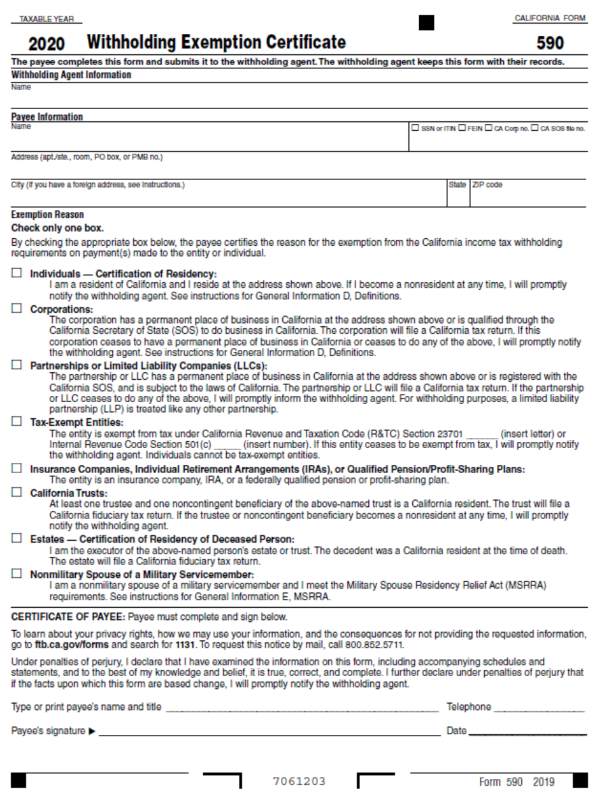
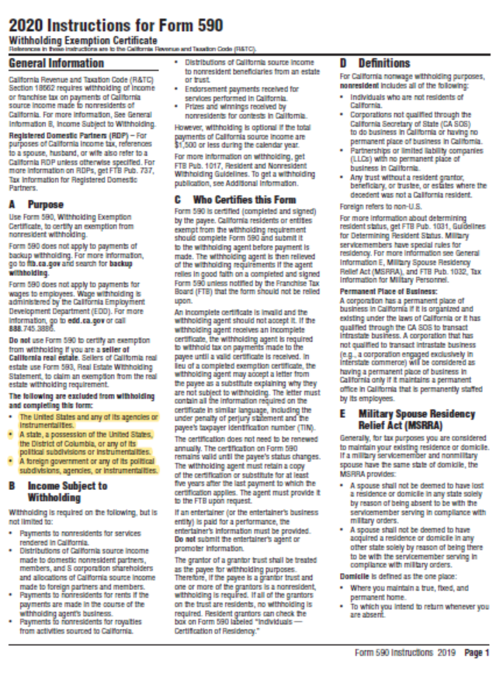
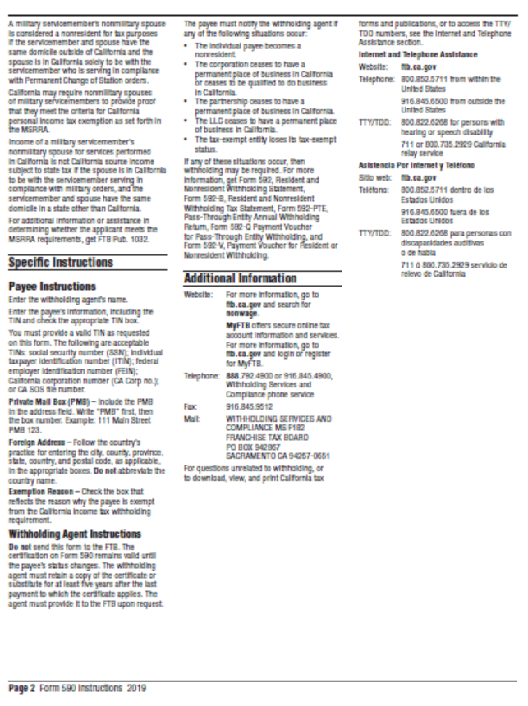
BUSINESS STATUS CERTIFICATIONS

Federal guidance for utilization of disadvantaged business enterprises allows a vendor to be deemed a small business enterprise (SBE), minority business enterprise (MBE) or women business enterprise (WBE) if it meets the criteria below.
- is certified by the Small Business Administration or
- is certified by a state or federal agency or
- is an independent MBE(s) or WBE(s) business concern which is at least 51 percent owned and controlled by minority group member(s) who are citizens of the United States.

Statements of certification:

As a prime contractor to South Coast AQMD, (name of business) will engage in good faith efforts to achieve the fair share in accordance with 40 CFR Section 33.301, and will follow the six affirmative steps listed below for contracts or purchase orders funded in whole or in part by federal grants and contracts.

- Place qualified SBEs, MBEs, and WBEs on solicitation lists.
- Assure that SBEs, MBEs, and WBEs are solicited whenever possible.
- When economically feasible, divide total requirements into small tasks or quantities to permit greater participation by SBEs, MBEs, and WBEs.
- Establish delivery schedules, if possible, to encourage participation by SBEs, MBEs, and WBEs.
- Use services of Small Business Administration, Minority Business Development Agency of the Department of Commerce, and/or any agency authorized as a clearinghouse for SBEs, MBEs, and WBEs.
- If subcontracts are to be let, take the above affirmative steps.

Self-Certification Verification: Also for use in awarding additional points, as applicable, in accordance with South Coast AQMD Procurement Policy and Procedure:

Check all that apply:

Small Business Enterprise/Small Business Joint Venture Women-owned Business Enterprise
Local business Disabled Veteran-owned Business Enterprise/DVBE Joint Venture
Minority-owned Business Enterprise Most Favored Customer Pricing Certification

Percent of ownership: %

Name of Qualifying Owner(s):

State of California Public Works Contractor Registration No. ______________________. MUST BE INCLUDED IF BID PROPOSAL IS FOR PUBLIC WORKS PROJECT.

I, the undersigned, hereby declare that to the best of my knowledge the above information is accurate. Upon penalty of perjury, I certify information submitted is factual.

NAME TITLE

TELEPHONE NUMBER DATE

Definitions

Disabled Veteran-Owned Business Enterprise means a business that meets all of the following criteria:
- is a sole proprietorship or partnership of which is at least 51 percent owned by one or more disabled veterans, or in the case of any business whose stock is publicly held, at least 51 percent of the stock is owned by one or more disabled veterans; a subsidiary which is wholly owned by a parent corporation but only if at least 51 percent of the voting stock of the parent corporation is owned by one or more disabled veterans; or a joint venture in which at least 51 percent of the joint venture’s management and control and earnings are held by one or more disabled veterans.
- the management and control of the daily business operations are by one or more disabled veterans. The disabled veterans who exercise management and control are not required to be the same disabled veterans as the owners of the business.
- is a sole proprietorship, corporation, partnership, or joint venture with its primary headquarters office located in the United States and which is not a branch or subsidiary of a foreign corporation, firm, or other foreign-based business.

Joint Venture means that one party to the joint venture is a DVBE and owns at least 51 percent of the joint venture. In the case of a joint venture formed for a single project this means that DVBE will receive at least 51 percent of the project dollars.

Local Business means a business that meets all of the following criteria:

- has an ongoing business within the boundary of South Coast AQMD at the time of bid application.
- performs 90 percent of the work within South Coast AQMD’s jurisdiction.

Minority-Owned Business Enterprise means a business that meets all of the following criteria:

- is at least 51 percent owned by one or more minority persons or in the case of any business whose stock is publicly held, at least 51 percent of the stock is owned by one or more minority persons.
- is a business whose management and daily business operations are controlled or owned by one or more minority person.
- is a business which is a sole proprietorship, corporation, partnership, joint venture, an association, or a cooperative with its primary headquarters office located in the United States, which is not a branch or subsidiary of a foreign corporation, foreign firm, or other foreign business.

“Minority” person means a Black American, Hispanic American, Native American (including American Indian, Eskimo, Aleut, and Native Hawaiian), Asian-Indian American (including a person whose origins are from India, Pakistan, or Bangladesh), Asian-Pacific American (including a person whose origins are from Japan, China, the Philippines, Vietnam, Korea, Samoa, Guam, the United States Trust Territories of the Pacific, Northern Marianas, Laos, Cambodia, or Taiwan).

Small Business Enterprise means a business that meets the following criteria:

- 1) an independently owned and operated business; 2) not dominant in its field of operation; 3) together with affiliates is either:

- A service, construction, or non-manufacturer with 100 or fewer employees, and average annual gross receipts of ten million dollars ($10,000,000) or less over the previous three years, or

- A manufacturer with 100 or fewer employees.

- Manufacturer means a business that is both of the following:

- Primarily engaged in the chemical or mechanical transformation of raw materials or processed substances into new products.

- Classified between Codes 311000 to 339000, inclusive, of the North American Industrial Classification System (NAICS) Manual published by the United States Office of Management and Budget, 2007 edition.

Small Business Joint Venture means that one party to the joint venture is a Small Business and owns at least 51 percent of the joint venture. In the case of a joint venture formed for a single project this means that the Small Business will receive at least 51 percent of the project dollars.

Women-Owned Business Enterprise means a business that meets all of the following criteria:

- is at least 51 percent owned by one or more women or in the case of any business whose stock is publicly held, at least 51 percent of the stock is owned by one or more women.
- is a business whose management and daily business operations are controlled or owned by one or more women.
- is a business which is a sole proprietorship, corporation, partnership, or a joint venture, with its primary headquarters office located in the United States, which is not a branch or subsidiary of a foreign corporation, foreign firm, or other foreign business.

Most Favored Customer as used in this policy means that the South Coast AQMD will receive at least as favorable pricing, warranties, conditions, benefits and terms as other customers or clients making similar purchases or receiving similar services.
 CAMPAIGN CONTRIBUTIONS DISCLOSURE

In accordance with California law, bidders and contracting parties are required to disclose, at the time the application is filed, information relating to any campaign contributions made to Board Members or members/alternates of the MSRC, including: the name of the party making the contribution (which includes any parent, subsidiary or otherwise related business entity, as defined below), the amount of the contribution, and the date the contribution was made. 2 C.C.R. §18438.8(b).

California law prohibits a party, or an agent, from making campaign contributions to SCAQMD Governing Board Members or members/alternates of the Mobile Source Air Pollution Reduction Review Committee (MSRC) of more than $250 while their contract or permit is pending before the SCAQMD; and further prohibits a campaign contribution from being made for three (3) months following the date of the final decision by the Governing Board or the MSRC on a donor’s contract or permit. Gov’t Code §84308(d). For purposes of reaching the $250 limit, the campaign contributions of the bidder or contractor plus contributions by its parents, affiliates, and related companies of the contractor or bidder are added together. 2 C.C.R. §18438.5.

In addition, Board Members or members/alternates of the MSRC must abstain from voting on a contract or permit if they have received a campaign contribution from a party or participant to the proceeding, or agent, totaling more than $250 in the 12-month period prior to the consideration of the item by the Governing Board or the MSRC. Gov’t Code §84308(c).

The list of current SCAQMD Governing Board Members can be found at the SCAQMD website (www.aqmd.gov). The list of current MSRC members/alternates can be found at the MSRC website (http://www.cleantransportationfunding.org).

SECTION I.
Contractor (Legal Name):

- DBA, Name , County Filed in
Corporation, ID No.
LLC/LLP, ID No.
List any parent, subsidiaries, or otherwise affiliated business entities of Contractor:
(See definition below).

Campaign Contributions Disclosure, continued:

SECTION II.

Has Contractor and/or any parent, subsidiary, or affiliated company, or agent thereof, made a campaign contribution(s) totaling $250 or more in the aggregate to a current member of the South Coast Air Quality Management Governing Board or member/alternate of the MSRC in the 12 months preceding the date of execution of this disclosure?

Yes No If YES, complete Section II below and then sign and date the form.
If NO, sign and date below. Include this form with your submittal.

Name of Contributor

Governing Board Member or MSRC Member/Alternate Amount of Contribution Date of Contribution

Name of Contributor

Governing Board Member or MSRC Member/Alternate Amount of Contribution Date of Contribution

Name of Contributor

Governing Board Member or MSRC Member/Alternate Amount of Contribution Date of Contribution

Name of Contributor

Governing Board Member or MSRC Member/Alternate Amount of Contribution Date of Contribution

I declare the foregoing disclosures to be true and correct.

By:

Title:

Date:

DEFINITIONS

Parent, Subsidiary, or Otherwise Related Business Entity (2 Cal. Code of Regs., §18703.1(d).)

(1) Parent subsidiary. A parent subsidiary relationship exists when one corporation directly or indirectly owns shares possessing more than 50 percent of the voting power of another corporation.

(2) Otherwise related business entity. Business entities, including corporations, partnerships, joint ventures and any other organizations and enterprises operated for profit, which do not have a parent subsidiary relationship are otherwise related if any one of the following three tests is met:
(A) One business entity has a controlling ownership interest in the other business entity.
(B) There is shared management and control between the entities. In determining whether there is shared management and control, consideration should be given to the following factors:
- The same person or substantially the same person owns and manages the two entities;
- There are common or commingled funds or assets;
- The business entities share the use of the same offices or employees, or otherwise share activities, resources or personnel on a regular basis;
- There is otherwise a regular and close working relationship between the entities; or
(C) A controlling owner (50% or greater interest as a shareholder or as a general partner) in one entity also is a controlling owner in the other entity.

Attachment C: Sample Contract
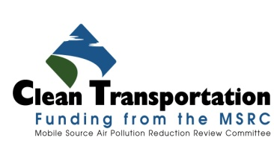


AB 2766/MSRC WOrk program CONTRACT

- PARTIES - The parties to this Contract are the South Coast Air Quality Management District (hereinafter referred to as "SCAQMD") whose address is 21865 Copley Drive, Diamond Bar, California 91765-4178, and the *** (hereinafter referred to as "CONTRACTOR") whose address is ***.

- RECITALS
- SCAQMD is the local agency with primary responsibility for regulating stationary source air pollution within the geographical boundaries of the South Coast Air Quality Management District in the State of California (State). SCAQMD is authorized under State Health & Safety Code Section 44225 (AB 2766) to levy a fee on motor vehicles for the purpose of reducing air pollution from such vehicles and to implement the California Clean Air Act.
- Under AB 2766, SCAQMD's Governing Board has authorized the imposition of the statutorily set motor vehicle fee. By taking such action, the State's Department of Motor Vehicles (DMV) is required to collect such fee and remit it periodically to SCAQMD.
- AB 2766 further mandates that thirty (30) percent of such vehicle registration fees be placed by SCAQMD into a separate account for the sole purpose of implementing and monitoring programs to reduce air pollution from motor vehicles.
- AB 2766 creates a regional Mobile Source Air Pollution Reduction Review Committee (MSRC) to develop a work program to fund projects from the separate account. Pursuant to approval of the work program by SCAQMD's Governing Board, SCAQMD authorized this Contract with CONTRACTOR for equipment or services described in Attachment 1 - Statement of Work, expressly incorporated herein by this reference and made a part hereof of this Contract.
- CONTRACTOR has met the requirements for receipt of AB 2766 Discretionary Funds as set forth in CONTRACTOR's *** Program Application/Proposal dated ***.
- CONTRACTOR is authorized to do business in the State of California and attests that it is in good tax standing with the California Franchise Tax Board.
- All parties to this Contract have had the opportunity to have this Contract reviewed by their attorney.

- DMV FEES - CONTRACTOR acknowledges that SCAQMD cannot guarantee that the amount of fees to be collected under AB 2766 will be sufficient to fund this Contract. CONTRACTOR further acknowledges that payment under this Contract is contingent upon SCAQMD receiving sufficient funds from the DMV, and that SCAQMD assumes no responsibility for the collection and remittance of motor vehicle registration fees.

- AUDIT AND RECORDS RETENTION
  - CONTRACTOR shall, at least once every two years, or within two years of the termination of the Contract if the term is less than two years, be subject to an audit by SCAQMD or its authorized representative to determine if the revenues received by CONTRACTOR were spent for the reduction of pollution from motor vehicles pursuant to the Clean Air Act of 1988.
  - CONTRACTOR agrees to maintain records related to this Contract during the Contract term and continue to retain these records for a period of two years beyond the Contract term, except that in no case shall CONTRACTOR be required to retain more than the most recent five years’ records. SCAQMD shall coordinate such audit through CONTRACTOR'S audit staff.
  - If an amount is found to be inappropriately expended, SCAQMD may withhold funding, or seek reimbursement, from CONTRACTOR in the amount equal to the amount that was inappropriately expended. Such withholding shall not be construed as SCAQMD's sole remedy and shall not relieve CONTRACTOR of its obligation to perform under the terms of this Contract.

- TERM - The term of this Contract is for *** (**) months from the date of execution by both parties, unless terminated earlier as provided for in the TERMINATION clause of this Contract, the EARLY TERMINATION clause, [OPTIONAL] or the term is extended by amendment of this Contract in writing. No work shall commence prior to the Contract start date, except at CONTRACTOR's cost and risk, and no charges are authorized until this Contract is fully executed, subject to the provisions stated in the PRE-CONTRACT COSTS clause of this Contract.

- SUCCESSORS-IN-INTEREST - This Contract, and the obligations arising under the Contract, shall be binding on and inure to the benefit of CONTRACTOR and their executors, administrators, successors, and assigns.

- REPORTING - CONTRACTOR shall submit reports to SCAQMD as outlined in Attachment 1 - Statement of Work. SCAQMD reserves the right to review, comment, and request changes to any report produced as a result of this Contract.

- TERMINATION
  - In the event any party fails to comply with any term or condition of this Contract, or fails to provide services in the manner agreed upon by the parties, including, but not limited to, the requirements of Attachment 1 – Statement of Work, this failure shall constitute a breach of this Contract. The non-breaching party shall notify the breaching party that it must cure this breach or provide written notification of its intention to terminate this contract. Notification shall be provided in the manner set forth in the NOTICES clause of this Contract. The non-breaching party reserves all rights under law and equity to enforce this Contract and recover damages.
  - SCAQMD reserves the right to terminate this Contract, in whole or in part, without cause, upon thirty (30) days’ written notice. Once such notice has been given, CONTRACTOR shall, except as and to the extent or directed otherwise by SCAQMD, discontinue any Work being performed under this Contract and cancel any of CONTRACTOR’s orders for materials, facilities, and supplies in connection with such Work, and shall use its best efforts to procure termination of existing subcontracts upon terms satisfactory to SCAQMD. Thereafter, CONTRACTOR shall perform only such services as may be necessary to preserve and protect any Work already in progress and to dispose of any property as requested by SCAQMD.
- Either party may terminate this Contract upon thirty (30) days written notice to the other party.
- CONTRACTOR shall be paid in accordance with this Contract for all Work performed before the effective date of termination under section B of the TERMINATION clause of this Contract. Before expiration of the thirty (30) days’ written notice, CONTRACTOR shall promptly deliver to SCAQMD all copies of documents and other information and data prepared or developed by CONTRACTOR under this Contract with the exception of a record copy of such materials, which may be retained by CONTRACTOR.

- EARLY TERMINATION - This Contract may be terminated early due to the following circumstances: The infrastructure identified in Attachment 1, Statement of Work, becomes inoperable, and is either not technically able to be repaired, or is too costly to repair, and such failure is not caused by CONTRACTOR’s negligence, misuse, or malfeasance. [OPTIONAL]

- STOP WORK - SCAQMD may, at any time, by written notice to CONTRACTOR, require CONTRACTOR to stop all or any part of the Statement of Work tasks in this Contract. A stop work order may be issued for reasons including, but not limited to, the project exceeding the budget, out of scope work, delay in project schedule, or misrepresentations. Upon receipt of the stop work order, CONTRACTOR shall immediately take all necessary steps to comply with the order. CONTRACTOR shall resume the work only upon receipt of written instructions from SCAQMD cancelling the stop work order. CONTRACTOR agrees and understands that CONTRACTOR will not be paid for performing work while the stop work order is in effect, unless SCAQMD agrees to do so in its written cancellation of the stop work order.

- INSURANCE
- CONTRACTOR shall furnish evidence to SCAQMD of workers' compensation insurance for each of its employees, in accordance with either California or other states’ applicable statutory requirements prior to commencement of any work on this Contract.
- CONTRACTOR shall furnish evidence to SCAQMD of general liability insurance with a limit of at least $1,000,000 per occurrence, and $2,000,000 in a general aggregate prior to commencement of any work on this Contract. SCAQMD shall be named as an additional insured on any such liability policy, and thirty (30) days written notice prior to cancellation of any such insurance shall be given by CONTRACTOR to SCAQMD.
- CONTRACTOR shall furnish evidence to SCAQMD of automobile liability insurance with limits of at least $100,000 per person and $300,000 per accident for bodily injuries, and $50,000 in property damage, or $1,000,000 combined single limit for bodily injury or property damage, prior to commencement of any work on this Contract. SCAQMD shall be named as an additional insured on any such liability policy, and thirty (30) days written notice prior to cancellation of any such insurance shall be given by CONTRACTOR to SCAQMD.
- CONTRACTOR shall furnish evidence to SCAQMD of Professional Liability Insurance with an aggregate limit of not less than $5,000,000. [OPTIONAL]
- If CONTRACTOR fails to maintain the required insurance coverage set forth above, SCAQMD reserves the right either to purchase such additional insurance and to deduct the cost thereof from any payments owed to CONTRACTOR or terminate this Contract for breach.
- All insurance certificates shall be mailed to: SCAQMD, 21865 Copley Drive, Diamond Bar, CA 91765-4178, Attention: Cynthia Ravenstein, MSRC Contracts Administrator. The SCAQMD Contract Number must be included on the face of the certificate.
- CONTRACTOR must provide updates on the insurance coverage throughout the term of the Contract to ensure that there is no break in coverage during the period of contract performance. Failure to provide evidence of current coverage shall be grounds for termination for breach of Contract.

[Use above clause or Self Insurance clause below]

Self Insurance Clause:

INSURANCE - CONTRACTOR represents that it is permissibly self-insured and will maintain such self-insurance in accordance with applicable provisions of California law throughout the term of this Contract. CONTRACTOR shall provide evidence of sufficient coverage during the term of this Contract and any extensions thereof that meet or exceed the minimum requirements set forth by the SCAQMD below. The certificate of self-insurance shall be mailed to: SCAQMD, 21865 Copley Drive, Diamond Bar, CA 91765-4178, Attention: Cynthia Ravenstein, MSRC Contracts Administrator. The SCAQMD Contract Number must be included on the face of the certificate. If CONTRACTOR fails to maintain the required insurance coverage, SCAQMD reserves the right to terminate the Contract or purchase such additional insurance and bill CONTRACTOR or deduct the cost thereof from any payments owed to CONTRACTOR. Minimum insurance coverages are as follows:

- Worker’s compensation insurance in accordance with either California or other state’s applicable statutory requirements.

- General Liability insurance with a limit of at least $1,000,000 per occurrence, and $2,000,000 in general aggregate.

- Automobile Liability insurance with limits of at least $100,000 per person and $300,000 per accident for bodily injuries and $50,000 in property damage, or $1,000,000 combined single limit for bodily injury or property damage.

- INDEMNIFICATION - CONTRACTOR agrees to hold harmless, defend and indemnify SCAQMD, its officers, employees, agents, representatives, and successors-in-interest against any and all loss, damage, costs, lawsuits, claims, demands, causes of action, judgments, attorney’s fees, or any other expenses arising from or related to any third party claim against SCAQMD, its officers, employees, agents, representatives, or successors in interest that arise or result in whole or in part, from any actual or alleged act or omission of CONTRACTOR, its employees, subcontractors, agents or representatives in the performance of this Contract. This Indemnification Clause shall survive the expiration or termination (for any reason) of the Contract and shall remain in full force and effect.

- DISCLAIMER OF WARRANTY - The purchase or lease of funded vehicles/equipment is the CONTRACTOR’s decision. The SCAQMD does not make any express or implied warranty of merchantability, fitness for a particular purpose or otherwise, quality or usefulness of the technology or product. Without limiting the foregoing, the SCAQMD will not be financially responsible, or otherwise liable, for the installation or performance of the vehicle/equipment. [OPTIONAL]

- PAYMENT
- SCAQMD shall reimburse CONTRACTOR up to a total amount of *** Dollars ($***) in accordance with Attachment 2 – Payment/Cost Schedule expressly incorporated herein by this reference and made a part hereof of the Contract.
- A withhold amount or percentage (if any) shall be identified in the Payment/Cost Schedule, and such amount shall be withheld from each invoice. Upon satisfactory completion of project and final acceptance of work and the final report, CONTRACTOR’s invoice for the withheld amount shall be released. Proof of project completion shall include a Final Report detailing the project goals and accomplishments, data collected during project performance, if any, documentation of significant results, and emissions reduction input data needed for calculation of emissions reductions.
- Any funds not expended upon early Contract termination or Contract completion shall revert to the AB 2766 Discretionary Fund. Payment of charges shall be made by SCAQMD to CONTRACTOR within thirty (30) days after approval by SCAQMD of an itemized invoice prepared and furnished by CONTRACTOR.
- An invoice submitted to SCAQMD for payment must be prepared in duplicate, on company letterhead, and list SCAQMD's contract number, period covered by invoice, and CONTRACTOR's social security number or Employer Identification Number and submitted to:

South Coast Air Quality Management District
21865 Copley Drive
Diamond Bar, CA 91765-4178
Attn: Cynthia Ravenstein, MSRC Contracts Administrator

1. Charges for equipment, material, and supply costs, travel expenses, subcontractors, and other charges, as applicable, must be itemized by CONTRACTOR. Reimbursement for equipment, material, supplies, subcontractors, and other charges, as applicable, shall be made at actual cost. Supporting documentation must be provided for all individual charges (with the exception of direct labor charges provided by CONTRACTOR).
2. SCAQMD shall pay CONTRACTOR for travel-related expenses only if such travel is expressly set forth in Attachment 2 – Payment/Cost Schedule of this Contract or pre-authorized by SCAQMD in writing.
3. CONTRACTOR’s failure to provide receipts shall be grounds for SCAQMD’s non-reimbursement of such charges. CONTRACTOR may reduce payments on invoices by those charges for which receipts were not provided.
4. CONTRACTOR must submit final invoice no later than ninety (90) days after the termination date of this Contract or invoice may not be paid.

- COMPLIANCE WITH APPLICABLE LAWS - CONTRACTOR agrees to comply with all federal, state, and local laws, ordinances, codes and regulations and orders of public authorities in the performance of this Contract. CONTRACTOR must also ensure that the vehicles and/or equipment to be purchased, leased or installed is in compliance with all applicable federal, state, and local air quality rules and regulations, and that it will maintain compliance for the full Contract term. CONTRACTOR shall ensure that the provisions of this clause are included in all subcontracts.

- MOBILE SOURCE EMISSION REDUCTION CREDITS (MSERCs)
- The MSRC has adopted a policy that no MSERCs resulting from AB 2766 Discretionary Funds may be generated and/or sold.
- CONTRACTOR has the opportunity to generate MSERCs as a by-product of the project if a portion of the air quality benefits attributable to the project resulted from funding sources other than AB2766. These MSERCs, which are issued by SCAQMD, are based upon the quantified vehicle miles traveled (VMT) by project vehicles or other activity data as appropriate. Therefore, a portion of prospective MSERCs, generated as a result of AB 2766 Funds, must be retired. The portion of prospective credits funded by the AB 2766 program, and which are subject to retirement, shall be referred to as "AB 2766-MSERCs."
- The determination of AB 2766-MSERC's is to be prorated based upon the AB 2766 program's contribution to the cost associated with the air quality benefits. In the case where AB 2766 Discretionary Funds are used to pay for the full differential cost of a new alternative fuel vehicle or for the retrofitting or repowering of an existing vehicle, all MSERCs attributable to AB 2766 Discretionary Funds must be retired. The determination of AB 2766-MSERCs for infrastructure and other ancillary items is to be prorated based upon the AB 2766 program’s contribution to the associated air quality benefits. Determination of the project's overall cost will be on a case-by-case basis at the time an MSERC application is submitted. SCAQMD staff, at the time an MSERC application is submitted, will calculate total MSERCs and retire the AB 2766-MSERCs. CONTRACTOR would then receive the balance of the MSERCs not associated with AB 2766 funding.

- NOTICES - All notices that are required under this Contract shall be provided in the manner set forth herein, unless specified otherwise. Notice to a party shall be delivered to the attention of the person listed below, or to such other person or persons as may hereafter be designated by that party in writing. Notice shall be in writing sent by email, U.S. Mail, express, certified, return receipt requested, or a nationally recognized overnight courier service. In the case of email communications, valid notice shall be deemed to have been delivered upon sending, provided the sender obtained an electronic confirmation of delivery. Email communications shall be deemed to have been received on the date of such transmission, provided such date was a business day (Tuesday-Friday) and delivered prior to 5:30pm Pacific Standard Time. Otherwise, receipt of email communications shall be deemed to have occurred on the following business day. In the case of U.S. Mail notice, notice shall be deemed to be received when delivered or five (5) business days after deposit in the U. S. Mail. In the case of a nationally recognized overnight courier service, notice shall be deemed received when delivered (written receipt of delivery).

SCAQMD:
South Coast Air Quality Management District
21865 Copley Drive
Diamond Bar, CA 91765-4178
Attn: Cynthia Ravenstein, MSRC Contracts Administrator, email: cravenstein@aqmd.gov

CONTRACTOR:
***
***
***
Attn: ***, email: ***

- INDEPENDENT CONTRACTOR - CONTRACTOR is an independent contractor. CONTRACTOR, its officers, employees, agents, representatives, or subcontractors shall in no sense be considered employees or agents of SCAQMD, nor shall CONTRACTOR, its officers, employees, agents, representatives, or subcontractors be entitled to or eligible to participate in any benefits, privileges, or plans, given or extended by SCAQMD to its employees. SCAQMD will not supervise, direct, or have control over, or be responsible for, CONTRACTOR’s or subcontractor’s means, methods, techniques, work sequences or procedures, or for the safety precautions and programs incident thereto, or for any failure by them to comply with any local, state, or federal laws, or rules or regulations, including state minimum wage laws and OSHA requirements.

- SUBCONTRACTOR APPROVAL - If CONTRACTOR intends to subcontract all or a portion of the work under this Contract, then CONTRACTOR must first obtain written approval from SCAQMD’s Executive Officer or designee prior to subcontracting any work. Any material changes to the subcontract(s) that affect the scope of work, deliverable schedule, and/or payment/cost schedule shall also require the prior written approval of the SCAQMD Executive Officer or designee. No subcontract charges will be reimbursed unless the required approvals have been obtained from SCAQMD.

- OWNERSHIP - Title and full ownership rights to any equipment purchased under this Contract shall at all times remain with CONTRACTOR.

[Use above clause, or USE clause below for PROFESSIONAL SERVICES

OWNERSHIP - Title and full ownership rights to any products purchased or developed under this Contract shall at all time remain with CONTRACTOR. CONTRACTOR shall also retain title and full ownership rights to any documents or reports developed under this Contract. All of the above shall be subject to the following limitations:
- PATENT RIGHTS - CONTRACTOR shall have patent rights, as well as title and full ownership rights, for invention(s) developed under this Contract, subject to SCAQMD retaining a no-cost, nonexclusive, nontransferable, irrevocable license to use or test such invention(s) for SCAQMD purposes. CONTRACTOR must obtain agreements to effectuate this clause with all persons or entities obtaining an ownership interest in the patented subject invention(s). Previously documented (whether patented or unpatented under the patent laws of the United States, 35 U.S.C. 1 et seq., or any foreign country) inventions are exempt from this provision. CONTRACTOR shall submit a written report to SCAQMD's Agent disclosing each subject invention and specifying patents applied for, patents issued, and patent application(s) abandoned and/or cosponsored participants on subject invention(s).
- RIGHTS OF TECHNICAL DATA - SCAQMD shall have unlimited right to use technical data resulting from performance of CONTRACTOR under this Contract. CONTRACTOR shall have the right to use data for its own benefit.
- COPYRIGHT - CONTRACTOR agrees to grant SCAQMD a royalty free, nonexclusive, irrevocable, nontransferable license to produce, translate, publish, use, and dispose of all copyrightable material first produced or composed in the performance of this Contract.
- SOFTWARE RIGHTS - CONTRACTOR agrees to grant SCAQMD a worldwide, royalty free, nonexclusive, irrevocable, nontransferable license in perpetuity to use any software developed by CONTRACTOR in performing its obligations under this Contract. CONTRACTOR further agrees to obtain the rights required from any third party for SCAQMD to have a worldwide, royalty free, nonexclusive, irrevocable license in perpetuity to use any other software essential to performance of CONTRACTOR'S obligations under this Contract or necessary to the operation of the software developed by CONTRACTOR. CONTRACTOR shall provide SCAQMD with documentation confirming CONTRACTOR'S right to assign the use of such software. CONTRACTOR shall also provide SCAQMD with all documentation and manuals required to operate the software developed by it or third parties.
- CONTRACTOR'S INSOLVENCY OR BANKRUPTCY, or PROJECT'S DISCONTINUATION - CONTRACTOR agrees that in the event that CONTRACTOR becomes insolvent or files for bankruptcy during the term of the Contract or does not complete the intent of the Contract, title to goods, services software, and equipment purchased for the performance of this Contract with AB 2766 Discretionary Funds shall revert to the SCAQMD.

- SECURITY INTEREST - CONTRACTOR hereby grants SCAQMD a security interest in any and all equipment purchased, in whole or in part, with funding provided by SCAQMD pursuant to this Contract. CONTRACTOR acknowledges and agrees that SCAQMD shall have all lien rights as a secured creditor on any and all equipment purchased in whole or in part by the CONTRACTOR, under this Contract or any amendments thereto. The SCAQMD shall have lien rights in effect until the CONTRACTOR satisfies all terms under the Contract, including but not limited to, the use and reporting requirements. Accordingly, CONTRACTOR further agrees that SCAQMD is authorized to file a UCC filing statement or similar security instrument to secure its interests in the equipment that is the subject of the Contract. In the event CONTRACTOR files for bankruptcy protection, CONTRACTOR shall notify SCAQMD within 10 business days of such filing. [OPTIONAL]

- NON-DISCRIMINATION - In the performance of this Contract, CONTRACTOR shall not discriminate in recruiting, hiring, promotion, demotion, or termination practices on the basis of race, religious creed, color, national origin, ancestry, sex, age, or physical handicap and shall comply with the provisions of the California Fair Employment & Housing Act (Government Code Section 12900, et seq.), the Federal Civil Rights Act of 1964 (P.L. 88-352) and all amendments thereto, Executive Order No. 11246 (30 Federal Register 12319), and all administrative rules and regulations issued pursuant to said Acts and Order. CONTRACTOR shall likewise require each subcontractor to comply with this clause and shall include in each such subcontract language similar to this clause.

- CITIZENSHIP AND ALIEN STATUS
- CONTRACTOR warrants that it fully complies with all laws regarding the employment of aliens and others, and that its employees performing services hereunder meet the citizenship or alien status requirements contained in federal and state statutes and regulations including, but not limited to, the Immigration Reform and Control Act of 1986 (P.L. 99-603). CONTRACTOR shall obtain from all covered employees performing services hereunder all verification and other documentation of employees' eligibility status required by federal statutes and regulations as they currently exist and as they may be hereafter amended. CONTRACTOR shall have a continuing obligation to verify and document the continuing employment authorization and authorized alien status of employees performing services under this Contract to insure continued compliance with all federal statutes and regulations. Notwithstanding the above, CONTRACTOR, in the performance of this Contract, shall not discriminate against any person in violation of 8 USC Section 1324b.
- CONTRACTOR shall retain such documentation for all covered employees for the period described by law. CONTRACTOR shall indemnify, defend, and hold harmless SCAQMD, its officers and employees from employer sanctions and other liability which may be assessed against CONTRACTOR or SCAQMD, or both in connection with any alleged violation of federal statutes or regulations pertaining to the eligibility for employment of persons performing services under this Contract.

- ASSIGNMENT AND TRANSFER OF EQUIPMENT
  - The rights and responsibilities granted hereby may not be assigned, sold, licensed, or otherwise transferred by CONTRACTOR without the prior written consent of SCAQMD, and any attempt by CONTRACTOR to do so shall be void upon inception.
  - CONTRACTOR agrees to obtain SCAQMD’s written consent to any assignment, sale, license or transfer of Equipment, if any, prior to completing the transaction. CONTRACTOR shall inform the proposed assignee, buyer, licensee or transferee (collectively referred to here as “Buyer”) of the terms of this Contract. CONTRACTOR is responsible for establishing contact between SCAQMD and the Buyer and shall assist SCAQMD in facilitating the transfer of this Contract’s terms and conditions to the Buyer. CONTRACTOR will not be relieved of the legal obligation to fulfill the terms and conditions of this Contract until and unless the Buyer has assumed responsibility of this Contract’s terms and conditions through an executed contract with SCAQMD. [OPTIONAL]

- NON-EFFECT OF WAIVER - The failure of CONTRACTOR or SCAQMD to insist upon the performance of any or all of the terms, covenants, or conditions of this Contract, or failure to exercise any rights or remedies hereunder, shall not be construed as a waiver or relinquishment of the future performance of any such terms, covenants, or conditions, or of the future exercise of such rights or remedies, unless otherwise provided for herein.

- PROPOSAL INCORPORATION – CONTRACTOR’s Technical Proposal dated *** submitted in response to Request for Proposal (RFP) #***, is expressly incorporated herein by this reference and made a part hereof of this Contract. In the event of any conflict between the terms and conditions of this Contract and CONTRACTOR’s Technical Proposal, this Contract shall govern and control. [OPTIONAL]

- KEY PERSONNEL - [OPTIONAL]insert person's name is deemed critical to the successful performance of this Contract. Any changes in key personnel by CONTRACTOR must be approved by SCAQMD. All substitute personnel must possess qualifications/experience equal to the original named key personnel and must be approved by SCAQMD. SCAQMD reserves the right to interview proposed substitute key personnel. [OPTIONAL]

- TAX IMPLICATIONS FROM RECEIPT OF MSRC FUNDS - CONTRACTOR is advised to consult a tax attorney regarding potential tax implications from receipt of MSRC funds.

- ATTORNEYS' FEES - In the event any action is filed in connection with the enforcement or interpretation of this Contract, each party in said action shall pay its own attorneys' fees and costs.

- FORCE MAJEURE - Neither SCAQMD nor CONTRACTOR shall be liable or deemed to be in default for any delay or failure in performance under this Contract or interruption of services resulting, directly or indirectly, from acts of God, civil or military authority, acts of public enemy, war, strikes, labor disputes, shortages of suitable parts, materials, labor or transportation, or any similar cause beyond the reasonable control of SCAQMD or CONTRACTOR.

- SEVERABILITY - In the event that any one or more of the provisions contained in this Contract shall for any reason be held to be unenforceable in any respect by a court of competent jurisdiction, such holding shall not affect any other provisions of this Contract, and the Contract shall then be construed as if such unenforceable provisions are not a part hereof.

- HEADINGS - Headings on the clauses of this Contract are for convenience and reference only, and the words contained therein shall in no way be held to explain, modify, amplify, or aid in the interpretation, construction, or meaning of the provisions of this Contract.

- DUPLICATE EXECUTION - This Contract is executed in duplicate. Each signed copy shall have the force and effect of an original.

- GOVERNING LAW - This Contract shall be construed and interpreted and the legal relations created thereby shall be determined in accordance with the laws of the State of California. Venue for resolution of any disputes under this Contract shall be Los Angeles County, California.

- PRE-CONTRACT COSTS - Any costs incurred by CONTRACTOR prior to CONTRACTOR receipt of a fully executed Contract shall be incurred solely at the risk of the CONTRACTOR. In the event that a formal Contract is not executed, neither the MSRC nor the SCAQMD shall be liable for any amounts expended in anticipation of a formal Contract. If a formal Contract does result, pre-contract cost expenditures authorized by the Contract will be reimbursed in accordance with the Payment/Cost Schedule and payment provision of the Contract.

- CHANGE TERMS - Changes to any part of this Contract must be requested in writing by CONTRACTOR and approved by MSRC in accordance with MSRC policies and procedures. CONTRACTOR must make requests a minimum of 90 days prior to desired effective date of change. All modifications to this Contract shall be in writing and signed by the authorized representatives of the parties. Fueling station location changes shall not be approved under any circumstances.

- PREVAILING WAGES – CONTRACTOR is alerted to the prevailing wage requirements of California Labor Code section 1770 et seq., and the compliance monitoring and enforcement of such requirements by the Department of Industrial Relations (“DIR”). CONTRACTOR and all of CONTRACTOR’s subcontractors must comply with the California Public Works Contractor Registration Program and, where applicable, must be registered with the DIR to participate in public works projects. CONTRACTOR shall be responsible for determining the applicability of the provisions of California Labor Code and complying with the same, including, without limitation, obtaining from the Director of the Department of Industrial Relations the general prevailing rate of per diem wages and the general prevailing rate for holiday and overtime work, making the same available to any interested party upon request, paying any applicable prevailing rates, posting copies thereof at the job site and flowing all applicable prevailing wage rate requirements to its subcontractors. Proof of compliance with these requirements must be provided to SCAQMD upon request. CONTRACTOR shall indemnify, defend and hold harmless the South Coast Air Quality Management District against any and all claims, demands, damages, defense costs or liabilities based on failure to adhere to the above referenced statutes. [OPTIONAL]

- ENTIRE CONTRACT - This Contract represents the entire agreement between CONTRACTOR and SCAQMD. There are no understandings, representations, or warranties of any kind except as expressly set forth herein. No waiver, alteration, or modification of any of the provisions herein shall be binding on any party unless in writing and signed by the authorized representative of the party against whom enforcement of such waiver, alteration, or modification is sought.

- AUTHORITY - The signator hereto represents and warrants that he or she is authorized and empowered and has the legal capacity to execute this Contract and to legally bind CONTRACTOR both in an operational and financial capacity and that the requirements and obligations under this Contract are legally enforceable and binding on CONTRACTOR.

(THE REMAINDER OF THIS PAGE IS INTENTIONALLY LEFT BLANK)

IN WITNESS WHEREOF, the parties to this Contract have caused this Contract to be duly executed on their behalf by their authorized representatives.

SOUTH COAST AIR QUALITY MANAGEMENT DISTRICT ***

By: __________________________________________ By: __________________________________________
Dr. William A. Burke, Chairman, Governing Board Name:
Title:

Date: _________________________________________ Date: _________________________________________

ATTEST:
Faye Thomas, Clerk of the Board

By: __________________________________________

APPROVED AS TO FORM:
Bayron Gilchrist, General Counsel

By: __________________________________________

//MSRC Master Boilerplate
Revised January 27, 2016

“Near-Zero” engines compatible with Class 7 and Class 8 heavy-duty trucks currently include natural gas engines certified by the California Air Resources Board at the Optional Low-NOx Certification Standard of 0.02 g/bhp-hr.
MSRC Clean Transportation Funding™ is derived from motor vehicle registration fees collected by the California Department of Motor Vehicles (DMV) in accordance with the California Health and Safety Code. The availability of MSRC Clean Transportation Funding™ is contingent upon the timely receipt of funds from the DMV. Neither the MSRC nor South Coast AQMD can guarantee the collection or remittance of registration fees by the DMV.

