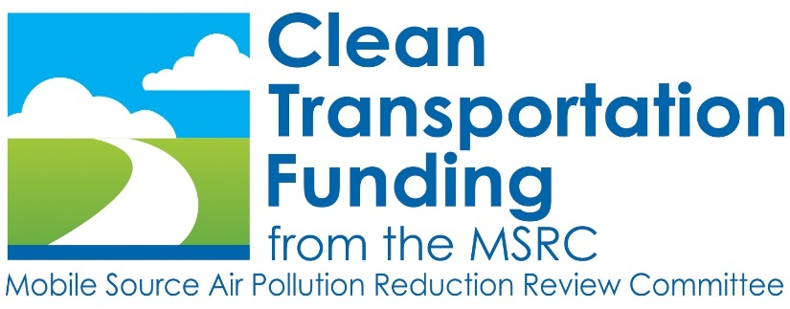

REQUEST FOR PROPOSALS P2022-05

For Technical Advisor Services
for the Mobile Source Air
Pollution Reduction Review Committee
(MSRC)

September 3, 2021

The Mobile Source Air Pollution Reduction Review Committee (MSRC) requests proposals for technical advisor services pursuant to the terms and conditions outlined in this Request for Proposals (RFP). In the preparation of this RFP, the words "Proposer," "Contractor," "Consultant," “Bidder,” and “Independent Contractor” are used interchangeably.

PURPOSE

The purpose of this RFP is to solicit proposals from consultants with strong technical expertise to provide services as the Technical Advisor to the MSRC. So long as expertise and qualifications meet the requirements, individually or collectively, proposals may be submitted by: 1) a single independent contractor, 2) two or more independent contractors submitting a joint proposal; or 3) a consulting firm designating a team of key personnel. The purpose of the Technical Advisor is to provide independent, objective assistance and advice to the MSRC and the MSRC's Technical Advisory Committee (MSRC-TAC) on technical issues related to the AB 2766 Discretionary Fund Program and projects funded under the MSRC’s Work Program. The successful Bidder must enter into a Time & Materials (T&M) type contract with the South Coast Air Quality Management District (South Coast AQMD) in order to receive reimbursement for T&M incurred under this contract. This RFP is also being used to supplement existing MSRC-TAC and MSRC staff resources with specialized outside expertise.

The MSRC requires an independent contractor for Technical Advisor services to plan, implement and monitor its Work Program pursuant to Health & Safety Code Sections 44220-44247. Proposer shall have general business office equipment at their primary office location. However, should Proposer desire, the MSRC shall also make available to the Contractor as a convenience, the following at no additional cost to the Contractor and for the purposes of fulfilling the duties under this contract. These items are all located at South Coast AQMD Headquarters in Diamond Bar, California:

- computer, printer, scanner and digital camera
- telephone and copier machine
- miscellaneous general office supplies
- on-site print shop services
- on-site mail services (postage & handling)
- on-site office space and office furnishings including access and use of conference center facilities
- on-site parking

The period of performance will be for a base 24-month term beginning January 1, 2022 and ending December 31, 2023. The contract will contain an option provision to renew the contract for an additional 24-month term based upon the MSRC's determination of satisfactory performance by the Technical Advisor. Supplemental funding for each additional term of the contract will require review and approval by the MSRC and subsequent SCAQMD approval as part of the MSRC Work Program and is contingent upon this review and approval.

INDEX - The following Sections are contained in this RFP:

Section I Introduction/Background Information
Section II Contact Persons
Section III Schedule of Events
Section IV Statement of Work/Schedule of Deliverables
Section V Required Qualifications
Section VI Proposal Format and Submittal Requirements
Section VII Proposal Submission
Section VIII Audit Procedures
Section IX Proposal Evaluation Process
Section X Contractor Selection Criteria
Section XI DVBE/Local Business/Small Business Status
Section XII Draft Standard Contract
Attachment A - Certifications and Representations

SECTION I: INTRODUCTION/BACKGROUND INFORMATION

In September 1990, Assembly Bill 2766 was signed into law (Health & Safety Code Sections 44220-44247). This legislation authorizes the imposition of an additional motor vehicle registration fee of $2 in 1991 and $4 in 1992 and subsequent years to fund the implementation of programs to reduce air pollution from mobile sources pursuant to air quality management plans and provisions of the California Clean Air Act. The provisions of the bill stated that the fee would be imposed by non-attainment air pollution control districts upon the approval of the fee and a corresponding program to reduce mobile source air pollution by the Governing Board of the SCAQMD. In November of 1990, the SCAQMD Governing Board approved the $2 fee to be levied beginning April 1, 1991, and the $4 fee to be levied on April 1, 1992, and thereafter.

AB 2766 also provided that the monies collected by the Department of Motor Vehicles would be distributed to the SCAQMD for distribution in the following manner: thirty cents of every dollar shall be used by the SCAQMD for programs to reduce air pollution from motor vehicles and to carry out planning, monitoring, enforcement and technical studies which are authorized by, or necessary to implement, the California Clean Air Act; forty cents of every dollar shall be distributed by the SCAQMD to cities and counties located in the South Coast District to be used to reduce mobile source air pollution; and thirty cents of every dollar shall be deposited by the SCAQMD in a discretionary account (the AB 2766 Discretionary Fund) to be used to implement or monitor programs to reduce motor vehicle air pollution.

To determine which projects should be funded by the AB 2766 Discretionary Fund, AB 2766 called for the creation of the MSRC (Health & Safety Code Section 44244) to: 1) develop a Work Program for evaluating programs; 2) evaluate said programs; and 3) make a final recommendation to the South Coast AQMD Governing Board as to which programs and/or projects should be funded. The legislation also called for the formation of the MSRC-TAC to assist and advise the MSRC.

Technical Advisor services will be funded through the AB 2766 Discretionary Fund and will provide technical assistance in evaluation of proposed AB 2766 Discretionary Fund projects, monitor the technical performance of AB 2766 Discretionary Fund contractors, review all final reports on AB 2766 Discretionary Fund projects, keep the MSRC and MSRC-TAC apprised on the latest technologies and scientific developments which may affect AB 2766 Discretionary Fund projects, and prepare the annual California Air Resources Board (ARB) required report assessing the emissions benefits and cost effectiveness of AB 2766 Discretionary Fund projects.

The MSRC has not established a budget for Technical Advisor services for the subject period. As a point of reference, however, the MSRC’s last award for Technical Advisor provided $350,000 for an initial 27-month term and $363,300 for the two-year option term.

For more information on the MSRC and the AB 2766 Discretionary Fund, please visit their website at www.CleanTransportationFunding.org. The South Coast AQMD acts as the contracting and fiduciary agency for the MSRC. For more information on the Soast Coast AQMD, the air pollution control agency for all of Orange County and the urban portions of Los Angeles, Riverside and San Bernardino counties, which is the smoggiest region in the U.S., please visit their website at www.aqmd.gov.

SECTION II: CONTACT PERSONS

Questions regarding the content or intent of this RFP or on procedural matters should be addressed to:

Mr. Dean Hughbanks, Procurement Manager
South Coast AQMD
21865 Copley Drive
Diamond Bar, CA 91765-4178
(909) 396-2808

General questions regarding this RFP, including the scope of work, please contact:

Ms. Jenny Chan
MSRC-TAC Chair
Riverside County Transportation Commission
Phone: (951) 787-7141
E-mail: JChan@RCTC.org

Technical questions regarding this RFP, please contact:

Mr. Aaron Katzenstein
South Coast AQMD
21865 Copley Drive
Diamond Bar, CA 91765
Phone: (909) 396-2219
Email: akatzenstein@aqmd.gov

SECTION III: SCHEDULE OF EVENTS

September 3, 2021 RFP Released
October 14, 2021 All Proposals Due by 2:00 p.m.
October 15-22 Proposal Evaluation Period
October 22, 2021 by Noon Notification of Interview on or around October 27
On or around October 27, 2021 Interviews of Top-Ranked Bidders 9 am to 5 pm (at discretion of Subcommittee)
November 4, 2021 MSRC-TAC Mtg/Recommendations
November 18, 2021 MSRC Mtg/Proposal Review & Approval
December 3, 2021 Governing Board Approval of Contract

It is up to the discretion of the MSRC-TAC Technical Advisor Evaluation Subcommittee whether or not interviews will be conducted. Proposers which meet the minimum RFP criteria shall be notified by Noon on October 22, 2021, as to whether or not an interview will be conducted on or around October 27, 2021, and the time. If interviews are held, interviews are a MANDATORY requirement of this RFP. If the Bidder is unable to attend an interview either by phone, Zoom meeting application or in person at the MSRC offices, then the Bidder will be disqualified from this RFP process. Primary team members or key personnel (who would be performing the deliverables under the contract) shall be part of the interview process.

SECTION IV: STATEMENT OF WORK/SCHEDULE OF DELIVERABLES

The following Statement of Work becomes an integral part of the Contract. The Contractor shall perform the following tasks in support of the AB 2766 Discretionary Fund Program:

Task 1 – RFP and Contract Preparation Assistance

  - Preparation of AB 2766 Discretionary Fund Solicitations

Contractor will provide support in the preparation of Requests for Proposals (RFPs) and/or Program Announcements, as appropriate, for the Work Program categories as established and approved by the MSRC. This support shall include, but not be limited to, preparation of category RFPs including the statements of work, verification of the accuracy of technical information to be provided in the RFPs, and drafting appropriate evaluation criteria. Throughout the RFP and Contract preparation period, Proposer shall communicate significant questions/concerns to the Evaluation Committee, the MSRC-TAC and the MSRC as necessary, including, but not limited to verbal notifications and/or supplemental bulletins.

  - Bidders' Conference(s) and/or Proposer Assistance

Based upon RFPs approved by the MSRC, should Bidders’ Conference(s) be required, Contractor will prepare and present technical information relative to the RFPs at the Bidders' Conference(s), any technical workshops, or requests made through individuals. Types of information which may be prepared and presented by CONTRACTOR may include, but are not necessarily limited to:

- brief overview on the background of the Discretionary Fund program;
- description of the RFP categories for which proposals are sought;
- discussion of the RFP requirements;
- proposal preparation instructions;
- examples of statements of works;
- proposal preparation checklist;
- emissions calculation methodologies.

Throughout the proposal preparation period as outlined in each RFP, Contractor will be available to respond to technical questions raised at all Bidders’ Conferences, workskhops, or via individual requests.

  - Proposal Evaluation Support

Contractor will provide technical assistance to the MSRC-TAC Evaluation Subcommittees including but not limited to assessment of proposals' overall technical merit, assessment of proposed projects' technical feasibility and probability of achieving proposed objectives, and verification of proposed emissions benefit calculations. Contractor may be asked to provide comments in written form or by means of an oral presentation to the Evaluation Subcommittees. Contractor shall advise the Evaluation Subcommittees on the effectiveness of past projects in the areas proposed and inform the Evaluation Subcommittees regarding proposed projects which duplicate work being funded by other sources and any relevant regulatory requirements that may apply to the proposed projects. Contractor shall provide independent, objective technical advice to the Evaluation Subcommittees, but shall not score proposals. Contractor shall compile the results of the Subcommittees’ evaluation and scoring. Should the MSRC require within a specific RFP, evaluation criteria based on emission and quantitative criteria only, MSRC may direct Contractor to evaluate proposals submitted within that category, and present final results to the Evaluation Subcommittee. Where appropriate, Contractor shall provide information from documented sources in relevant technical fields to support his/her technical conclusions.

  - Review and Prepare Contract Work Statements

Upon award by the MSRC and during the contract preparation period, Contractor will review statements of work for technical adequacy on an as-needed basis. Contractor shall work directly with MSRC staff and/or AB 2766 awardees to revise inadequate statements of work and resolve technical issues.

  - Prepare and Present Debriefs for Proposals Not Recommended for Funding

Upon direction by the MSRC, or upon bidder’s request, Contractor may be required to prepare and present debriefs to unsuccessful AB 2766 bidders. These will be performed one-on-one with the unsuccessful bidders or via a written report. This activity will be coordinated with the appropriate MSRC-TAC evaluation subcommittee chair and MSRC staff.

Task 2 – Work Program Support

2.1 Progress Report Technical Evaluation

On an as-needed basis, Contractor will review and evaluate AB 2766 Discretionary Fund progress reports relative to technical issues and concerns. Contractor will recommend a course of action to resolve technical issues identified during progress report review and participate in face-to-face or remote meetings with contractors as required. Contractor will notify the MSRC-TAC and the MSRC of any technical problems that should arise from Contractor’s review of Progress Reports.

2.2 Final Report Evaluation

Contractor will review and evaluate all AB 2766 Discretionary Fund Final Reports. Contractor will quantify emissions benefits and cost effectiveness of each final report using methodologies approved by the ARB. Final reports shall be submitted to the MSRC-TAC and MSRC on a monthly basis, for final review/approval.

  - Invoice Technical Evaluation

On an as-needed basis, Contractor will review and evaluate AB 2766 Discretionary Fund work program invoices relative to the appropriateness of charges in fulfillment of statement of work technical requirements. Contractor will recommend a course of action to resolve concerns identified during invoice review. If required, Contractor shall notify MSRC-TAC and MSRC of any technical concerns/issues that cannot be remedied.
2.4 Technical Review Meetings and Visits to Contractor Facilities

As required, Contractor will conduct technical review meetings with AB 2766 contractors and will visit contractor facilities as required to physically verify reported progress on AB 2766 projects.

2.5 Work Program Development Support

Contractor will provide technical support to the MSRC during its review of past Work Programs, as well as the development of its future work program(s). This process may include one to three separate meetings/workshops, where the Proposer would be responsible for:
- coordinating speakers (ARB, SCAQMD, to name a few) on their respective programs and areas of focus,
- preparing presentation materials (including power points and spreadsheets),
- summarizing past MSRC-funded projects and results, including emissions and cost-effectiveness assessments,
- identifying current and upcoming state of the art technologies, relevant to the MSRC funded programs,
- identifying mobile source emissions reductions programs and initiatives being funded by other sources,
- identifying local, state and federal regulations/rules impacting possible MSRC-funded programs, including, but not limited to relevant AQMP strategies and control measures ,
- recommendations on possible work program categories, as well as suggestions on how to improve the technical quality of AB 2766 projects,
- steps and/or barriers to implementing possible work program categories, and
- summarizing resulting MSRC priorities from these various meetings/workshops.

Proposer will work closely with MSRC staff, MSRC-TAC Chair, MSRC-TAC Subcommittee Chairs and the MSRC Chair in the coordination and presentation of materials at these meetings/workshops, as well as be responsible for summarizing results of workshops, and presenting results at future meetings.

2.6 Areas of Expertise/Support Required for Annual Work Programs

Contractor will provide technical support, as necessary, for the MSRC's annual Work Program to include, but not be limited to, the following technical areas:

- Alternative fuel infrastructure, implementation and operations
- Clean-fuel technologies, for light, medium and heavy duty vehicles (including both on- and off-road vehicles), including engine technologies and retrofit technologies for a variety of alternative fuels
- Vehicle emission control and low carbon fuel technologies
- Local, State and Federal air quality and related climate change regulations
- Technologies in the early deployment stage, such as fuel cells, hydrogen technology, advanced batteries, to name a few
- Transportation control measure strategies, such as ridesharing, non-motorized transportation, to name a few
- Research and development issues, impacting the above technologies
- Requirements of the Health & Safety Codes, as well as MSRC policies and procedures
- ARB certification and verification processes
- Other areas as deemed appropriate by the MSRC

2.7 Vehicle Incentive Program Support

Upon direction by the MSRC, Contractor will provide technical and operational support to any of MSRC’s vehicle incentive programs including, but not limited to, developing manufacturer qualifications, reviewing and evaluating vehicle manufacturer’s qualification packets, program implementation, and monitoring.

Task 3 – General/Other Support

3.1 Annual ARB Report on AB 2766 Projects

Contractor will prepare the annual ARB report on the assessment of emissions benefits and cost effectiveness for AB 2766 Discretionary Fund projects using the ARB provided electronic format. The AB 2766 Discretionary Fund data will be integrated with South Coast AQMD generated data for submission to the ARB.

3.2 Professional Symposia and Technical Conferences

At the direction of the MSRC, Contractor will attend professional symposia and technical conferences related to AB 2766 Discretionary Fund Work Program areas. Contractor may, from time to time, be asked to prepare and/or present technical papers on behalf of the MSRC, or to provide technical information/support to MSRC-TAC and/or MSRC members at such events.

3.3 Meeting Attendance

Contractor will attend the monthly MSRC-TAC and MSRC meetings (typically scheduled monthly on the first and third Thursdays, respectively) and bidder’s conferences. Contractor attendance may be required at MSRC-TAC Evaluation Subcommittees, as well as other meetings as required. Most meetings are held at the South Coast AQMD offices. Contractor will be required to prepare for all meetings, including materials/handouts, as well as consulting with MSRC-TAC and/or Subcommittee Chairs and MSRC staff as needed. Contractor may also be required to attend monthly South Coast AQMD Governing Board meetings (typically first Friday of the month) when MSRC items are on the Board agenda, and shall respond to questions by Governing Board members, as needed.

3.4 Special Projects/Other Related Duties

Contractor will support any special projects and will provide assistance to other duties, as requested/directed by the MSRC. It is conceivable the MSRC may direct special projects on a task-order basis and/or may direct or allow the Technical Advisor to subcontract a special task, in which case a not-to-exceed amount for the task order or subcontract work will be identified and included in the contract at the time of execution or through a future contract amendment.

3.5 Assistance to MSRC Outreach Coordinator

Contractor will assist the MSRC Outreach Coordinator in the review of documents and materials which contain technical material, providing information on emissions reductions of MSRC programs. Contractor shall review any other public outreach materials generated by the MSRC, as well as provide input into technical sections of the MSRC website.

Task 4 - Contract Deliverables

4.1 Final Report Summaries

No later than the last Thursday of every month, Contractor will submit summaries of all final reports received, evaluated and finalized for inclusion in the MSRC-TAC agenda.

4.2 Materials

As appropriate, Contractor will provide copies of presentation material, hand-out materials, PowerPoint presentations and other materials, as described in Tasks 1, 2 and 3 above, to the appropriate MSRC Chair, MSRC-TAC Chair, or Subcommittee Chair. Materials for the MSRC-TAC Agenda packets are due by the last Thursday of each month, and materials for the MSRC Agenda packet are due by no later than the second Thursday of each month.

4.3 ARB Final Report - as defined in Task 3.1 above.

SECTION V: MINIMUM QUALIFICATIONS

The successful bidder must meet the following minimum qualifications and demonstrate an understanding of the MSRC's mission. Individuals can team to submit a joint proposal should they have complementary expertise and qualifications that collectively meet the requirements. Key team members to perform Technical Advisor services to the MSRC must possess minimum years of experience in Items 2 and 3 below.

- B.A. or B.S. in engineering, environmental science, urban planning, or other related disciplines.
- Five years of experience in managing technical projects
- Five years of experience working with public agencies and elected officials.
- Knowledge of local, state and federal air quality laws and regulations.
- Familiarity with South Coast AQMD programs and regulations for mobile sources, as well as EPA and ARB approved methodologies for calculating emissions benefits and cost effectiveness.
- Understanding of technologies and scientific developments related to reduction of air pollution from mobile sources, to include, but not be limited to, alternative fuel vehicles and infrastructure, alternative fueling infrastructure, fuel cell technology and transportation control measures.
- The ability to quickly respond, on short notice, to requests for technical assistance.
- Established relationships with equipment manufacturers and industry and professional associations.

In addition to the minimum qualifications above, the most competitively qualified candidates will possess thorough knowledge of the strategies in the South Coast AQMD’s Air Quality Management Plan, as well as thorough knowledge of South Coast AQMD incentive programs.

Include detailed description of experience, education and training of Proposer and key staff. Also indicate proof of qualification requirements such as licenses, memberships and/or endorsements. Proposer must submit a resume or similar statement of qualifications including, but not limited to, educational degrees and area of study, summary of relevant professional experience, list of technical publications, organizational affiliations, and other information which demonstrates Proposer's knowledge of laws and regulations pertaining to air quality and current and emerging technologies related to reduction of mobile source air pollution, and experience interacting with State agencies.

SECTION VI: PROPOSAL FORMAT AND SUBMITTAL REQUIREMENTS

Submitted proposals must follow the format outlined below and all requested information must be supplied. Failure to submit proposals in the required format will result in elimination from proposal evaluation.

Proposals must be submitted electronically in PDF format using the MSRC Website. We believe this benefits the proposer, the MSRC staff, and the environment. A tutorial has been developed to guide proposers step by step through the electronic proposal submittal process; this tutorial is available on the MSRC www.cleantransportationfunding.org website at this link: http://www.cleantransportationfunding.org/sites/default/files/downloads/Guide%20to%20Using%20the%20Website_v3.pdf

Note that the tutorial is one section of the Contractor Guide for Using the Website. You will not see the screens pictured until after you have registered as a Contractor on the website. If you are registering a new account on the site, make sure you select the “Contractor” role.
Format - The maximum length of proposals accepted will be thirty (30) pages. All pages and appendices must be numbered. Technical appendices of no more than fifty (50) pages, including information on bidder's past projects and experience, may be attached.
Cover Letter - Transmittal of the proposal must specify the subject of the proposal, the MSRC RFP number, and Bidder's name, address, telephone number and e-mail address. The letter shall specify contact person(s) for technical and contractual matters, and be signed by the person(s) authorized to contractually bind the bidding entity. For joint proposals (from more than one entity and/or consultant) the bidder must include a statement confirming authorization to act on behalf of other co-bidders. The bidder must include a letter of support or memorandum of understanding, including project contact name, telephone and fax number, from all proposing entities. Proposer will acknowledge that the interview date is on or around October 27, 2021 and that Proposer, including key personnel who would be performing contract deliverables, intends to be available for that date. Proposal should also acknowledge that proposal shall constitute a firm offer and may not be withdrawn for a period of ninety (90) days following the last day to accept proposals, and that they have checked the website for addenda and/or supplementary information to the RFP; failure to do so may disqualify the bidder.

Table of Contents - Clearly identify material contained in the proposal by section and page number.

SECTION I - Technical Approach for Accomplishing the Statement of Work: List, and concisely describe approach to the tasks and subtasks, and milestones if any and if appropriate. The tasks and subtask descriptions shall be sufficiently specific for inclusion into a binding contractual document.

SECTION 2 - Program Schedule: Since the majority of the work performed is per the direction of the MSRC, or is based on milestones as established by the MSRC or another agency such as the ARB, a program schedule is not required. However, in this section, please identify if there may be any conflicts in completing all the tasks, or any issues related to task delivery.

SECTION 3 - Project Organization: This section should describe the labor organization required to perform the proposed services. This section should include assigned personnel and any subcontractors. Resumes of assigned personnel and anticipated subcontractors should be included in the proposal. As part of your proposal, certify that you are a legal entity capable of entering into contracts within the State of California.

SECTION 4 - Conflict of Interest – Address possible conflicts of interest with other clients affected by actions performed by the firm on behalf of the MSRC. Provide a list of current clients. Although the Proposer will not be automatically disqualified by reason of work performed for such firms, MSRC reserves the right to consider the nature and extent of such work in evaluating the proposal and in issuing future task orders.

Please note that the Technical Advisor will be subject to the requirements and restrictions of the South Coast AQMD Conflicts of Interest Code, as well as state law and regulations governing economic conflicts of interest. The following language (or similar) will be included in the Technical Advisor’s contract:

As a condition of the contract, as the Technical Advisor of the MSRC, CONTRACTOR agrees to avoid any actual or perceived conflicts of interest between CONTRACTOR’s economic interests and its duties under the contract. To ensure that no conflicts exist with CONTRACTOR’s other clients, CONTRACTOR agrees to immediately notify SCAQMD of any potential conflicts of interest prior to entering into or renewing a contract with any person, company, organization or governmental entity that CONTRACTOR reasonably foresees will apply to receive funding from the MSRC during the term of this contract

SECTION 5 - Cost Schedule: This schedule should include a full and complete cost element breakdown by Statement of Work Task. The cost schedule must include:

- Total Proposed Cost - include total proposed cost for the base 27-month term as well as the 24-month option term.

- Labor - identify each professional category of direct project support, the number of hours by Task, and the fully burdened rate per hour. Provide an explanation for the overall fully burdened rate per hour per professional category, and how that rate was obtained (including a breakout and explanation for overhead, fringe, other general and administrative expenses, and profit). If subcontractors are not identified, provide an estimate of their rates of compensation and number of hours or days the subcontractor's services will be utilized. The Bidder is required to certify as part of their proposal submission that the prime contractor and subcontractor rates contained in the proposal are no higher than the rates offered to the prime or subcontractor's most favored customer.

- Travel and Related Expenses - Please confirm that the technical expert can meet the District's practice in charging travel and related expenses stated below.

- Will not pay for interest or fees accrued on credit cards, when using credit cards for payments.
- Will pay a maximum of $150 per day for lodging, unless prior written approval is received from the SCAQMD.
- Will pay class C or economy rates for automobile rental, unless prior written approval is received from the SCAQMD.
- Will only pay coach rate for airfare.
- Will not pay profit or fee on charges for supplies, equipment, travel, and subcontractors.
- Will reimburse mileage at the current SCAQMD rate (currently $0.535 per mile).
- Will reimburse for meals, based on the current SCAQMD rate (currently a maximum of $50.00/day for meals).
- Will reimburse costs on an as-incurred basis only.
- Charges for supplies, equipment, and subcontractors will be paid at cost. No profit will be paid on these costs.

- Supplies and Equipment - Capital costs are not eligible for funding. Provide an itemized list of supplies and equipment to be used and/or purchased and reimbursed for under this contract (include item brand, cost and purpose).

- Subcontractor Costs - Identify subcontractors by name, the basis for the subcontractors selection and describe in detail the work the subcontractors will be hired to perform, list their cost per hour or per day, and the number of hours or days their services will be used.

- Miscellaneous Costs - if any

SECTION 6 - Past Performance: This section must include the following information on at least three contracts for similar or related projects which the Proposer has performed in the past five years:
- a brief description of the project;
- the contract value at inception and expiration (any cost growth should be explained);
- the period of contract performance;
- the contract type, such as fixed price, T&M or cost reimbursement; and
- the name and telephone number of the contracting agency's representative.

SECTION 7 - All certifications and representations (see Attachment A to this RFP) must also be provided.

SECTION VII: PROPOSAL SUBMISSION

All proposals must be submitted according to specifications set forth in the section above. Failure to adhere to these specifications may be cause for rejection of proposal.

Signature - All proposals should be signed by an authorized representative of the Proposer.

Due Date - All proposals are due no later than 2:00 p.m., October 14, 2021. Proposers are encouraged to start early in case of any issues encountered with the electronic submission process. Late bids/proposals and proposals submitted via email and/or by FAX will not be accepted. Please note that any proposal received at 2:01 p.m. or later on October 14, 2021, will not be evaluated and will not be eligible for MSRC funding. NO exceptions for any reason will be granted. Any correction or re-submission done by the bidder will not extend the submittal due date.

Addenda - MSRC may modify the RFP and/or issue supplementary information or guidelines relating to the RFP during the proposal preparation period, from September 3, 2021 through October 14, 2021, at 2:00 p.m. Check back on the MSRC’s website periodically throughout this open bid period for supplementary information or guidelines.

Disposition of Proposals - MSRC reserves the right to reject any or all proposals. All responses become the property of MSRC.

Modification or Withdrawal - Once submitted, proposals cannot be altered without the prior written consent of South Coast AQMD. All proposals shall constitute firm offers and may not be withdrawn for a period of ninety (90) days following the last day to accept proposals; this shall be noted in the Cover Letter required under Section VI.

SECTION VIII: AUDIT PROCEDURES

The AB 2766 legislation requires that the South Coast AQMD, at least once every two years, undertake an audit of programs or projects funded. The audit is to be conducted by an independent auditor selected by the South Coast AQMD. Any bidder who receives monies from the AB 2766 Discretionary Fund may, at least once every two years, be subject to an audit of each program or project funded.

Under the completion of an audit, the South Coast AQMD will make the audit available to the public and to the bidder upon request and will review the audit to determine if the monies were used for the reduction of air pollution from motor vehicles pursuant to the California Clean Air Act of 1988. If the South Coast AQMD determines that the monies were expended in a manner contrary to law, the SCAQMD will notify the contractor of the determination and, within 45 days, may hold a public hearing at which the contractor may present information related to the expenditure of monies.

SECTION IX: PROPOSAL EVALUATION PROCESS

An Evaluation Subcommittee of the MSRC-TAC will evaluate all proposals to determine responsiveness to the RFP. South Coast AQMD staff may provide administrative and technical assistance during the proposal evaluation process.

Proposals will be evaluated and points awarded based upon the criteria outlined in Section X. The evaluation criteria are included to provide the bidder additional guidance as to the particular components of the proposal that will be evaluated. The top-ranked bidders may be interviewed by an Evaluation Subcommittee of the MSRC-TAC on or around Wednesday, October 27, 2021. Bidders will be notified by noon on Friday October 22, 2021, if they are invited to the interview process. If interviews are held, participation in the interview process on the date set aside is a MANDATORY requirement of this RFP. Primary team members or key personnel (who would be performing the deliverables under the contract) shall be part of the interview process.

At the completion of the evaluation process, the MSRC will consider and vote on the Subcommittee recommendation at its November 18, 2021 meeting. The MSRC’s contract award is subject to approval by the South Coast AQMD Governing Board to execute a contract with the successful bidder. The resulting contract will include a key personnel clause.

NOTE: Pursuant to the Brown Act, public comments are allowed at MSRC and MSRC-TAC meetings during the "public comment" period and on any specific agenda item. All bidders have the opportunity to attend full committee meetings and are encouraged to do so.

SECTION X: CONTRACTOR SELECTION CRITERIA
An Evaluation Subcommittee of the MSRC-TAC will identify the successful bidder as the one with the highest-scored proposal based upon the following evaluation criteria. The recommended selection will be forwarded to the MSRC-TAC and MSRC for their consideration. Final selection by the MSRC will be made on November 18, 2021, and submitted to the South Coast AQMD Governing Board for consideration and approval at its December 3, 2021 meeting.

The maximum score available is 100 points.

#1: Technical Qualifications/Experience 40 Points
The Proposer will be evaluated based on their educational credentials, experience managing technical projects, experience working with public agencies/elected officials, knowledge of technologies and scientific developments related to reduction of mobile source air pollution, experience using ARB methodologies to calculate emissions benefits and knowledge of local, state and federal air quality laws/regulations.

#2: Technical Approach 20 Points
The Proposer will be evaluated based on their understanding of the statement of work requirements as well as the outlined approach for interfacing with MSRC, MSRC-TAC, MSRC staff, other government agencies, industry groups, and members of the public. This interface includes an understanding/experience for resolving conflicts, method for establishing priorities and protocol for responding to requests for information.

3#: Proposed Cost 20 Points
Maximum points will be awarded to the Proposer offering the lowest fully burdened labor rates during the base term (two years) and the option (two-year term). Points awarded to other Proposers will be prorated based on the lowest proposed rate.
#4: Past Performance 10 Points
Quality of past performance on similar or related projects performed in the past five years based upon verification of the information provided in proposal.

#5: DVBE/Local Business/Small Business Status 10 Points
Certified as DVBE, local business and/or small business as described in Section XI of this RFP.

Maximum Point Award 100 points

SECTION XI: DVBE/LOCAL BUSINESS/SMALL BUSINESS STATUS
On May 27, 1999, the MSRC approved a policy regarding other evaluation factors for inclusion in MSRC procurements. MSRC procurements, where the services/product solicited are assistance to the MSRC in implementing its work program and where a portion or all of these services are not readily quantifiable, the MSRC shall only have the following "Other" Criteria in the evaluation component of the procurements which do not emphasize quantifiable emissions reductions:

It is the policy of the MSRC to encourage participation by disabled veteran business entities, local businesses and small business and in the bidding process. The MSRC shall provide five (5) points each for Proposers who meet the following criteria, with the maximum points available not-to-exceed ten (10) points. Points shall only be awarded should the Proposer, upon submission of its proposal, provide documents from a state or local agency certifying that it qualifies in the categories described below:

#1 "Disabled Veteran" as used herein is a United States military, a naval, or air service veteran with at least 10 percent service-connected disability. "Disabled Veteran Business Enterprise" as used herein means a sole proprietorship or partnership or corporation which is at least 51 percent owned by one or more disabled veterans and whose management and control of the daily business operations are by one or more disabled veterans.

#2 "Local Business" as used herein means a Proposer which can demonstrate that it has an on-going business within the South Coast AQMD at the time of the bid application and performs 90% of the work related to the contract with the South Coast AQMD.

#3 "Small Business" as used herein means a business that is:
- independently owned and operated business, and
- is not dominant in its field of operation and
- together with affiliates is either a service, construction, or non-manufacturer with 100 or fewer employees, and average annual gross receipts of ten million dollars or less over the previous three years, or a manufacturer with 100 or fewer employees.

SECTION XII - DRAFT SAMPLE CONTRACT

Bidders whose projects are selected for funding must enter into a Time & Materials (T&M) type contract with the South Coast AQMD as a condition of receiving funds. Contract preparation will begin immediately upon approval by the South Coast AQMD Governing Board.

A sample South Coast AQMD contract document may be downloaded from this page: http://www.aqmd.gov/grants-bids. Each bidder should review the sample contract for all possible exceptions to the boilerplate provisions. Any exceptions to the sample contract terms and conditions should be identified in the proposal. Please note that this is a sample only, and the MSRC may modify provisions.

Attachment A: Certifications

South Coast
Air Quality Management District
21865 Copley Drive, Diamond Bar, CA 91765-4178
(909) 396-2000 • www.aqmd.gov

BUSINESS INFORMATION REQUEST

Business Name
Division of
Subsidiary of
Website Address
Type of Business  Check One: | - Individual  - DBA, Name _______________, County Filed in _______________  - Corporation, ID No. ________________  - LLC/LLP, ID No. _______________  - Other _______________

REMITTING ADDRESS INFORMATION
Address
City/Town
State/Province |  | Zip
Phone | ( ) - Ext | Fax | ( ) -
Contact |  | Title
E-mail Address
Payment Name if Different

BUSINESS STATUS CERTIFICATIONS

Federal guidance for utilization of disadvantaged business enterprises allows a vendor to be deemed a small business enterprise (SBE), minority business enterprise (MBE) or women business enterprise (WBE) if it meets the criteria below.
- is certified by the Small Business Administration or
- is certified by a state or federal agency or
- is an independent MBE(s) or WBE(s) business concern which is at least 51 percent owned and controlled by minority group member(s) who are citizens of the United States.

Statements of certification:

As a prime contractor to South Coast AQMD, (name of business) will engage in good faith efforts to achieve the fair share in accordance with 40 CFR Section 33.301, and will follow the six affirmative steps listed below for contracts or purchase orders funded in whole or in part by federal grants and contracts.

- Place qualified SBEs, MBEs, and WBEs on solicitation lists.
- Assure that SBEs, MBEs, and WBEs are solicited whenever possible.
- When economically feasible, divide total requirements into small tasks or quantities to permit greater participation by SBEs, MBEs, and WBEs.
- Establish delivery schedules, if possible, to encourage participation by SBEs, MBEs, and WBEs.
- Use services of Small Business Administration, Minority Business Development Agency of the Department of Commerce, and/or any agency authorized as a clearinghouse for SBEs, MBEs, and WBEs.
- If subcontracts are to be let, take the above affirmative steps.

Self-Certification Verification: Also for use in awarding additional points, as applicable, in accordance with South Coast AQMD Procurement Policy and Procedure:

Check all that apply:

Small Business Enterprise/Small Business Joint Venture Women-owned Business Enterprise
Local business Disabled Veteran-owned Business Enterprise/DVBE Joint Venture
Minority-owned Business Enterprise Most Favored Customer Pricing Certification

Percent of ownership: %

Name of Qualifying Owner(s):

State of California Public Works Contractor Registration No. ______________________. MUST BE INCLUDED IF BID PROPOSAL IS FOR PUBLIC WORKS PROJECT.

I, the undersigned, hereby declare that to the best of my knowledge the above information is accurate. Upon penalty of perjury, I certify information submitted is factual.

NAME TITLE

TELEPHONE NUMBER DATE

Definitions

Disabled Veteran-Owned Business Enterprise means a business that meets all of the following criteria:
- is a sole proprietorship or partnership of which is at least 51 percent owned by one or more disabled veterans, or in the case of any business whose stock is publicly held, at least 51 percent of the stock is owned by one or more disabled veterans; a subsidiary which is wholly owned by a parent corporation but only if at least 51 percent of the voting stock of the parent corporation is owned by one or more disabled veterans; or a joint venture in which at least 51 percent of the joint venture’s management and control and earnings are held by one or more disabled veterans.
- the management and control of the daily business operations are by one or more disabled veterans. The disabled veterans who exercise management and control are not required to be the same disabled veterans as the owners of the business.
- is a sole proprietorship, corporation, partnership, or joint venture with its primary headquarters office located in the United States and which is not a branch or subsidiary of a foreign corporation, firm, or other foreign-based business.

Joint Venture means that one party to the joint venture is a DVBE and owns at least 51 percent of the joint venture. In the case of a joint venture formed for a single project this means that DVBE will receive at least 51 percent of the project dollars.

Local Business means a business that meets all of the following criteria:

- has an ongoing business within the boundary of South Coast AQMD at the time of bid application.
- performs 90 percent of the work within South Coast AQMD’s jurisdiction.

Minority-Owned Business Enterprise means a business that meets all of the following criteria:

- is at least 51 percent owned by one or more minority persons or in the case of any business whose stock is publicly held, at least 51 percent of the stock is owned by one or more minority persons.
- is a business whose management and daily business operations are controlled or owned by one or more minority person.
- is a business which is a sole proprietorship, corporation, partnership, joint venture, an association, or a cooperative with its primary headquarters office located in the United States, which is not a branch or subsidiary of a foreign corporation, foreign firm, or other foreign business.

“Minority” person means a Black American, Hispanic American, Native American (including American Indian, Eskimo, Aleut, and Native Hawaiian), Asian-Indian American (including a person whose origins are from India, Pakistan, or Bangladesh), Asian-Pacific American (including a person whose origins are from Japan, China, the Philippines, Vietnam, Korea, Samoa, Guam, the United States Trust Territories of the Pacific, Northern Marianas, Laos, Cambodia, or Taiwan).

Small Business Enterprise means a business that meets the following criteria:

- 1) an independently owned and operated business; 2) not dominant in its field of operation; 3) together with affiliates is either:

- A service, construction, or non-manufacturer with 100 or fewer employees, and average annual gross receipts of ten million dollars ($10,000,000) or less over the previous three years, or

- A manufacturer with 100 or fewer employees.

- Manufacturer means a business that is both of the following:

- Primarily engaged in the chemical or mechanical transformation of raw materials or processed substances into new products.

- Classified between Codes 311000 to 339000, inclusive, of the North American Industrial Classification System (NAICS) Manual published by the United States Office of Management and Budget, 2007 edition.

Small Business Joint Venture means that one party to the joint venture is a Small Business and owns at least 51 percent of the joint venture. In the case of a joint venture formed for a single project this means that the Small Business will receive at least 51 percent of the project dollars.

Women-Owned Business Enterprise means a business that meets all of the following criteria:

- is at least 51 percent owned by one or more women or in the case of any business whose stock is publicly held, at least 51 percent of the stock is owned by one or more women.
- is a business whose management and daily business operations are controlled or owned by one or more women.
- is a business which is a sole proprietorship, corporation, partnership, or a joint venture, with its primary headquarters office located in the United States, which is not a branch or subsidiary of a foreign corporation, foreign firm, or other foreign business.

Most Favored Customer as used in this policy means that the South Coast AQMD will receive at least as favorable pricing, warranties, conditions, benefits and terms as other customers or clients making similar purchases or receiving similar services.

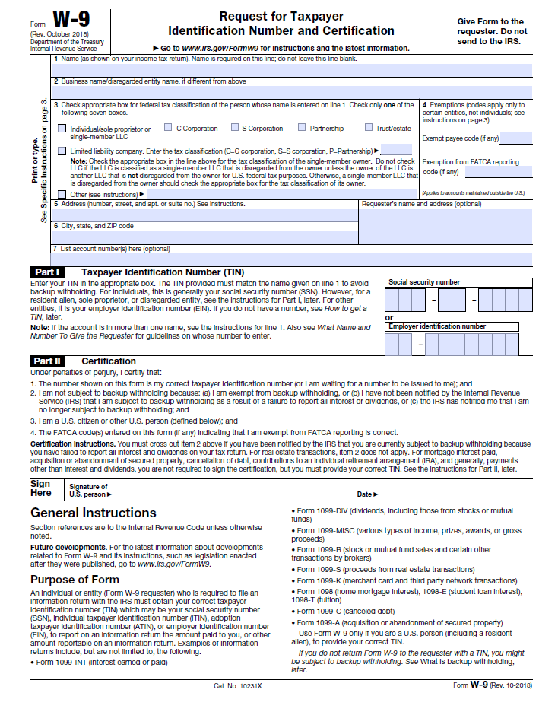
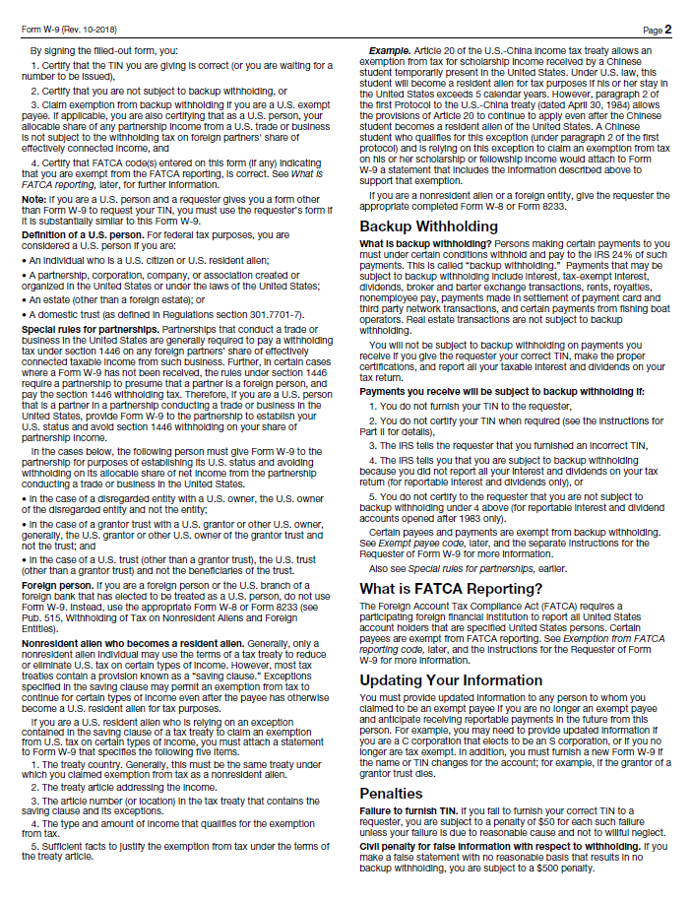
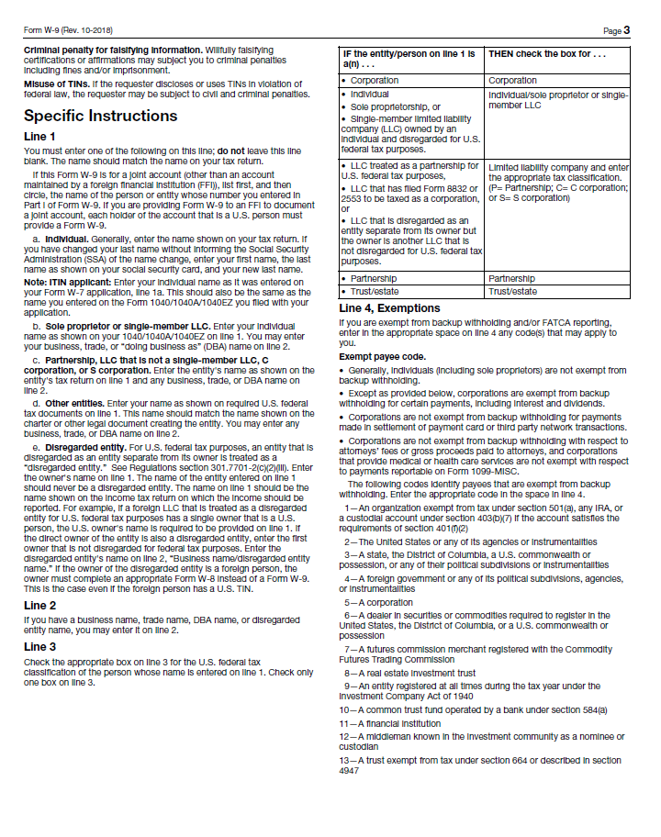
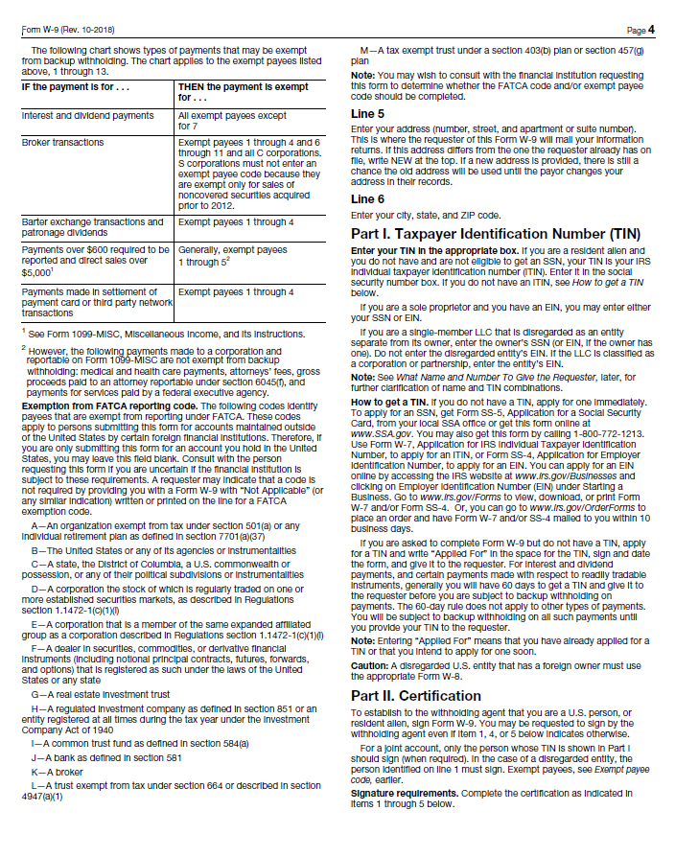
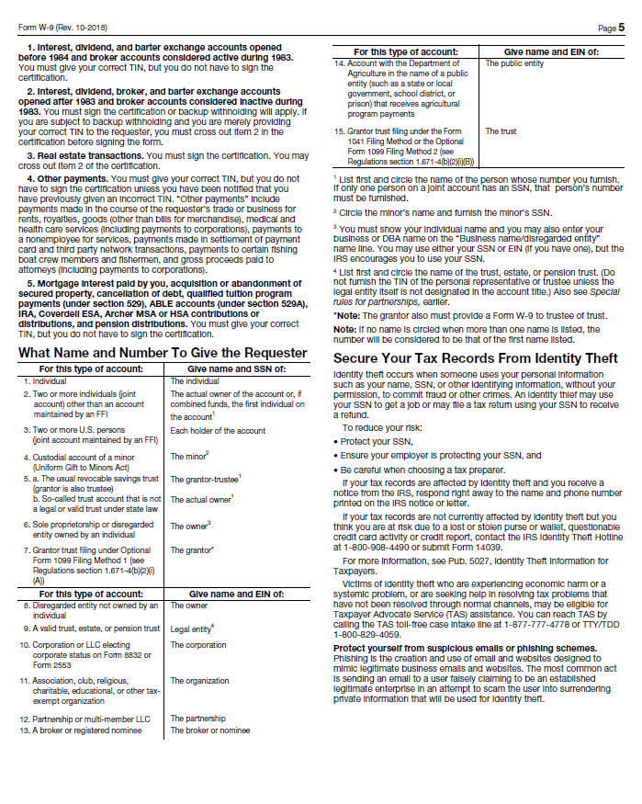

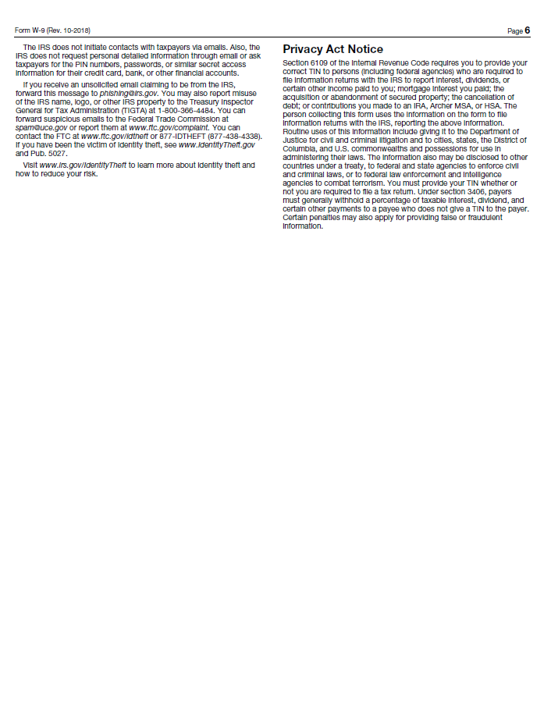
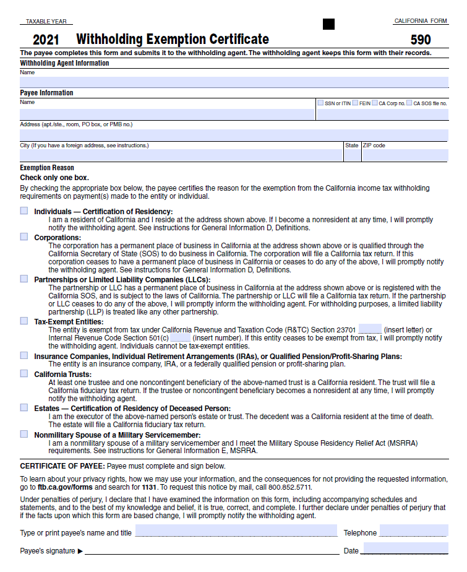

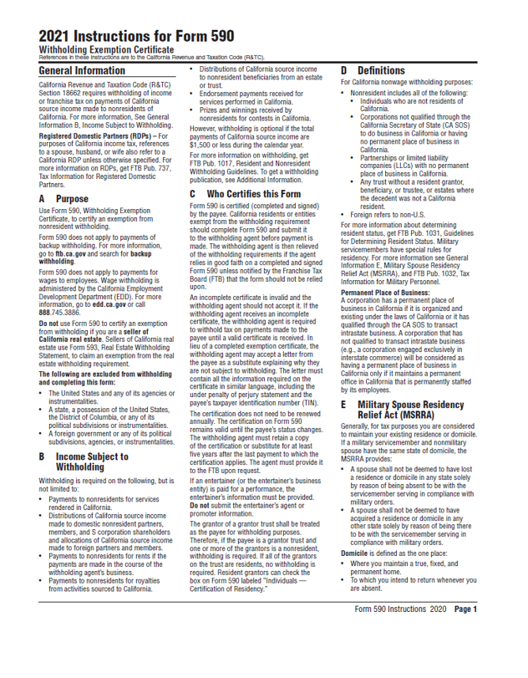

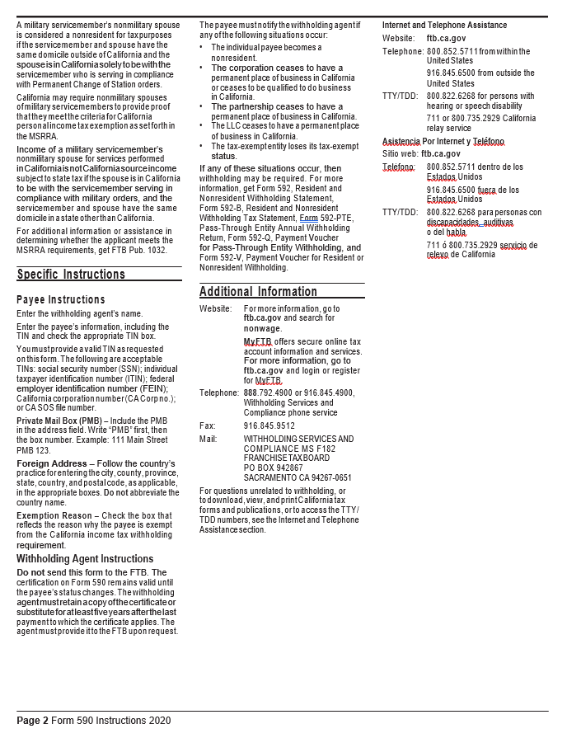

Certification Regarding
Debarment, Suspension, and Other Responsibility Matters

The prospective participant certifies to the best of its knowledge and belief that it and the principals:
- Are not presently debarred, suspended, proposed for debarment, declared ineligible, or voluntarily excluded from covered transactions by any Federal department or agency;
- Have not within a three year period preceding this proposal been convicted of or had a civil judgement rendered against them or commission of fraud or a criminal offense in connection with obtaining, attempting to obtain, or performing a public (Federal, State, or local) transaction or contract under a public transaction: violation of Federal or State antitrust statute or commission of embezzlement, theft, forgery, bribery, falsification or destruction of records, making false statements, or receiving stolen property:
- Are not presently indicted for or otherwise criminally or civilly charged by a government entity (Federal, State, or local) with commission of any of the offenses enumerated in paragraph (b) of this certification; and
- Have not within a three-year period preceding this application/proposal had one or more public transactions (Federal, State, or local) terminated for cause or default.

I understand that a false statement on this certification may be grounds for rejection of this proposal or termination of the award. In addition, under 18 USC Sec. 1001, a false statement may result in a fine of up to $10,000 or imprisonment for up to 5 years, or both.

________________________________________________________________________
Typed Name & Title of Authorized Representative

________________________________________________________________________
Signature of Authorized Representative Date

I am unable to certify to the above statements. My explanation is attached.

CAMPAIGN CONTRIBUTIONS DISCLOSURE

In accordance with California law, bidders and contracting parties are required to disclose, at the time the application is filed, information relating to any campaign contributions made to South Coast Air Quality Management District (South Coast AQMD) Board Members or members/alternates of the MSRC, including: the name of the party making the contribution (which includes any parent, subsidiary or otherwise related business entity, as defined below), the amount of the contribution, and the date the contribution was made. 2 C.C.R. §18438.8(b).

California law prohibits a party, or an agent, from making campaign contributions to South Coast AQMD Governing Board Members or members/alternates of the Mobile Source Air Pollution Reduction Review Committee (MSRC) of more than $250 while their contract or permit is pending before South Coast AQMD; and further prohibits a campaign contribution from being made for three (3) months following the date of the final decision by the Governing Board or the MSRC on a donor’s contract or permit. Gov’t Code §84308(d). For purposes of reaching the $250 limit, the campaign contributions of the bidder or contractor plus contributions by its parents, affiliates, and related companies of the contractor or bidder are added together. 2 C.C.R. §18438.5.

In addition, South Coast AQMD Board Members or members/alternates of the MSRC must abstain from voting on a contract or permit if they have received a campaign contribution from a party or participant to the proceeding, or agent, totaling more than $250 in the 12-month period prior to the consideration of the item by the Governing Board or the MSRC. Gov’t Code §84308(c).

The list of current South Coast AQMD Governing Board Members can be found at South Coast AQMD website (www.aqmd.gov). The list of current MSRC members/alternates can be found at the MSRC website (http://www.cleantransportationfunding.org).

SECTION I.
Contractor (Legal Name):

DBA, Name , County Filed in
Corporation, ID No.
LLC/LLP, ID No.

List any parent, subsidiaries, or otherwise affiliated business entities of Contractor:
(See definition below).

SECTION II.

Has Contractor and/or any parent, subsidiary, or affiliated company, or agent thereof, made a campaign contribution(s) totaling $250 or more in the aggregate to a current member of the South Coast Air Quality Management Governing Board or member/alternate of the MSRC in the 12 months preceding the date of execution of this disclosure?

Yes No If YES, complete Section II below and then sign and date the form.
If NO, sign and date below. Include this form with your submittal.
Campaign Contributions Disclosure, continued:

Name of Contributor

Governing Board Member or MSRC Member/Alternate Amount of Contribution Date of Contribution

Name of Contributor

Governing Board Member or MSRC Member/Alternate Amount of Contribution Date of Contribution

Name of Contributor

Governing Board Member or MSRC Member/Alternate Amount of Contribution Date of Contribution

Name of Contributor

Governing Board Member or MSRC Member/Alternate Amount of Contribution Date of Contribution

I declare the foregoing disclosures to be true and correct.

By:

Title:

Date:

DEFINITIONS

Parent, Subsidiary, or Otherwise Related Business Entity (2 Cal. Code of Regs., §18703.1(d).)

(1) Parent subsidiary. A parent subsidiary relationship exists when one corporation directly or indirectly owns shares possessing more than 50 percent of the voting power of another corporation.

(2) Otherwise related business entity. Business entities, including corporations, partnerships, joint ventures and any other organizations and enterprises operated for profit, which do not have a parent subsidiary relationship are otherwise related if any one of the following three tests is met:
(A) One business entity has a controlling ownership interest in the other business entity.
(B) There is shared management and control between the entities. In determining whether there is shared management and control, consideration should be given to the following factors:
- The same person or substantially the same person owns and manages the two entities;
- There are common or commingled funds or assets;
- The business entities share the use of the same offices or employees, or otherwise share activities, resources or personnel on a regular basis;
- There is otherwise a regular and close working relationship between the entities; or
(C) A controlling owner (50% or greater interest as a shareholder or as a general partner) in one entity also is a controlling owner in the other entity.

