

Implementation of New or Expanded

MICROTRANSIT SERVICE

Funding for the Implementation of Zero Emission Shared Mobility in the South Coast Air Quality Management District

Request for Proposals

P2023-07

January 6, 2023

**SECTION 1 - INTRODUCTION**

For over 30 years, the Mobile Source Air Pollution Reduction Review Committee (MSRC) has sought to deploy cutting-edge transportation demand management (TDM) and “smart mobility” programs that expand the boundaries of how we live, work, and play in the South Coast AQMD region – striving for faster, cheaper, and *greener* transportation solutions. As an investor in clean mobility, collaboration with expert project partners is essential to achieve the MSRC’s objective of improving air quality by reducing motor vehicle pollution in the South Coast AQMD region.

The MSRC has identified **Microtransit** as a mobility strategy that closely aligns with MSRC objectives. For the purpose of this Request for Proposals, microtransit is defined broadly as technology-enabled, shared transportation, that fills the void between traditional “fixed route” transit and “ride hailing” technology.

As discussed in subsequent sections of this RFP, the MSRC places a high level of emphasis on deploying microtransit in areas that will most directly benefit from this mobility solution. These include, but are not limited to:

* Areas where Microtransit can be directly integrated into other transit systems – enhancing transit in areas where deploying traditional fixed-route service would prove challenging;
* High-density urban or suburban communities where deployment of traditional fixed-route transit does not meet the mobility needs of the residents, including areas in proximity to activity centers that attract patrons from other areas;
* Disadvantaged Communities (DAC) or other regions that lack adequate transportation and mobility options;
* Areas that suffer disproportionately from air pollution.

Additionally, the MSRC seeks to invest in Microtransit service with the following features:

* The applicant proposes a **New** microtransit mobility solution within a specified geographic area, or the **Expansion** of an existing microtransit service(s) targeting new service area(s), new riders, and additional reductions in automobile vehicle miles traveled (VMT);
* The MSRC funding serves as **Seed Money** – an initial investment to launch or expand innovative microtransit mobility solutions;
* The applicant presents a strong **Business Case** for the new or expanded microtransit service, including a service continuation plan that thoroughly explains how the proposed microtransit service will be sustainable beyond the MSRC funding period.

The following Sections describe the eligibility requirements to participate in the MSRC Microtransit Services Program, and guidelines for proposal preparation. It is important to recognize that the MSRC must ensure that the use of Clean Transportation funds will result in direct, tangible, and quantifiable air quality benefits. To this end, this RFP stipulates specific performance thresholds and participation obligations that must be met in order to be deemed eligible for an MSRC funding award.

MSRC staff members are available to answer questions and provide technical and programmatic guidance as appropriate. Please refer to Section 6 of this document for a list of MSRC Staff contacts.

**SECTION 2 – RFP OVERVIEW & ELIGIBILITY REQUIREMENTS**

2.1 - Available Funding - The total amount of MSRC Clean Transportation Funding™ allocated for the Microtransit Services Program is **$2.5M**. This funding level is a targeted amount – should meritorious projects be received totaling greater than $2.5M, the MSRC reserves the right to increase the amount of total funding available.

Also, should the MSRC receive proposals with total requests less than the amount allocated, or if proposals are deemed non-meritorious, the MSRC reserves the right to reduce the total funding available and reallocate funds to other Work Program categories. The MSRC also reserves the right to not fund any of the proposals received, irrespective of the merits of the proposals submitted.

Please note that the source of MSRC Clean Transportation Funding™ for projects submitted in response to this RFP is motor vehicle registration fees collected by the California Department of Motor Vehicles (DMV) in accordance with the California Health and Safety Code. Thus, the availability of MSRC Clean Transportation Funding™ is contingent upon the timely receipt of funds from the DMV. Neither the MSRC nor South Coast AQMD can guarantee the collection or remittance of registration fees by the DMV.

2.2 - Geographical Funding Minimum - The MSRC has established a Geographical Funding Minimum for each county within the SCAQMD. The geographical funding minimum amount has been set at $312,500 per county. This funding set-aside guarantees a minimum level of funding for each county to implement microtransit service. Following the completion of proposal evaluation, scoring, and ranking, if any county has funds remaining in its geographical funding minimum, these funds will be made available to qualifying projects from any other county in rank order of project score.

2.3 – Eligibility Requirements - For the purpose of this RFP, the following eligibility requirements apply:

* Eligible Microtransit Service Providers – includes but is not necessarily limited to a) public transit agencies, including regional and municipal transit agencies and authorities; b) private transportation operators, including subcontractor service providers to public transit agencies; and c) paratransit providers and other licensed, private transportation and shuttle service providers;
* Qualifying Microtransit Vehicles – all microtransit vehicles must meet the following requirements:
  + All vehicles must be California Air Resources Board certified zero-emission vehicles (i.e., no tailpipe emissions);
  + There is flexibility as it pertains to vehicle range and size; however eligible vehicles must accommodate a minimum of four (4) seated passengers in addition to the driver. Eligible vehicles can include neighborhood electric vehicles, low-speed vehicles, vans, shuttles, etc.;
  + Vehicles must meet all Americans with Disabilities Act (ADA), US Department of Transportation (DOT), California Department of Motor Vehicles (DMV), and other applicable regulatory agency standards.
* Eligible Uses of MSRC Funds – MSRC funds may be used to offset Direct Operating Costs associated with new or expanded microtransit service, as follows:
  + Transportation Operations – Direct costs associated with operations of microtransit services;
  + Marketing, outreach, and promotion of the availability of the microtransit service;
  + Reasonable administrative costs. The determination of what constitutes “reasonable” costs is within the sole discretion of the MSRC.
* Ineligible Uses of MSRC Funds – MSRC funds cannot be used to pay for the following project elements. Costs associated with these project elements are required to be co-funded by the microtransit project applicant:
  + Capital costs associated with microtransit vehicle purchase or lease;
  + Acquisition of real property;
  + Costs associated with electric vehicle charging infrastructure (EVSE) purchase or installation;

**SECTION 3 – CONDITIONS & FUNDING CONSTRAINTS**

3.1 – Maximum MSRC-Funded Operations Period – the maximum length of time MSRC funding can be used to subsidize new or expanded microtransit service operations is **eighteen (18) months**.

3.2 – Microtransit Service Outreach, Marketing, and Promotion – all microtransit service projects that receive an MSRC Clean Transportation Funding™ award must include advertising and promotion of the availability of the service as a project element.

3.3 – Project Co-Funding Requirements – microtransit service projects funded by the MSRC are required to provide minimum project co-funding. Co-funding must be greater than or equal to **50% of the total project cost**, i.e., a maximum of 50% of total project costs to be co-funded by the MSRC.

Eligible project co-funding includes the following:

* Direct Cost Share – Cash, direct labor, and microtransit vehicle, facilities, and support equipment use contributions from the transportation provider can be accounted for as co-funding;
* Indirect Cost Share – Overhead costs and general and administrative expenses can be accounted for as co-funding;
* Fare Box Revenue – Fare box revenue collected to augment MSRC-funded transportation program can be documented and applied as co-funding;
* Microtransit Service Outreach, Marketing, and Promotion – Direct costs associated with advertising the availability of microtransit service projects may be applied as co-funding.

3.4 – MSRC Funds Remitted on a Reimbursement Basis - MSRC funds will be distributed on a reimbursement basis only upon completion of approved project milestones and submittal of all required reports and invoices.

3.5 – Additional Conditions on MSRC Funding – the following conditions apply to all MSRC-funded microtransit service projects:

* MSRC microtransit service projects are funded on a “area-specific” basis; that is, each project is evaluated with respect to the proposed service area’s location, activity centers, traffic congestion, availability of other transportation options, etc. Proposals that result in an award of MSRC funds are not allowed to change the microtransit service location under any circumstances. In the event the proposed service area becomes unavailable, nonviable, or no longer cost-effective, either contract negotiations will terminate, or the contract will terminate, as applicable.
* Certifications – All Proposers must complete and submit the included Attachment G forms as an element of their Proposal (unless specifically exempted below):
* Internal Revenue Service Form W-9 – Request for Taxpayer Identification Number and Certification, and Franchise Tax Board Form 590 – Withholding Exemption Certificate. If you are selected for an award, you cannot be established as a vendor without this information.
* Campaign Contributions Disclosure. This information must be provided at the time of application in accordance with California law. You may be asked for an update when awards are considered.
* Certification Regarding Debarment, Suspension and Other Responsibility Matters – The SCAQMD needs this information for their vendor database.
* Disadvantaged Business Certification. The SCAQMD needs this information for their vendor database. It will not be considered in the determination of your MSRC funding award. Governmental entities do not need to complete this form.
* Finally, in accordance with state law, all projects awarded MSRC Clean Transportation Funding™ are subject to audit. The provisions of audits are discussed in the Sample Contract, attached to this RFP.

**SECTION 4 – RFP TIMELINE**

The MSRC has established an approximately ten (10) week period for proposal preparation and submittal as shown below in Table 4-1:

Table 4-1 – Key RFP Dates

|  |  |
| --- | --- |
| Program Event | Date |
| RFP Release | January 6, 2023 |
| Online Bidders’ Conference | January 19, 2023 |
| Latest Date/Time for Electronic Proposal Submittal | March 24, 2023 @ 4:00 p.m. |

**IMPORTANT!** Proposals must be submitted to the MSRC website no later than 4:00 pm on March 24, 2023. Late proposals cannot be accepted for any reason. Please refer to Section 5, below, for instructions on how to submit a proposal.

4.1 – Online Bidders’ Conference – this Zoom Webinar will further explain the requirements of this RFP and provide an opportunity for participants to ask questions. Participation in the online bidders’ conference is voluntary. The webinar will take place on Thursday, January 19th at 10:00 am and can be accessed using the following link:

When: Thursday, January 19, 2023, 10:00 AM-11:30 AM (UTC-08:00) Pacific Time (US & Canada).  
Where:  [**https://scaqmd.zoom.us/j/99515157106**](https://scaqmd.zoom.us/j/99515157106)  
  
Join from a PC, Mac, iPad, iPhone or Android device:  
    Please click this URL to join. [**https://scaqmd.zoom.us/j/99515157106**](https://scaqmd.zoom.us/j/99515157106)   
  
Or join by phone:  
    Dial(for higher quality, dial a number based on your current location):  
        US: +1 669 900 6833  or +1 253 215 8782  or +1 346 248 7799  or +1 929 436 2866  or +1 301 715 8592  or +1 312 626 6799   
    Webinar ID: 995 1515 7106

In addition, proposers seeking clarification to this RFP can contact the MSRC staff at any time – see Section 6 for MSRC staff contact information.

**SECTION 5 - Proposal Preparation & submittal instructions**

Microtransit Service Proposals must be prepared and submitted in accordance with the instructions outlined below.

5.1 – Proposal Preparation – The following information must be included in all Proposals seeking MSRC Clean Transportation Funding™ under the Microtransit Service Program:

1. Attachments A-H – Proposals must include the following completed Attachments, including all required supporting documentation as requested. Proposal Templates and Instructions are included in Section 8 of this Program Announcement:

* Attachment A: Proposer and Project Participant Information
* Attachment B: Project Description
* Attachment C: Project Cost Breakdown
* Attachment D: Project Implementation Schedule
* Attachment E: Proof of Permit, Memorandum of Understanding, or Operating Authorization between service area authority and microtransit service provider (as applicable)
* Attachment F: Microtransit Service Ridership Estimates
* Attachment G: Microtransit Service Continuation Plan
* Attachment H: Certifications, including:
  1. Disadvantaged Business Certification Form
  2. IRS Form W-9
  3. California Form 590 Withholding Exemption Certificate
  4. Certification Regarding Debarment, Suspension, and Other Responsibility Matters
  5. Campaign Contribution Disclosure Form

5.2 – Electronic Application Submittal Process – the Microtransit Service Program requires that proposals be submitted electronically in PDF format using the MSRC Website. The proposal will be submitted as a PDF document comprised of eight (8) primary sections – these correspond to the application Attachments A-H noted above. These eight sections, including Attachment H certifications, are to be compiled into a single PDF document for submittal to the MSRC Clean Transportation Funding™ Website. **Please note that ONLY PDF format can be accepted**. Microsoft Word documents cannot be accepted by the MSRC Website.

**APPLICANTS WILL NEED TO REGISTER ON THE MSRC CLEAN TRANSPORTATION FUNDING WEBSITE**! A tutorial has been developed to guide proposers step by step through the electronic proposal submittal process. This tutorial is available on the MSRC Website at www.cleantransportationfunding.org. Look for the tutorial on the “Proposal Process – Proposal Upload Tutorial” page:

<http://www.cleantransportationfunding.org/sites/default/files/downloads/Guide%20to%20Using%20the%20Website.pdf>

5.3 – Addenda – The Mobile Source Air Pollution Reduction Review Committee may modify the Program Announcement and/or issue supplementary information or guidelines relating to the Program Announcement during the Proposal preparation and acceptance period of January 6, 2023, to March 24, 2023. Amendments will be posted on the MSRC website at [www.cleantransportationfunding.org](http://www.cleantransportationfunding.org).

5.4 – Proposal Modifications - Once submitted, Proposals cannot be altered without the prior written consent of the Mobile Source Air Pollution Reduction Review Committee.

5.5 – Certificates of Insurance - Upon notification of an MSRC funding award, a certificate(s) of insurance naming the South Coast Air Quality Management District (SCAQMD) as an additional insured will be required within forty-five (45) days. Entities that are self-insured will be required to provide proof of self-insurance prior to contract execution.

**SECTION 6 - IF YOU NEED HELP…**

This RFP can be obtained by accessing the MSRC website at [www.cleantransportationfunding.org](http://www.cleantransportationfunding.org). MSRC staff members are available to answer questions during the proposal acceptance period. In order to help expedite assistance, please direct your inquiries to the applicable staff person, as follows:

* For General or Technical Assistance, please contact:

Ray Gorski

MSRC Technical Advisor

Phone: 909-396-2479

E-mail: [Ray@CleanTransportationFunding.org](mailto:Ray@CleanTransportationFunding.org)

* For Contractual or Administrative Assistance, please contact:

Cynthia Ravenstein

MSRC Contracts Administrator

Phone: 909-396-3269

E-mail: [Cynthia@CleanTransportationFunding.org](mailto:Cynthia@CleanTransportationFunding.org)

**sECTION 7 - Proposal Evaluation & SCORING Process**

All proposals received prior to the RFP deadline will undergo evaluation, scoring, and ranking by a Subcommittee comprised of members of the MSRC Technical Advisory Committee (MSRC-TAC). Proposals will be evaluated and scored against four (4) evaluation criteria:

1. Overall Project Cost-Effectiveness (35 points maximum)
2. Project Sustainability and Continuation Plan (35 points maximum)
3. Connectivity and integration with other public transit (15 points maximum), and
4. The extent to which the proposed project serves Disadvantaged Communities (DAC), areas that lack adequate transportation and mobility options, or are disproportionally impacted by unhealthful air quality (15 points maximum).

The total maximum points available is 100.

1. MICROTRANSIT SERVICE COST-EFFECTIVENESS (0 – 35 Points). Proposals will be evaluated as to their ability to displace automobile trips and VMT and corresponding reductions in reactive organic gases, oxides of nitrogen (NOx), and particulate matter exhaust pollution. Cost-effectiveness will be computed as the ratio of the MSRC funding request amount to the quantified emission reductions, using the methodology included in the California Air Resources Board publication “*Methods to Find the Cost-Effectiveness of Funding Air Quality Projects For Evaluating Motor Vehicle Registration Fee Projects*”. The maximum score of 35 points will be assigned to the project deemed most cost-effective, with points assigned to all other proposals received on a prorated basis.
2. SERVICE CONTINUATION PLAN (0 – 35 Points). MSRC microtransit service funding is intended as “seed money” for new or expanded service and is not intended to serve as an ongoing funding source for microtransit operations. Proposers are required to discuss how the proposed microtransit service will continue beyond the MSRC funding period, including the sources of internal and external revenue that will be pursued to augment and ultimately replace MSRC funding. Projects that have a definitive plan for continuing the microtransit service well beyond the MSRC funding period will be awarded a higher point allocation.
3. CONNECTIVITY TO AND INTEGRATION WITH OTHER PUBLIC TRANSIT SERVICES (0 - 15 Points). The extent to which the proposed microtransit service is coordinated and integrated with other existing public transportation services, including connectivity with existing regional or municipal bus service, Metrolink, light rail, transit centers, etc. Proposers should clearly outline the proposed microtransit service connectivity with other existing public transit services in their proposal.
4. MOBILITY ENHANCEMENT IN DISADVANTAGED OR UNDERSERVED AREAS (0 – 15 Points). The extent to which the proposed microtransit service project serves disadvantaged Communities (DAC), areas that lack adequate transportation and mobility options, or are disproportionally impacted by unhealthful air quality.

Following scoring, proposals will be ranked based on the numerical score assigned as well as the Geographic Funding requirements discussed above in Section 2.2. The highest ranked proposals will be forwarded to the MSRC for funding consideration.

SECTION 8 - Proposal ATTACHMENTS

Attachment A: Proposal CONTACT Information

1. Please provide the following Proposer information in the space provided (This is information about the entity submitting the proposal):

|  |  |
| --- | --- |
| Business Name |  |
| Division of: |  |
| Subsidiary of: |  |
| Website Address |  |
| Type of Business  *Check One:* | * Individual * DBA, Name _______________, County Filed in _______________ * Corporation, ID No. ________________ * LLC/LLP, ID No. _______________ * Other _______________ |

**REMITTING ADDRESS INFORMATION**

|  |  |  |  |
| --- | --- | --- | --- |
| Address |  | | |
| City |  | | |
| State |  | Zip |  |
| Phone | (     )      -      Ext | Fax | (     )      - |
| Contact Name |  | Title |  |
| E-mail Address |  | | |
| Payment Name if Different |  | | |

1. Funding Request Summary:

MSRC **Clean Transportation Funding**™ Requested: $____________________

Other Co-Funding Applied to Project: $____________________

**Total Project Cost**: $____________________

1. Please provide the following information about the Microtransit Service Provider in the space provided (If this information was provided in Section 8.A, simply type “See Above”):

|  |  |
| --- | --- |
| Business Name |  |
| Division of: |  |
| Subsidiary of: |  |
| Website Address |  |
| Type of Business |  |

|  |  |  |  |
| --- | --- | --- | --- |
| Address |  | | |
| City/Town |  | | |
| State/Province |  | Zip |  |
| Phone | (     )      -      Ext | Fax | (     )      - |
| Contact Name |  | Title |  |
| E-mail Address |  | | |
| Payment Name if Different |  | | |

Attachment B: project Description

1. Proposed Microtransit Service Description – Provide a detailed description of the proposed microtransit service. This should include, at a minimum:
2. A description of the vehicles proposed to perform transportation services, including the make and model, seating positions, and total capacity (seated and standing, as applicable) for each vehicle proposed to be utilized in microtransit service.
3. The geographic area(s) where the microtransit service will be deployed, including a description of the trip attractors, activity centers, population density and demographics, etc. **Discuss whether the proposed microtransit service will provide mobility within a DAC, areas that lack adequate transportation and mobility options, or are disproportionally impacted by unhealthful air quality**.
4. A description of how the microtransit service will be conducted, including passenger pickup locations, passenger drop-off locations, anticipated headways, hours of operation, etc.
5. For circulator-type transportation services, please include a map of the vehicle route(s) that graphically illustrates vehicle routing, passenger pickup and drop-off locations, etc.
6. A description of the microtransit service mobile smartphone app, compatibility, where it can be downloaded, alternative ride hailing methods, etc.
7. A description of the microtransit cost model, proposed fares, farebox return estimates, etc.
8. Microtransit Continuation Plan – Please describe what efforts will be made by the microtransit service provider to identify and secure necessary resources to continue microtransit service beyond the MSRC funding period.
9. Connectivity and Integration with Other Public Transit Service - Please discuss potential connectivity with other public transit services, including but not limited to potential connectivity with existing regional or municipal bus lines, Metrolink, light rail, transit centers, park and ride lots, etc.
10. Advertising, Marketing, Outreach, and Promotion of the Microtransit Service – Please describe the plan for conducting outreach and promotion of the availability of microtransit service.

Attachment C: Cost Breakdown

Please provide a detailed cost breakdown of the proposed microtransit service project. Please note that MSRC Clean Transportation Funding™ is intended to help offset the cost of transportation program, and cannot be applied to capital equipment purchases. The MSRC reserves the right to exclude cost elements deemed unallowable, as well as award funding in an amount less than the requested amount.

Attachment D: PROJECT IMPLEMENTATION SCHEDULE

Please provide a Milestone Schedule for your proposed microtransit service project. This should include, at a minimum, the anticipated date service will commence, as well as any additional information regarding special events to be supported by microtransit services.

Attachment E: PROOF OF PERMIT, MOU, OR Authorization Between MICROTRANSIT service provider and SERVICE AREA (IF APPLICABLE)

If the microtransit service provider requires permits or other authorization to operate in the proposed geographic area, proof of permit or other authorizing documentation should be provided, if applicable.

Attachment F: microtransit service Ridership Estimates

Please provide an estimate of the anticipated utilization of the microtransit service as proposed. Please include any empirical information used to generate ridership estimates, including but not limited to survey results, focus group results, etc.

Please note that as a condition of funding award, the contractor will be required to survey, document, or otherwise quantify the patronage of the microtransit service in order for the MSRC to quantify motor vehicle emission reductions achieved by the microtransit service at the completion of the MSRC funding period.

**BUSINESS STATUS CERTIFICATIONS**

Federal guidance for utilization of disadvantaged business enterprises allows a vendor to be deemed a small business enterprise (SBE), minority business enterprise (MBE) or women business enterprise (WBE) if it meets the criteria below.

* is certified by the Small Business Administration or
* is certified by a state or federal agency or
* is an independent MBE(s) or WBE(s) business concern which is at least 51 percent owned and controlled by minority group member(s) who are citizens of the United States.

Statements of certification:

As a prime contractor to South Coast AQMD, (name of business) will engage in good faith efforts to achieve the fair share in accordance with 40 CFR Section 33.301, and will follow the six affirmative steps listed below **for contracts or purchase orders funded in whole or in part by federal grants and contracts.**

1. Place qualified SBEs, MBEs, and WBEs on solicitation lists.
2. Assure that SBEs, MBEs, and WBEs are solicited whenever possible.
3. When economically feasible, divide total requirements into small tasks or quantities to permit greater participation by SBEs, MBEs, and WBEs.
4. Establish delivery schedules, if possible, to encourage participation by SBEs, MBEs, and WBEs.
5. Use services of Small Business Administration, Minority Business Development Agency of the Department of Commerce, and/or any agency authorized as a clearinghouse for SBEs, MBEs, and WBEs.
6. If subcontracts are to be let, take the above affirmative steps.

###### Self-Certification Verification: Also for use in awarding additional points, as applicable, in accordance with South Coast AQMD Procurement Policy and Procedure:

Check all that apply:

Small Business Enterprise/Small Business Joint Venture  Women-owned Business Enterprise

*Local business*  *Disabled Veteran-owned Business Enterprise/DVBE Joint Venture*

Minority-owned Business Enterprise  Most Favored Customer Pricing Certification

*Percent of ownership: %*

Name of Qualifying Owner(s):

**State of California Public Works Contractor Registration No.** ______________________. **MUST BE INCLUDED IF BID** **PROPOSAL IS FOR PUBLIC WORKS PROJECT.**

I, the undersigned, hereby declare that to the best of my knowledge the above information is accurate. Upon penalty of perjury, I certify information submitted is factual.

## NAME TITLE

## TELEPHONE NUMBER DATE

**Definitions**

**Disabled Veteran-Owned Business Enterprise** means a business that meets all of the following criteria:

1. is a sole proprietorship or partnership of which is at least 51 percent owned by one or more disabled veterans, or in the case of any business whose stock is publicly held, at least 51 percent of the stock is owned by one or more disabled veterans; a subsidiary which is wholly owned by a parent corporation but only if at least 51 percent of the voting stock of the parent corporation is owned by one or more disabled veterans; or a joint venture in which at least 51 percent of the joint venture’s management and control and earnings are held by one or more disabled veterans.
2. the management and control of the daily business operations are by one or more disabled veterans. The disabled veterans who exercise management and control are not required to be the same disabled veterans as the owners of the business.
3. is a sole proprietorship, corporation, partnership, or joint venture with its primary headquarters office located in the United States and which is not a branch or subsidiary of a foreign corporation, firm, or other foreign-based business.

**Joint Venture** means that one party to the joint venture is a DVBE and owns at least 51 percent of the joint venture. In the case of a joint venture formed for a single project this means that DVBE will receive at least 51 percent of the project dollars.

**Local Business** means a business that meets all of the following criteria:

* has an ongoing business within the boundary of South Coast AQMD at the time of bid application.
* performs 90 percent of the work within South Coast AQMD’s jurisdiction.

**Minority-Owned Business Enterprise** means a business that meets all of the following criteria:

1. is at least 51 percent owned by one or more minority persons or in the case of any business whose stock is publicly held, at least 51 percent of the stock is owned by one or more minority persons.
2. is a business whose management and daily business operations are controlled or owned by one or more minority person.
3. is a business which is a sole proprietorship, corporation, partnership, joint venture, an association, or a cooperative with its primary headquarters office located in the United States, which is not a branch or subsidiary of a foreign corporation, foreign firm, or other foreign business.

“Minority” person means a Black American, Hispanic American, Native American (including American Indian, Eskimo, Aleut, and Native Hawaiian), Asian-Indian American (including a person whose origins are from India, Pakistan, or Bangladesh), Asian-Pacific American (including a person whose origins are from Japan, China, the Philippines, Vietnam, Korea, Samoa, Guam, the United States Trust Territories of the Pacific, Northern Marianas, Laos, Cambodia, or Taiwan).

**Small Business Enterprise** means a business that meets the following criteria:

1. 1) an independently owned and operated business; 2) not dominant in its field of operation; 3) together with affiliates is either:

* A service, construction, or non-manufacturer with 100 or fewer employees, and average annual gross receipts of ten million dollars ($10,000,000) or less over the previous three years, or
* A manufacturer with 100 or fewer employees.

1. Manufacturer means a business that is both of the following:
2. Primarily engaged in the chemical or mechanical transformation of raw materials or processed substances into new products.
3. Classified between Codes 311000 to 339000, inclusive, of the North American Industrial Classification System (NAICS) Manual published by the United States Office of Management and Budget, 2007 edition.

**Small Business Joint Venture** means that one party to the joint venture is a Small Business and owns at least 51 percent of the joint venture. In the case of a joint venture formed for a single project this means that the Small Business will receive at least 51 percent of the project dollars.

**Women-Owned Business Enterprise** means a business that meets all of the following criteria:

1. is at least 51 percent owned by one or more women or in the case of any business whose stock is publicly held, at least 51 percent of the stock is owned by one or more women.
2. is a business whose management and daily business operations are controlled or owned by one or more women.
3. is a business which is a sole proprietorship, corporation, partnership, or a joint venture, with its primary headquarters office located in the United States, which is not a branch or subsidiary of a foreign corporation, foreign firm, or other foreign business.

**Most Favored Customer** as used in this policy means that the South Coast AQMD will receive at least as favorable pricing, warranties, conditions, benefits and terms as other customers or clients making similar purchases or receiving similar services.

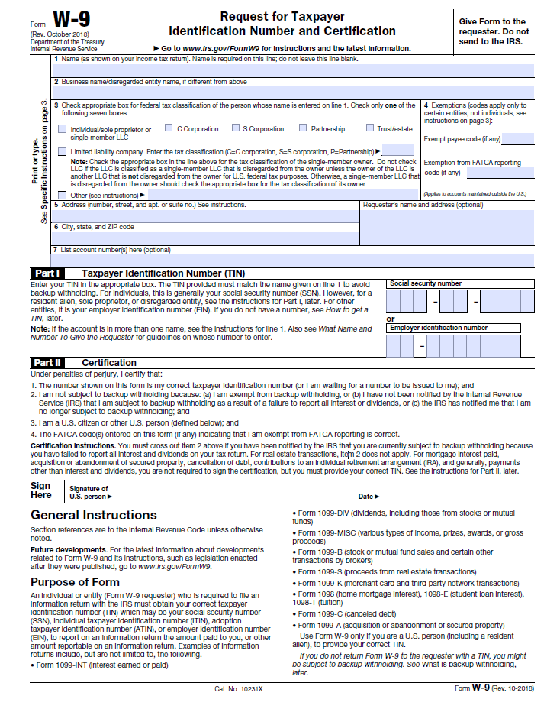

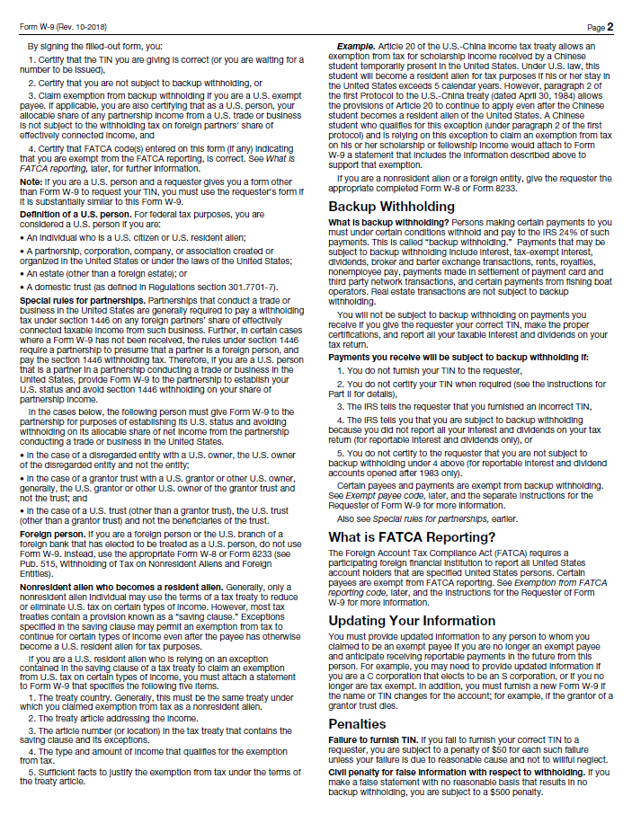

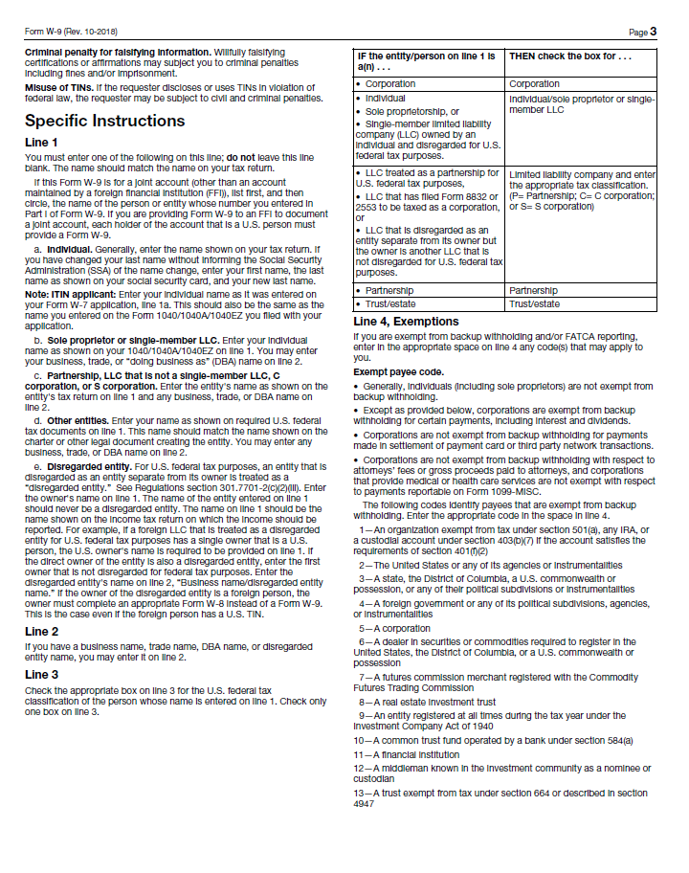

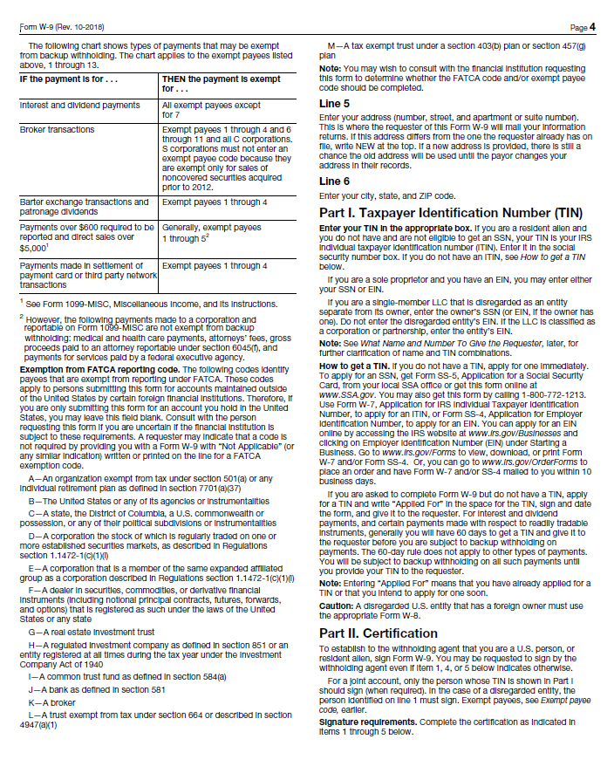

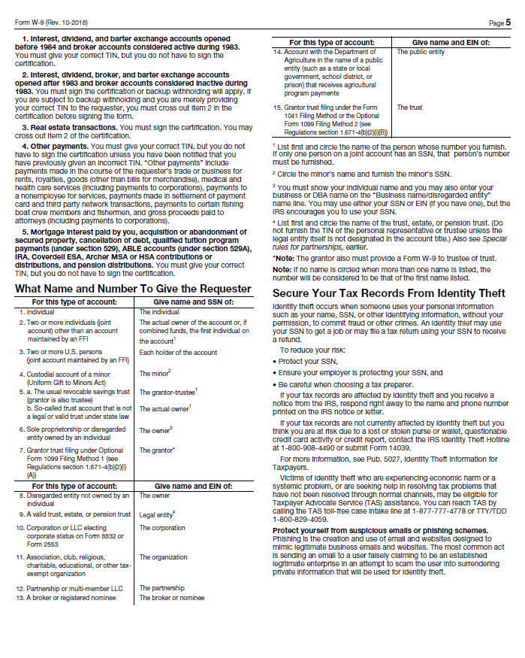

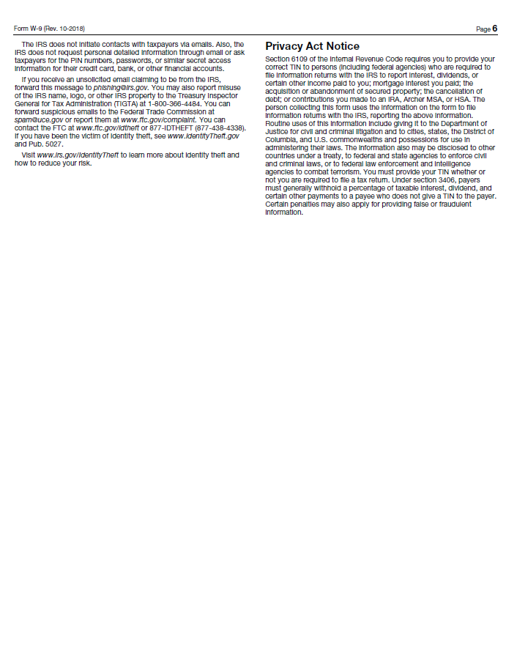

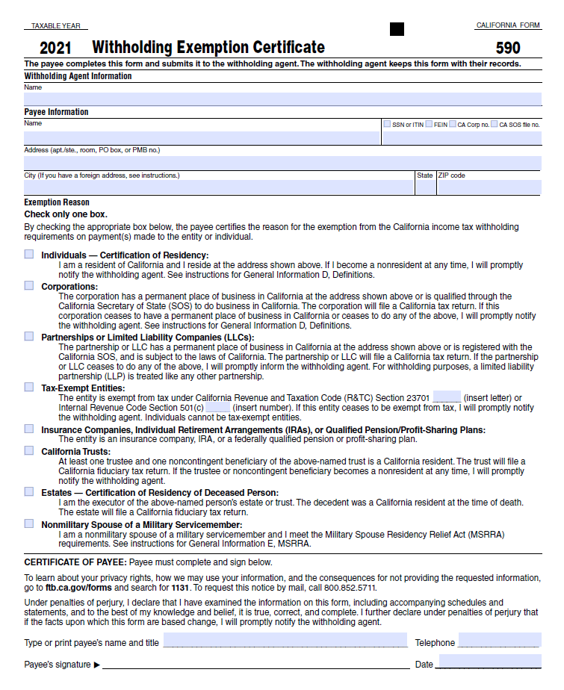

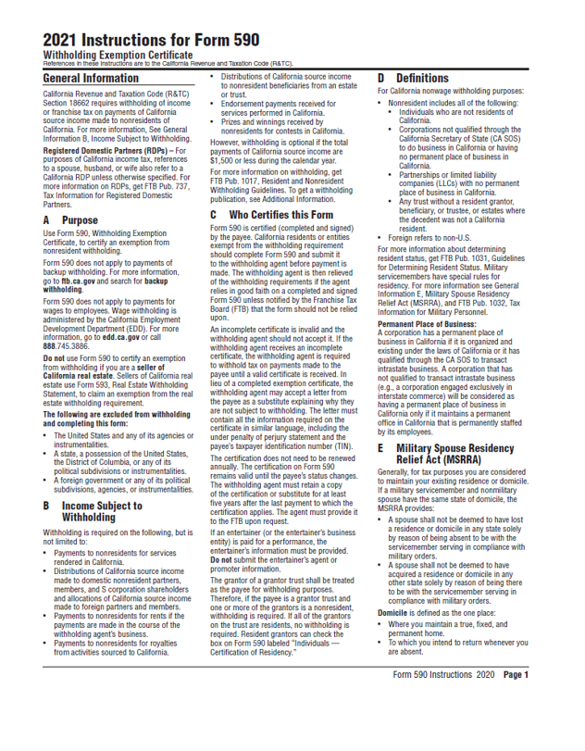

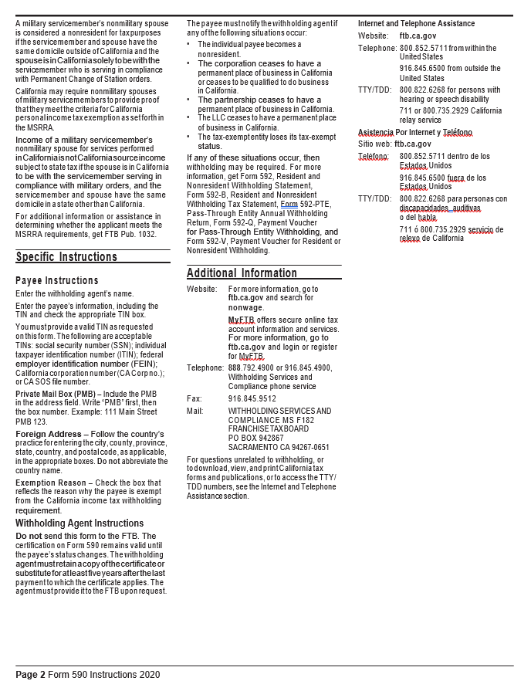**Certification Regarding**

**Debarment, Suspension, and Other Responsibility Matters**

The prospective participant certifies to the best of its knowledge and belief that it and the principals:

1. Are not presently debarred, suspended, proposed for debarment, declared ineligible, or voluntarily excluded from covered transactions by any Federal department or agency;
2. Have not within a three year period preceding this proposal been convicted of or had a civil judgement rendered against them or commission of fraud or a criminal offense in connection with obtaining, attempting to obtain, or performing a public (Federal, State, or local) transaction or contract under a public transaction: violation of Federal or State antitrust statute or commission of embezzlement, theft, forgery, bribery, falsification or destruction of records, making false statements, or receiving stolen property:
3. Are not presently indicted for or otherwise criminally or civilly charged by a government entity (Federal, State, or local) with commission of any of the offenses enumerated in paragraph (b) of this certification; and
4. Have not within a three-year period preceding this application/proposal had one or more public transactions (Federal, State, or local) terminated for cause or default.

I understand that a false statement on this certification may be grounds for rejection of this proposal or termination of the award. In addition, under 18 USC Sec. 1001, a false statement may result in a fine of up to $10,000 or imprisonment for up to 5 years, or both.

________________________________________________________________________

Typed Name & Title of Authorized Representative

________________________________________________________________________

Signature of Authorized Representative Date

❑ I am unable to certify to the above statements. My explanation is attached.

**CAMPAIGN CONTRIBUTIONS DISCLOSURE**

In accordance with California law, bidders and contracting parties are required to disclose, at the time the application is filed, information relating to any campaign contributions made to South Coast Air Quality Management District (SCAQMD) Board Members or members/alternates of the MSRC, including: the name of the party making the contribution (which includes any parent, subsidiary or otherwise related business entity, as defined below), the amount of the contribution, and the date the contribution was made. 2 C.C.R. §18438.8(b). Where a proposed rule or proposed amended rule impacts three or fewer facilities, those facilities will be treated in much the same manner as contracting parties and so must also complete this form, disclosing information relating to any campaign contributions made to any SCAQMD Board Members. *See* Quadri Advice Letter (2002) A-02.096.1 In the event that a qualifying campaign contribution is made, the Board Member to whom it was made may be disqualified from participating in the actions involving that donor.

California law prohibits a party, or an agent, from making campaign contributions to SCAQMD Governing Board Members or members/alternates of the Mobile Source Air Pollution Reduction Review Committee (MSRC) of more than $250 while their contract or permit is pending before the SCAQMD; and further prohibits a campaign contribution from being made for three (3) months following the date of the final decision by the Governing Board or the MSRC on a donor’s contract or permit. Gov’t Code §84308(d). For purposes of reaching the $250 limit, the campaign contributions of the bidder or contractor *plus* contributions by its parents, affiliates, and related companies of the contractor or bidder are added together. 2 C.C.R. §18438.5.

In addition, SCAQMD Board Members or members/alternates of the MSRC must abstain from voting on a contract or permit if they have received a campaign contribution from a party or participant to the proceeding, or agent, totaling more than $250 in the 12-month period prior to the consideration of the item by the Governing Board or the MSRC. Gov’t Code §84308(c).

The list of current SCAQMD Governing Board Members can be found at the SCAQMD website ([www.aqmd.gov](http://www.aqmd.gov/)). The list of current MSRC members/alternates can be found at the MSRC website ([http://www.cleantransportationfunding.org](http://www.cleantransportationfunding.org/)).

**SECTION I.**

**Contractor (Legal Name):**

-

DBA, Name , County Filed in

Corporation, ID No. LLC/LLP, ID No.

**List any parent, subsidiaries, or otherwise affiliated business entities of Contractor**:

***(See definition below).***

**SECTION II.**

Has Contractor and/or any parent, subsidiary, or affiliated company, or agent thereof, made a campaign contribution(s) totaling $250 or more in the aggregate to a current member of the

1 The information provided on this form does not, and is not intended to, constitute legal advice. To the extent that you may have questions regarding any case law, citations, or legal interpretations provided above please seek the guidance of your own independent counsel.

South Coast Air Quality Management Governing Board or member/alternate of the MSRC in the 12 months preceding the date of execution of this disclosure?

Yes  No **If YES, complete Section II below and then sign and date the form.  
If NO, sign and date below. Include this form with your submittal. Campaign Contributions Disclosure,** c*ontinued:*

Name of Contributor

Governing Board Member or MSRC Member/Alternate Amount of Contribution Date of Contribution

Name of Contributor

Governing Board Member or MSRC Member/Alternate Amount of Contribution Date of Contribution

Name of Contributor

Governing Board Member or MSRC Member/Alternate Amount of Contribution Date of Contribution

Name of Contributor

Governing Board Member or MSRC Member/Alternate Amount of Contribution Date of Contribution

**I declare the foregoing disclosures to be true and correct.**

By:

Title:

Date:



**DEFINITIONS**

Parent, Subsidiary, or Otherwise Related Business Entity (2 Cal. Code of Regs., §18703.1(d).)

1. Parent subsidiary. A parent subsidiary relationship exists when one corporation directly or indirectly owns shares possessing more than 50 percent of the voting power of another corporation.
2. Otherwise related business entity. Business entities, including corporations, partnerships, joint ventures and any other organizations and enterprises operated for profit, which do not have a parent subsidiary relationship are otherwise related if any one of the following three tests is met:
   1. One business entity has a controlling ownership interest in the other business entity.
   2. There is shared management and control between the entities. In determining whether there is shared management and control, consideration should be given to the following factors:
      1. The same person or substantially the same person owns and manages the two entities;
      2. There are common or commingled funds or assets;
      3. The business entities share the use of the same offices or employees, or otherwise share activities, resources or personnel on a regular basis;
      4. There is otherwise a regular and close working relationship between the entities; or
   3. A controlling owner (50% or greater interest as a shareholder or as a general partner) in one entity also is a controlling owner in the other entity.

**Sample Contract – actual terms subject to change**



**AB 2766/MSRC WOrk program GRANT AGREEMENT**

1. PARTIES

The parties to this Grant Agreement (“Agreement”) are the South Coast Air Quality Management District (referred to here as "SCAQMD") whose address is 21865 Copley Drive, Diamond Bar, California 91765-4178, and *** (referred to here as "RECIPIENT") whose address is ***.

1. RECITALS
2. SCAQMD is the local agency with primary responsibility for regulating stationary source air pollution within the geographical boundaries of the South Coast Air Quality Management District in the State of California (State).
3. Under State Health & Safety Code Sections 44225, *et seq.* (AB 2766), SCAQMD's Governing Board has authorized the imposition of the statutorily set motor vehicle fee for the purpose of reducing air pollution from motor vehicles and to implement the California Clean Air Act. By taking such action, the State's Department of Motor Vehicles (DMV) is required to collect such fee and remit it periodically to SCAQMD.
4. AB 2766 further mandates that thirty (30) percent of such vehicle registration fees be placed by SCAQMD into a separate account for the sole purpose of implementing and monitoring programs to reduce air pollution from motor vehicles.
5. AB 2766 creates a regional Mobile Source Air Pollution Reduction Review Committee (MSRC) to develop a work program to fund projects from the separate account. Pursuant to approval of the work program by SCAQMD's Governing Board, SCAQMD authorized this Agreement with RECIPIENT for equipment or services described in Attachment 1 - Statement of Work, expressly incorporated herein by this reference and made a part hereof of this Agreement.
6. RECIPIENT met the requirements for receipt of AB 2766 Discretionary Funds as set forth in RECIPIENT's *** Program Application/Proposal dated *** and was awarded a grant under the work program.
7. RECIPIENT is authorized to do business in the State of California and attests that it is in good tax standing with the California Franchise Tax Board.
8. All parties to this Agreement have had the opportunity to have this Agreement reviewed by their attorney.
9. DMV FEES

RECIPIENT acknowledges that SCAQMD cannot guarantee that the amount of fees to be collected under AB 2766 will be sufficient to fund this Agreement. RECIPIENT further acknowledges that payment under this Agreement is contingent upon SCAQMD receiving sufficient funds from the DMV, and that SCAQMD assumes no responsibility for the collection and remittance of motor vehicle registration fees.

1. AUDIT AND RECORDS RETENTION
   1. RECIPIENT shall, at least once every two years, or within two years of the termination of the Agreement if the term is less than two years, be subject to an audit by SCAQMD or its authorized representative to determine if the revenues received by RECIPIENT were spent for the reduction of pollution from motor vehicles pursuant to the Clean Air Act of 1988.
   2. RECIPIENT agrees to maintain records related to this Agreement during the Agreement term and continue to retain these records for a period of two years beyond the Agreement term, except that in no case shall RECIPIENT be required to retain more than the most recent five years’ records.  SCAQMD shall coordinate such audit through RECIPIENT'S audit staff.
   3. If an amount is found to be inappropriately expended, SCAQMD may withhold funding, or seek reimbursement, from RECIPIENT in the amount equal to the amount that was inappropriately expended.  Such withholding shall not be construed as SCAQMD's sole remedy and shall not relieve RECIPIENT of its obligation to perform under the terms of this Agreement.
2. TERM

The term of this Agreement is for *** (**) months from the date of execution by both parties, unless terminated earlier as provided for in the TERMINATION clause of this Agreement or the EARLY TERMINATION clause, [INCLUDE IF APPLICABLE] or the term is extended by amendment of this Agreement in writing. No work shall commence prior to the Agreement start date, except at RECIPIENT's cost and risk, and no charges are authorized until this Agreement is fully executed, subject to the provisions stated in the PRE-AGREEMENT COSTS clause of this Agreement.

1. SUCCESSORS-IN-INTEREST

This Agreement, and the obligations arising under the Agreement, shall be binding on and inure to the benefit of RECIPIENT and their executors, administrators, successors, and assigns.

1. REPORTING

RECIPIENT shall submit reports to SCAQMD as outlined in Attachment 1 - Statement of Work. SCAQMD reserves the right to review, comment, and request changes to any report produced as a result of this Agreement.

1. TERMINATION
   1. In the event any party fails to comply with any term or condition of this Agreement or fails to provide services in the manner agreed upon by the parties, including, but not limited to, the requirements of Attachment 1 - Statement of Work, this failure shall constitute a breach of this Agreement. The non-breaching party shall notify the breaching party that it must cure this breach or provide written notification of its intention to terminate this Agreement. Notification shall be provided in the manner set forth in the NOTICES clause of this Agreement. The non-breaching party reserves all rights under law and equity to enforce this Agreement and recover damages.
   2. SCAQMD reserves the right to terminate this Agreement, in whole or in part, without cause, upon thirty (30) days’ written notice. Once such notice has been given, RECIPIENT shall use all reasonable efforts to mitigate its expenses and obligations. RECIPIENT will be paid in accordance with this Agreement for tasks performed and costs incurred that could not be mitigated before the effective date of termination.
   3. RECIPIENT shall be paid in accordance with this Agreement for all Work performed before the effective date of termination under section B of the TERMINATION clause of this Agreement. Before expiration of the thirty (30) days’ written notice, RECIPIENT shall promptly deliver to SCAQMD all copies of documents and other information and data prepared or developed by RECIPIENT under this Agreement with the exception of a record copy of such materials, which may be retained by RECIPIENT.
2. EARLY TERMINATION

This Agreement may be terminated early due to the following circumstances: The infrastructure identified in Attachment 1, Statement of Work, becomes inoperable, and is either not technically able to be repaired, or is too costly to repair, and such failure is not caused by RECIPIENT’s negligence, misuse, or malfeasance. [INCLUDE IF APPLICABLE]

1. INSURANCE
2. RECIPIENT shall furnish evidence to SCAQMD of workers' compensation insurance for each of its employees, in accordance with either California or other states’ applicable statutory requirements prior to commencement of any work on this Agreement.
3. RECIPIENT shall furnish evidence to SCAQMD of general liability insurance with a limit of at least $1,000,000 per occurrence, and $2,000,000 in a general aggregate prior to commencement of any work on this Agreement. SCAQMD shall be named as an additional insured on any such liability policy, and thirty (30) days written notice prior to cancellation of any such insurance shall be given by RECIPIENT to SCAQMD.
4. RECIPIENT shall furnish evidence to SCAQMD of automobile liability insurance with limits of at least $100,000 per person and $300,000 per accident for bodily injuries, and $50,000 in property damage, or $1,000,000 combined single limit for bodily injury or property damage, prior to commencement of any work on this Agreement. SCAQMD shall be named as an additional insured on any such liability policy, and thirty (30) days written notice prior to cancellation of any such insurance shall be given by RECIPIENT to SCAQMD.
5. RECIPIENT shall furnish evidence to SCAQMD of Professional Liability Insurance with an aggregate limit of not less than $5,000,000. [INCLUDE IF APPLICABLE]
6. If RECIPIENT fails to maintain the required insurance coverage set forth above, SCAQMD reserves the right either to purchase such additional insurance and to deduct the cost thereof from any payments owed to RECIPIENT or terminate this Agreement for breach.
7. RECIPIENT must provide annual updates on the insurance coverage throughout the term of the Agreement to ensure that there is no break in coverage during the period of Agreement performance. Failure to provide evidence of current coverage shall be grounds for termination for breach of Agreement.
8. For MSRC Contracts Administrator: All insurance certificates shall be mailed to: SCAQMD, 21865 Copley Drive, Diamond Bar, CA 91765-4178, Attention: Cynthia Ravenstein, MSRC Contracts Administrator. **The SCAQMD Agreement Number must be included on the face of the certificate.**
9. For Risk Management Department: All insurance certificates and other documents evidencing coverage shall also be sent to SCAQMD Risk Management, by email ([insurancecertificate@aqmd.gov](mailto:insurancecertificate@aqmd.gov)). **The SCAQMD Agreement Number must be included on the face of the certificate.**

Self-Insurance Clause:

INSURANCE

RECIPIENT represents that it is permissibly self-insured and will maintain such self-insurance in accordance with applicable provisions of California law throughout the term of this Agreement.  RECIPIENT shall provide evidence of sufficient coverage during the term of this Agreement and any extensions thereof that meet or exceed the minimum requirements set forth by the SCAQMD below. All insurance certificates and other documents evidencing coverage must be sent to SCAQMD Risk Management, by email ([insurancecertificate@aqmd.gov](mailto:insurancecertificate@aqmd.gov)) or by fax (909-396-3979). The certificate of self-insurance shall also be mailed to: SCAQMD, 21865 Copley Drive, Diamond Bar, CA 91765-4178, Attention: Cynthia Ravenstein, MSRC Contracts Administrator. **The SCAQMD Agreement Number must be included on the face of the certificate.** If RECIPIENT fails to maintain the required insurance coverage, SCAQMD reserves the right to terminate the Agreement or purchase such additional insurance and bill RECIPIENT or deduct the cost thereof from any payments owed to RECIPIENT. Minimum insurance coverages are as follows:

1. Worker’s compensation insurance in accordance with either California or other state’s applicable statutory requirements.
2. General Liability insurance with a limit of at least $1,000,000 per occurrence, and $2,000,000 in general aggregate.
3. Automobile Liability insurance with limits of at least $100,000 per person and $300,000 per accident for bodily injuries and $50,000 in property damage, or $1,000,000 combined single limit for bodily injury or property damage.
4. INDEMNIFICATION

RECIPIENT agrees to hold harmless, defend and indemnify SCAQMD, its officers, employees, agents, representatives, and successors-in-interest against any and all loss, damage, costs, lawsuits, claims, demands, causes of action, judgments, attorney’s fees, or any other expenses arising from or related to any third party claim against SCAQMD, its officers, employees, agents, representatives, or successors in interest that arise or result in whole or in part, from any actual or alleged act or omission of RECIPIENT, its officers, its employees, contractors, agents or representatives in the performance of this Agreement.  This Indemnification Clause shall survive the expiration or termination (for any reason) of the Agreement and shall remain in full force and effect.

1. DISCLAIMER OF WARRANTY

The purchase or lease of funded vehicles/equipment is the RECIPIENT’s decision.  The SCAQMD does not make any express or implied warranty of merchantability, fitness for a particular purpose or otherwise, quality or usefulness of the technology or product.  Without limiting the foregoing, the SCAQMD will not be financially responsible, or otherwise liable, for the installation or performance of the vehicle/equipment. [INCLUDE IF APPLICABLE]

1. VIOLATION OF LABOR LAWS

RECIPIENT shall promptly notify SCAQMD in writing if RECIPIENT has been found by a court or federal or state agency to have violated labor laws. RECIPIENT shall complete a yearly certification in which RECIPIENT shall either state it has not been found by a court or federal or state agency to have violated labor laws or, if such violations have been found, RECIPIENT shall give SCAQMD details about those violations in the certification. If RECIPIENT has previously provided that information to the SCAQMD, it shall reattach that previous notification to the certification and provide any additional details about those violations that have not previously been provided. RECIPIENT’s yearly certification shall be due at the same time as the annual progress report(s) set forth in Attachment 1 - Statement of Work. SCAQMD reserves the right to terminate this Agreement upon such a finding, and RECIPIENT shall, at SCAQMD's request, return any and all Agreement funds, as determined by SCAQMD. RECIPIENT shall ensure that the provisions of this clause are included in all subcontracts. [INCLUDE IF APPLICABLE]

1. PAYMENT
2. SCAQMD shall reimburse RECIPIENT up to a total amount of *** Dollars ($***) in accordance with Attachment 2 - Payment/Cost Schedule expressly incorporated herein by this reference and made a part hereof of the Agreement.
3. A withhold amount or percentage (if any) shall be identified in the Payment/Cost Schedule, and such amount shall be withheld from each invoice. Upon satisfactory completion of project and final acceptance of work and the final report, RECIPIENT’s invoice for the withheld amount shall be released. Proof of project completion shall include a Final Report detailing the project goals and accomplishments, data collected during project performance, if any, documentation of significant results, and emissions reduction input data needed for calculation of emissions reductions.
4. Any funds not expended upon early Agreement termination or Agreement completion shall revert to the AB 2766 Discretionary Fund. Payment of charges shall be made by SCAQMD to RECIPIENT within thirty (30) days after approval by SCAQMD of an itemized invoice prepared and furnished by RECIPIENT.
5. An invoice submitted to SCAQMD for payment must be prepared in duplicate, on company letterhead, and list SCAQMD's Agreement number, period covered by invoice, and RECIPIENT's social security number or Employer Identification Number and submitted to:

South Coast Air Quality Management District

21865 Copley Drive

Diamond Bar, CA 91765-4178

Attn: Cynthia Ravenstein, MSRC Contracts Administrator

1. Charges for equipment, material, and supply costs, travel expenses, contractor, and other charges, as applicable, must be itemized by RECIPIENT. Reimbursement for equipment, material, supplies, contractor, and other charges, as applicable, shall be made at actual cost. Supporting documentation must be provided for all individual charges (with the exception of direct labor charges provided by RECIPIENT).

2. SCAQMD shall pay RECIPIENT for travel-related expenses only if such travel is expressly set forth in Attachment 2 - Payment/Cost Schedule of this Agreement or pre-authorized by SCAQMD in writing.

3. RECIPIENT’s failure to provide receipts shall be grounds for SCAQMD’s non-reimbursement of such charges. SCAQMD may reduce payments on invoices by those charges for which receipts were not provided.

4. RECIPIENT must submit final invoice no later than ninety (90) days after the termination date of this Agreement or invoice may not be paid.

1. COMPLIANCE WITH APPLICABLE LAWS, LICENSES, PERMITS

RECIPIENT agrees to comply with all federal, state, and local laws, ordinances, codes and regulations and orders of public authorities in the performance of this Agreement, including complying with all licensing and permitting requirements and obtaining all clearances from appropriate agencies applicable to the project.  RECIPIENT must also ensure that the vehicles and/or equipment to be purchased, leased or installed in the performance of this Agreement are in compliance with all applicable federal, state, and local air quality rules and regulations, and that it will maintain compliance for the full Agreement term.  RECIPIENT shall ensure that the provisions of this clause are included in all contracts and subcontracts.

1. MOBILE SOURCE EMISSION REDUCTION CREDITS (MSERCs)
2. The MSRC has adopted a policy that no MSERCs resulting from AB 2766 Discretionary Funds may be generated and/or sold.
3. RECIPIENT has the opportunity to generate MSERCs as a by-product of the project if a portion of the air quality benefits attributable to the project resulted from funding sources other than AB2766. These MSERCs, which are issued by SCAQMD, are based upon the quantified vehicle miles traveled (VMT) by project vehicles or other activity data as appropriate. Therefore, a portion of prospective MSERCs, generated as a result of AB 2766 Funds, must be retired. The portion of prospective credits funded by the AB 2766 program, and which are subject to retirement, shall be referred to as "AB 2766-MSERCs."
4. The determination of AB 2766-MSERC's is to be prorated based upon the AB 2766 program's contribution to the cost associated with the air quality benefits. In the case where AB 2766 Discretionary Funds are used to pay for the full differential cost of a new alternative fuel vehicle or for the retrofitting or repowering of an existing vehicle, all MSERCs attributable to AB 2766 Discretionary Funds must be retired. The determination of AB 2766-MSERCs for infrastructure and other ancillary items is to be prorated based upon the AB 2766 program’s contribution to the associated air quality benefits. Determination of the project's overall cost will be on a case-by-case basis at the time an MSERC application is submitted. SCAQMD staff, at the time an MSERC application is submitted, will calculate total MSERCs and retire the AB 2766-MSERCs. RECIPIENT would then receive the balance of the MSERCs not associated with AB 2766 funding.
5. NOTICES

All notices that are required under this Agreement shall be provided in the manner set forth herein, unless specified otherwise. Notice to a party shall be delivered to the attention of the person listed below, or to such other person or persons as may hereafter be designated by that party in writing. Notice shall be in writing sent by email, U.S. Mail, express, certified, return receipt requested, or a nationally recognized overnight courier service. In the case of email communications, valid notice shall be deemed to have been delivered upon sending, provided the sender obtained an electronic confirmation of delivery. Email communications shall be deemed to have been received on the date of such transmission, provided such date was a business day (Tuesday-Friday) and delivered prior to 5:30pm Pacific Standard Time. Otherwise, receipt of email communications shall be deemed to have occurred on the following business day. In the case of U.S. Mail notice, notice shall be deemed to be received when delivered or five (5) business days after deposit in the U.S. Mail. In the case of a nationally recognized overnight courier service, notice shall be deemed received when delivered (written receipt of delivery).

SCAQMD:

South Coast Air Quality Management District

21865 Copley Drive

Diamond Bar, CA 91765-4178

Attn: Cynthia Ravenstein, MSRC Contracts Administrator, email: [cravenstein@aqmd.gov](mailto:cravenstein@aqmd.gov)

RECIPIENT:

***

***

***

Attn: ***, email: ***

1. INDEPENDENT CONTRACTOR

RECIPIENT, its officers, employees, agents, or representatives shall act in an independent capacity, and shall in no sense be considered employees or agents of SCAQMD, nor shall RECIPIENT, its officers, employees, agents, or representatives be entitled to or eligible to participate in any benefits, privileges, or plans, given or extended by SCAQMD to its employees.  SCAQMD will not supervise, direct, or have control over, or be responsible for RECIPIENT’s means, methods, techniques, work sequences or procedures, or for the safety precautions and programs incident thereto, or for any failure by them to comply with any local, state, or federal laws, or rules or regulations, including state minimum wage laws and OSHA requirements.

1. OWNERSHIP

Title and full ownership rights to any equipment purchased under this Agreement shall at all times remain with RECIPIENT.

[Use above clause, or USE clause below for PROFESSIONAL SERVICES

OWNERSHIP

Title and full ownership rights to any products purchased or developed under this Agreement shall at all time remain with RECIPIENT. RECIPIENT shall also retain title and full ownership rights to any documents or reports developed under this Agreement. All of the above shall be subject to the following limitations:

1. PATENT RIGHTS - RECIPIENT shall have patent rights, as well as title and full ownership rights, for invention(s) developed under this Agreement, subject to SCAQMD retaining a no-cost, nonexclusive, nontransferable, irrevocable license to use or test such invention(s) for SCAQMD purposes. RECIPIENT must obtain agreements to effectuate this clause with all persons or entities obtaining an ownership interest in the patented subject invention(s). Previously documented (whether patented or unpatented under the patent laws of the United States, 35 U.S.C.Sections 1 *et seq*., or any foreign country) inventions are exempt from this provision. RECIPIENT shall submit a written report to SCAQMD's Agent disclosing each subject invention and specifying patents applied for, patents issued, and patent application(s) abandoned and/or cosponsored participants on subject invention(s).
2. RIGHTS OF TECHNICAL DATA - SCAQMD shall have unlimited right to use technical data resulting from performance of RECIPIENT under this Agreement. RECIPIENT shall have the right to use data for its own benefit.
3. COPYRIGHT - RECIPIENT agrees to grant SCAQMD a royalty free, nonexclusive, irrevocable, nontransferable license to produce, translate, publish, use, and dispose of all copyrightable material first produced or composed in the performance of this Agreement.
4. SOFTWARE RIGHTS - RECIPIENT agrees to grant SCAQMD a worldwide, royalty free, nonexclusive, irrevocable, nontransferable license in perpetuity to use any software developed by RECIPIENT in performing its obligations under this Agreement. RECIPIENT further agrees to obtain the rights required from any third party for SCAQMD to have a worldwide, royalty free, nonexclusive, irrevocable license in perpetuity to use any other software essential to performance of RECIPIENT'S obligations under this Agreement or necessary to the operation of the software developed by RECIPIENT. RECIPIENT shall provide SCAQMD with documentation confirming RECIPIENT'S right to assign the use of such software. RECIPIENT shall also provide SCAQMD with all documentation and manuals required to operate the software developed by it or third parties.
5. RECIPIENT'S INSOLVENCY OR BANKRUPTCY, or PROJECT'S DISCONTINUATION - RECIPIENT agrees that in the event that RECIPIENT becomes insolvent or files for bankruptcy during the term of the Agreement or does not complete the intent of the Agreement, title to goods, services software, and equipment purchased for the performance of this Agreement with AB 2766 Discretionary Funds shall revert to the SCAQMD.
6. SECURITY INTEREST

RECIPIENT hereby grants SCAQMD a security interest in any and all equipment purchased, in whole or in part, with funding provided by SCAQMD pursuant to this Agreement. RECIPIENT acknowledges and agrees that SCAQMD shall have all lien rights as a secured creditor on any and all equipment purchased in whole or in part by the RECIPIENT, under this Agreement or any amendments thereto. The SCAQMD shall have lien rights in effect until the RECIPIENT satisfies all terms under the Agreement, including but not limited to, the use and reporting requirements. **Accordingly, RECIPIENT further agrees that SCAQMD is authorized to file a UCC filing statement or similar security instrument to secure its interests in the equipment that is the subject of the Agreement.** In the event RECIPIENT files for bankruptcy protection, RECIPIENT shall notify SCAQMD within 14 calendar days of such filing. [INCLUDE IF APPLICABLE]

1. NON-DISCRIMINATION

In the performance of this Agreement, RECIPIENT shall not unlawfully discriminate, harass or allow harassment, against any employee or applicant for employment on the basis of race, religious creed, color, national origin, ancestry, sex, sexual orientation, marital status, age, mental status, medical condition, physical or mental disability, or allow unlawful denial of family and medical care leave, denial of pregnancy disability leave, or reasonable accommodations. RECIPIENT shall comply with the provisions of the California Fair Employment & Housing Act (Government Code Sections 12900 et seq.), the Federal Civil Rights Act of 1964 (P.L. 88-352) and all amendments thereto, Executive Order No. 11246 (30 Federal Register 12319), and all administrative rules and regulations issued pursuant to said Acts and Order.

1. ASSIGNMENT AND TRANSFER OF EQUIPMENT
   1. The rights and responsibilities granted hereby may not be assigned, sold, licensed, or otherwise transferred by RECIPIENT without the prior written consent of SCAQMD, and any attempt by RECIPIENT to do so shall be void upon inception.
   2. RECIPIENT agrees to obtain SCAQMD’s written consent to any assignment, sale, license or transfer of Equipment, if any, prior to completing the transaction. RECIPIENT shall inform the proposed assignee, buyer, licensee or transferee (collectively referred to here as “Buyer”) of the terms of this Agreement. RECIPIENT is responsible for establishing contact between SCAQMD and the Buyer and shall assist SCAQMD in facilitating the transfer of this Agreement’s terms and conditions to the Buyer. **RECIPIENT will not be relieved of the legal obligation to fulfill the terms and conditions of this Agreement until and unless the Buyer has assumed responsibility of this Agreement’s terms and conditions through an executed Agreement with SCAQMD.**
2. NON-EFFECT OF WAIVER

The failure of RECIPIENT or SCAQMD to insist upon the performance of any or all of the terms, covenants, or conditions of this Agreement, or failure to exercise any rights or remedies hereunder, shall not be construed as a waiver or relinquishment of the future performance of any such terms, covenants, or conditions, or of the future exercise of such rights or remedies, unless otherwise provided for herein.

1. PROPOSAL INCORPORATION

RECIPIENT’s Technical Proposal dated *** submitted in response to Request for Proposal (RFP) #***, is expressly incorporated herein by this reference and made a part hereof of this Agreement. In the event of any conflict between the terms and conditions of this Agreement and RECIPIENT’s Technical Proposal, this Agreement shall govern and control.  [INCLUDE IF APPLICABLE]

KEY PERSONNEL [INCLUDE IF APPLICABLE]

*insert person's name* is deemed critical to the successful performance of this Contract.  Any changes in key personnel by CONTRACTOR must be approved by SCAQMD.  All substitute personnel must possess qualifications/experience equal to the original named key personnel and must be approved by SCAQMD.  SCAQMD reserves the right to interview proposed substitute key personnel.

1. TAX IMPLICATIONS FROM RECEIPT OF MSRC FUNDS

RECIPIENT is advised to consult a tax attorney regarding potential tax implications from receipt of MSRC funds.

1. ATTORNEYS' FEES

In the event any action is filed in connection with the enforcement or interpretation of this Agreement, each party in said action shall pay its own attorneys' fees and costs.

1. FORCE MAJEURE

A party shall not be liable or deemed to be in default for any delay or failure in performance under this Agreement or interruption of services resulting, directly or indirectly, from acts of God, civil or military authority, acts of public enemy, war, strikes, labor disputes, shortages of suitable parts, materials, labor or transportation, or any similar cause beyond the party’s reasonable control.

1. SEVERABILITY

In the event that any one or more of the provisions contained in this Agreement shall for any reason be held to be unenforceable in any respect by a court of competent jurisdiction, such holding shall not affect any other provisions of this Agreement, and the Agreement shall then be construed as if such unenforceable provisions are not a part hereof.

1. HEADINGS

Headings on the clauses of this Agreement are for convenience and reference only, and the words contained therein shall in no way be held to explain, modify, amplify, or aid in the interpretation, construction, or meaning of the provisions of this Agreement.

1. SIGNATURES

This Agreement may be executed in any number of counterparts, each of which shall be deemed an original and all of which shall constitute together one and the same instrument.  Further, the parties agree that this Agreement or any counterpart may be executed and delivered by DocuSign, or by transmitting a manual signature by fax or .pdf, which shall have the same force and effect as copies executed and delivered with original manual signatures.

1. GOVERNING LAW

This Agreement shall be construed and interpreted, and the legal relations created thereby shall be determined in accordance with the laws of the State of California. Venue for resolution of any disputes under this Agreement shall be Los Angeles County, California.

1. PRE-AGREEMENT COSTS

Any costs incurred by RECIPIENT prior to RECIPIENT receipt of a fully executed Agreement shall be incurred solely at the risk of the RECIPIENT. In the event that this Agreement is not executed, neither the MSRC nor the SCAQMD shall be liable for any amounts expended in anticipation of a fully executed Agreement. If this Agreement is fully executed, pre-Agreement cost expenditures authorized by the Agreement will be reimbursed in accordance with the Payment/Cost Schedule and payment provision of the Agreement.

1. CHANGE TERMS

Changes to any part of this Agreement must be requested in writing by RECIPIENT and approved by MSRC in accordance with MSRC policies and procedures. RECIPIENT must make requests a minimum of 90 days prior to desired effective date of change. All modifications to this Agreement shall be in writing and signed by the authorized representatives of the parties

1. PUBLIC WORKS PROJECTS [INCLUDE IF APPLICABLE]

RECIPIENT agrees to comply with all of the applicable provisions of the California Labor Code pertaining to public works projects (Labor Code Sections 1720 – 1861). RECIPIENT shall be responsible for determining the applicability of the provisions of California Labor Code and complying with the same, including, without limitation, registering the public works project with the Department of Industrial Relations, obtaining from the Director of the Department of Industrial Relations the general prevailing rate of per diem wages and the general prevailing rate for holiday and overtime work, making the same available to any interested party upon request, paying the applicable prevailing rates, posting copies thereof at the job site and flowing all applicable requirements to its contractors. Proof of compliance must be provided to SCAQMD upon request. RECIPIENT shall indemnify, defend and hold harmless the SCAQMD against any and all claims, demands, damages, defense costs or liabilities based on failure to adhere to the above referenced statutes.

1. ENTIRE AGREEMENT

This Agreement represents the entire agreement between RECIPIENT and SCAQMD. There are no understandings, representations, or warranties of any kind except as expressly set forth herein. No waiver, alteration, or modification of any of the provisions herein shall be binding on any party unless in writing and signed by the authorized representative of the party against whom enforcement of such waiver, alteration, or modification is sought. No waiver by either party of any breach of, or of compliance with, any condition or provision of this Agreement by the other party shall be considered a waiver of any other condition or provision or of the same condition or provision at another time.

1. AUTHORITY

The signatory hereto represents and warrants that he or she is authorized and empowered and has the legal capacity to execute this Agreement and to legally bind RECIPIENT both in an operational and financial capacity and that the requirements and obligations under this Agreement are legally enforceable and binding on RECIPIENT.

(THE REMAINDER OF THIS PAGE IS INTENTIONALLY LEFT BLANK)

IN WITNESS WHEREOF, the parties to this Agreement have caused this Agreement to be duly executed on their behalf by their authorized representatives.

SOUTH COAST AIR QUALITY MANAGEMENT DISTRICT ***

By: __________________________________________ By: __________________________________________

Ben J. Benoit, Chair, Governing Board Name:

Title:

Date: _________________________________________ Date: _________________________________________

ATTEST:

Faye Thomas, Clerk of the Board

By: __________________________________________

APPROVED AS TO FORM:

Bayron T. Gilchrist, General Counsel

By: __________________________________________

*//MSRC Master Boilerplate*

*Revised December 1, 2021*