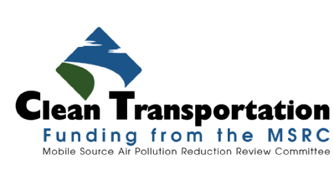

Natural Gas Infrastructure
Funding Opportunities

For New and Expanded Refueling Facilities in the South Coast Air Quality Management District

Program Announcement

PA2017-07

June 2, 2017

SECTION 1 - INTRODUCTION

The Mobile Source Air Pollution Reduction Review Committee (MSRC) is pleased to announce the availability of Clean Transportation Funding™ to assist in the construction of Natural Gas Refueling Infrastructure within the South Coast Air Quality Management District (SCAQMD).

This funding opportunity has at its core the following goals and objectives:
- Offer funding opportunities to most, if not all, entities interested in pursuing natural gas infrastructure projects, including public and private site owners, fleet owners, infrastructure providers, fuel providers, and school districts;
- Provide incentives for the construction or expansion of natural gas refueling stations;
- Provide an additional funding incentive for refueling stations that utilize natural gas produced from renewable sources;
- Offer incentives to fleets to upgrade their existing vehicle maintenance facilities to accommodate indoor maintenance of gaseous-fuel vehicles;
- Support the training of technicians in the maintenance of natural gas-fueled vehicles and infrastructure;
- Support fleets purchasing natural gas vehicles in compliance with the SCAQMD Fleet Rules, or pursuing vehicle incentives under the SCAQMD Carl Moyer Program.

To reduce the need to photocopy, package, and physically submit paper applications, the 2017 Edition of the Natural Gas Infrastructure Program requires that applications be submitted electronically in PDF format using the MSRC Website. We believe this benefits the applicant, the MSRC staff, and the environment.

The following Sections describe requirements for participation, guidelines for application preparation, as well as maximum incentive levels available as a function of the type of refueling infrastructure proposed and type of entity requesting funding assistance. The Natural Gas Infrastructure Program is not a competition in the traditional sense. Funding will be distributed on a first-come, first-served basis to applicants that satisfy specified project requirements. However, as funding is limited, the availability of funds cannot be guaranteed.

MSRC staff members are available to answer questions and provide technical and programmatic guidance as appropriate during the entire application preparation period. Please refer to Section 6 of this document for a list of MSRC Staff contacts.

SECTION 2 - PARTICIPATION GUIDELINES

The following guidelines, requirements, and conditions have been established and apply to all applicants:

  - Funding Availability - The amount of MSRC Clean Transportation Funding™ allocated for the Natural Gas Infrastructure Program is $4,000,000. Of this amount, a maximum of $150,000 may be awarded for technician training.
Please note that this funding level is a targeted amount – should meritorious projects be received totaling greater than the current funding allocation of $4,000,000, the MSRC reserves the right to increase the amount of total funding available. Also, should the MSRC receive applications with total requests less than the amount allocated, or if proposals are deemed non-meritorious, the MSRC reserves the right to reduce the total funding available and reallocate funds to other Work Program categories. The MSRC also reserves the right to not fund any of the applications received, irrespective of the merits of the applications submitted.
For the purpose of this Program, all qualified project applications received electronically on or before 11:59 p.m. on the first day of the Application Acceptance Period, June 2, 2017, will be deemed received at the same time. In the event the Program is oversubscribed following receipt of first-day applications, an across-the-board pro-rating factor will be determined so that all qualified project applications will receive the same percentage of the award to which they would otherwise have been entitled pursuant to the Program terms. Please note that the Geographic Funding Minimums discussed in paragraph 2, below, will take precedence in the event funding must be pro-rated. Qualifying applications received after 11:59 p.m. on June 2, 2017 will be funded in the order of receipt.
Please note that the source of MSRC Clean Transportation Funding™ for projects submitted in response to this solicitation is motor vehicle registration fees collected by the California Department of Motor Vehicles (DMV) in accordance with the California Health and Safety Code. Thus, the availability of MSRC Clean Transportation Funding™ is contingent upon the timely receipt of funds from the DMV. Neither the MSRC nor SCAQMD can guarantee the collection or remittance of registration fees by the DMV.
- Geographical Funding Minimum - The MSRC has established a Geographical Funding Minimum for each county within the SCAQMD. The geographical funding minimum amount has been set at $500,000 per county. This funding set-aside guarantees a minimum level of funding for each county to implement natural gas infrastructure projects. At the end of the application submittal period, June 29, 2018, if any county has funds remaining in its geographical minimum, these funds will be made available to qualifying projects from any other county in order of receipt.
- Eligible Applicants – Most entities interested in implementing natural gas refueling station projects within the SCAQMD jurisdiction are welcome to participate in the Program. Eligible applicants include, but are not necessarily restricted to:
- Infrastructure developers and alternative fuel providers;
- Fleet operators, both public and private, including fleets participating in the SCAQMD Carl Moyer Program;
- School districts seeking assistance for compressed natural gas refueling station development;
- Project teaming by multiple stakeholders, such as real property owners working in partnership with infrastructure providers or fleet operators, joint powers authorities, limited liability partnerships, etc., are eligible to participate. The MSRC does require, however, that a single prime contractor and contract signatory be designated at the time of application submission. Please note: except as discussed under Compression Services Tariff below, the MSRC also requires the applicant for a fueling station project to be the entity that will own the fueling equipment;
- Eligible Fuels – The following fuels are allowable under this Program:
- Compressed Natural Gas (CNG);
- Renewable Biogas (methane);
- Liquefied Natural Gas (LNG);
- Liquefied/Compressed Natural Gas (L/CNG);
- Maximum Total Funding Per Entity – To ensure broad-based participation, the MSRC has established the following maximum funding parameters:
- The maximum total funding award to any public or private entity under this solicitation shall not exceed 20% of the total Available Funding. This maximum funding restriction can be waived by the MSRC in the event the MSRC does not receive meritorious applications from other bidders that meet or exceed 80% of the total available funds, or if the MSRC allocates additional funds to the program. The MSRC reserves the right to determine which projects, if any, are deemed meritorious and warrant a Clean Transportation Funding™ award; and
- The total of the MSRC funding award cannot exceed 50% of the Total Project Cost.

- Signage Requirements – Publicly accessible refueling stations that receive an award must have motorist directional signage installed in proximity to the refueling station. This includes identification signs in immediate proximity to the refueling station and directional “trailblazer” signs on major streets and arterials in proximity to the refueling station. The installation of freeway signs is not required. The cost of sign procurement, permitting, and installation may be included as a station capital cost element.
- Federal Tax Credits – Entities that sell, compress and/or dispense alternative fuels may be eligible for a Federal Tax Credit. To promote the use of alternative fuel, the MSRC believes it is appropriate that any Federal Tax credit ultimately reduce the price of fuel dispensed. Therefore, commercial entities seeking MSRC funding, whose primary business is the construction of refueling stations and/or sale of fuel, must disclose how potential Federal Tax Credits are accounted for when developing station cost construction cost estimates and fuel pricing. Please refer to Attachment G.
- Funding Restrictions – MSRC funds cannot be used to fund the following project elements:
- Natural gas refueling station maintenance or operations costs, including utility costs, or fuel purchase costs;
- Purchase or lease of real property.

- Conflict of Interest - Address possible conflicts of interest with other clients affected by actions performed by the firm on behalf of the MSRC. Although the applicant will not be automatically disqualified by reason of work performed for such firms, the MSRC reserves the right to consider the nature and extent of such work in evaluating the application.

- Certifications – All applicants must complete and submit the following Attachment H forms as an element of their Application (unless specifically exempted below):
- Internal Revenue Service Form W-9 – Request for Taxpayer Identification Number and Certification, and Franchise Tax Board Form 590 – Withholding Exemption Certificate. If you are selected for an award, you cannot be established as a vendor without this information.
- Campaign Contributions Disclosure. This information must be provided at the time of application in accordance with California law. You may be asked for an update when awards are considered.
- MSRC Prospective Contractor Information. This information helps us to determine if any financial interests exist under the Government Code or any other State of California conflict-of-interest regulations.
- Disadvantaged Business Certification. The SCAQMD needs this information for their vendor database. IT WILL NOT BE CONSIDERED IN THE DETERMINATION OF YOUR MSRC AWARD. Governmental entities do not need to complete this form.
- Earliest Date for an MSRC-Funded Project to Commence – The release date of this Program Announcement, June 2, 2017, is the earliest date work on a project can commence and be potentially eligible for MSRC Natural Gas Infrastructure Funding. Any expenditures made in anticipation of an award and prior to execution of a contract are solely at the proposer’s risk. If no contract is executed, neither the MSRC nor South Coast AQMD are liable for payment of any funds expended in anticipation of a contract. Please note that in the event a contract is executed, reimbursement for any costs incurred by the proposer in anticipation of the contract is at the discretion of the MSRC and SCAQMD.
- Project Implementation Schedules - Applicants are expected to provide a realistic project implementation schedule as an element of their application. In order to ensure that MSRC funds are awarded to projects which are ready to proceed, the following requirements apply:
- All stations are expected to be operational within 24 months of contract execution. If a prospective applicant does not expect completion within this time frame, they should consider awaiting future funding opportunities.
- In the event an application is awarded MSRC funds, the project implementation schedule will become an element of the contract.
- Once a proposed contract is sent to the applicant for execution, the applicant must negotiate any requested changes and sign and return the contract within six months, or contract negotiations will terminate and the award will be returned to the Discretionary Fund.
- In the event a contractor is unable to meet project milestones and requires additional time, the MSRC reserves the right to administratively authorize a one-time extension to the period of performance, not to exceed an additional one (1) year. Beyond one year, additional extensions to the contract period of performance may only be granted if, at the discretion of the MSRC, there is adequate justification and the project would provide sufficiently large benefit to offset the delay.
- Additional Conditions on MSRC Funding
- MSRC funds will be distributed on a reimbursement basis only upon completion of approved project tasks and submission of all required reports and invoices.
- Recipients of MSRC Clean Transportation Funding™ must guarantee that projects implemented under this Program will remain operational and in the approved location for a period of no less than five (5) years from the date the project is fully implemented. For the purpose of refueling station construction, “fully implemented” is defined as the date the refueling station initiates fueling operations;
- Infrastructure projects funded under this Program Announcement are not eligible to receive additional funds under any other current MSRC Work Program solicitation;
- Infrastructure projects that received MSRC Clean Transportation Funding™ under a previous award are not eligible to seek additional funding for the same project;
- MSRC funds are not intended to fund staff salaries or administrative costs. Reasonable project management costs necessary to implement infrastructure projects are allowable; however, the MSRC reserves the right to reduce or delete program management costs that appear excessive;
- All projects must include a media and community outreach component. Acceptable outreach strategies may include, but are not limited to, a Grand Opening/project kickoff event, press releases, or press conference to highlight the project’s accomplishments;
- Finally, in accordance with state law, all projects awarded MSRC Clean Transportation Funding™ are subject to audit. It is highly recommended that bidders employ government acceptable standard accounting practices when administering their MSRC co-funded project.

SECTION 3 – PROJECT ELIGIBILITY AND INCENTIVE LEVELS
Project Eligibility - The MSRC Natural Gas Infrastructure Program offers incentives for a range of infrastructure types, including fast-fill stations, slow or time-fill stations, and limited-fill refueling apparatus. The expansion of existing operational stations to accommodate growing throughput needs is also eligible, except that commercial entities whose business is the construction, operation, maintenance, or sale of fuel are not eligible to seek funding for the expansion of their own stations, as these entities have an economic interest in keeping their own stations in an operable condition with sufficient throughput capacity.
Maintenance Facility Modifications - In addition to refueling stations, MSRC Clean Transportation Funding™ is available for the modification of existing facilities used for vehicle maintenance and repair. Allowable facility modifications include, but are not necessarily limited to, the following:
- Installation of building methane detection sensors;
- Electrical shielding;
- Heater element explosion proofing;
- Gas evacuation and ventilation upgrades.

MSRC Clean Transportation Funding™ levels for maintenance facility modifications are capped at a maximum of 50% of the project costs, not to exceed a maximum of $75,000 per facility.
Technician Training – Funding is also available to train technician(s) in the maintenance of natural gas-fueled vehicles and infrastructure. Training must be provided by an accredited educational institution. Funding is capped at a maximum of 50% of costs, not to exceed a maximum of $15,000 per entity and a maximum of $150,000 overall.
Projects must use new refueling station components - The relocation of existing natural gas refueling stations, or the reuse of components or equipment from existing stations, is prohibited. Furthermore, exclusively private-access stations are not eligible for funding under this Program Announcement—see Limited Access definition, below. Applications must identify at least one anchor fleet to use the station, and indicate the base number of vehicles committed to fuel at the station and/or the base throughput from that fleet. Applications for station upgrades must provide documentation that the proposed project will result in increased station utilization and increased fuel throughput.
Maximum Incentive Levels – The maximum “per facility” incentive awards under the MSRC’s Natural Gas Infrastructure Program are shown in Table 3-1. In no case shall the MSRC funding award exceed 50% of the combined cost of the facility capital equipment, site construction, signage, and reasonable project management costs or 50% of training costs, as applicable. The incentive levels also vary as a function of the type of refueling infrastructure proposed and type of entity requesting funding assistance. The following funding maximums apply for new and expansion refueling station projects, fleet vehicle maintenance facility modification projects, and technician training:
Table 3-1: Maximum “Per Facility” MSRC Funding Levels
Entity | Fuels | Limited Access | Full Access | Maintenance Facility Modifications | Technician Training | Renewable Natural Gas
Private | Single Fuel | $100,000 | $150,000 | $75,000 | $15,000 | $100,000
 | L/CNG | $150,000 | $200,000 | $75,000 | $15,000
Public | Single Fuel | $175,000 | $225,000 | $75,000 | $15,000 | $100,000
 | L/CNG | $225,000 | $275,000 | $75,000 | $15,000

For purposes of this Program Announcement, the following definitions apply:
- Private Entity – An applicant which is not a Public Entity as defined below.
- Public Entity – A government agency of any level, including but not limited to: municipal, county, State, Federal, special districts, and school districts.
- Full Access – A “Full Access” station is:
- Open 24 hours per day, 7 days per week to any user;
- Equipped with a universal card reader system which accepts Visa, MasterCard, and/or American Express, at a minimum; and
- Has capacity to dispense at least 3 gasoline gallon equivalents (GGE) per minute.
- Limited Access – A Limited Access station does not meet one or more of the Full Public Access criteria above. However, the station owner must attest to their willingness to make arrangements for at least one other fleet to use the station, if approached by an interested fleet. The “other fleet” must be a separate legal entity from the station owner. The owner of a Limited Access station may place reasonable restrictions on the “other fleet’s” hours of access, etc.
- L/CNG – Station offers both CNG and LNG fuels.
- Technician – An individual specializing in the maintenance of vehicles and/or fueling equipment, employed or otherwise sponsored by an entity which owns or maintains, or will soon own/maintain, natural-gas fueled vehicles or infrastructure.
Renewable Natural Gas – Stations that utilize natural gas produced from renewable sources (biogas) are eligible to receive an additional $100,000 incentive. To qualify for this additional incentive, the facility must use greater than 50% renewable natural gas for five years following commencement of operations, either by producing it on site or through the purchase of credits for biogas produced elsewhere. Applications for expansion of an existing station, which already uses greater than 50% renewable natural gas, are not eligible for the additional incentive. Documentation of an ongoing biogas source will be a component of required annual reporting.
Compression Services Tariff - The Southern California Gas Company Compression Services Tariff (CST) is an optional utility service offered to non-residential SoCalGas customers that allows SoCalGas to procure, construct, own, operate and maintain compression equipment on customer premises. SoCalGas customers taking service under CST can be eligible to receive a funding incentive on the compression equipment, in an amount not to exceed 25% of the CST pricing and not to exceed five years’ duration. CNG fueling dispensers (not integrated with a gas compressor/skid package), card readers, and other retailing/dispensing equipment which will be owned by applicant can still receive an incentive up to 50% of the combined cost of the capital equipment, site construction, signage, and reasonable project management costs.

Project applications that do not reasonably fit within the Eligible Project Categories outlined above will not be approved and will not be eligible to receive MSRC Clean Transportation Funding™. The MSRC retains sole discretion when determining project eligibility.

SECTION 4 - SCHEDULE OF EVENTS
The Natural Gas Infrastructure Program will be conducted in accordance with the timeline shown in Table 4-1, below. Project applications may be submitted at any time during the period commencing May 5, 2017 and ending June 29, 2018. Please note that applications must be received no later than 11:59 p.m. on June 29, 2018. All applications must be submitted electronically through the MSRC Clean Transportation Funding Website. Late applications will not be evaluated and will not be eligible for MSRC funding.

Table 4-1 - Key Natural Gas Infrastructure Program Dates
Program Event | Date
Program Announcement Release | June 2, 2017
Application Submittal Period | June 2, 2017 – June 29, 2018
Latest Date/Time for Application Submittal | June 29, 2018 @ 11:59 p.m.
Application Evaluation & Award Consideration | First-come, first-served (geographic funding minimums apply)

SECTION 5 - Application Preparation & Electronic submittal instructions

A Project Application must be completed and electronically submitted under this Program. As stated in the Introduction, only applications deemed complete will be evaluated and considered for a funding award. Applications must be prepared and submitted in accordance with the instructions outlined below.

- Application Preparation – The following information must be included in all Applications seeking MSRC Clean Transportation Funding™ under the Natural Gas Infrastructure Program:

- Cover letter - Transmittal of the Application must be accompanied by a cover letter. The letter should also provide the name, telephone and fax numbers, and e-mail address of the contact person(s) for technical and contractual matters, and be signed by the person(s) authorized to contractually bind the applying entity.

For joint Applications, the Proposer must include a statement confirming authorization to act on behalf of the other co-Proposers. The Proposer must include a letter of support, including contact name and telephone/fax number, from all proposing entities of a joint Application.

- Attachments A-H - Applications must include the following completed Attachments, including all required supporting documentation as requested. Application Templates and Instructions are included in Section 8 of this Request for Proposals; see page 13:
- Attachment A: Proposer Information
- Attachment B: Project Description & Technical Specifications
- Attachment C: Project Cost Breakdown
- Attachment D: Project Implementation Schedule
- Attachment E: Memorandum of Understanding/Memorandum of Agreement
- Attachment F: Utilization Estimates/Letters of Commitment
- Attachment G: Federal Tax Credit Accounting
- Attachment H: Certifications (W-9, 590, DBE, Campaign Contribution Disclosure, MSRC Prospective Contractor)
- Electronic application submittal process

In an effort to reduce the need to photocopy, package, and physically submit paper applications, the 2017 Natural Gas Infrastructure Program requires that applications be submitted electronically in PDF format using the MSRC Website. We believe this benefits the applicant, the MSRC staff, and the environment.

The application that will be submitted as a PDF document is comprised of Nine (9) primary sections – these correspond to the Cover Letter and application Attachments A-H as described in the preceding section.

Thus, a complete application will be comprised of the following nine elements:
- Signed Cover Letter;
- Attachment A: Proposer Information
- Attachment B: Project Description & Technical Specifications
- Attachment C: Project Cost Breakdown
- Attachment D: Project Implementation Schedule
- Attachment E: Memorandum of Understanding/Memorandum of Agreement
- Attachment F: Utilization Estimates/Letters of Commitment
- Attachment G: Federal Tax Credit Accounting
- Attachment H: Certifications
  - W-9 Form
  - Form 590
  - Disadvantaged Business Certification Form
  - Campaign Contribution Disclosure Form
  - MSRC Prospective Contractor
These nine sections, including Attachment H certifications, are to be compiled into a single PDF document for submittal to the MSRC Clean Transportation Funding Website. Please note that ONLY PDF format can be accepted. Microsoft Word documents cannot be accepted by the MSRC Website. Applicants will need to register on the MSRC Clean Transportation Funding website.

Please note that the latest date and time to submit an application is June 29, 2018 at 11:59 pm!
- Addenda – The Mobile Source Air Pollution Reduction Review Committee may modify the Program Announcement and/or issue supplementary information or guidelines relating to the Program Announcement during the Application preparation and acceptance period of June 2, 2017 to June 29, 2018. Amendments will be posted on the MSRC website at www.CleanTransportationFunding.org.
- Application Modifications - Once submitted, Applications cannot be altered without the prior written consent of the Mobile Source Air Pollution Reduction Review Committee.

- Certificates of Insurance - Proposers are required to provide a statement that upon notification of award, a certificate(s) of insurance naming the SCAQMD as an additional insured will be provided within forty-five (45) days. Entities that are self-insured are required to provide a statement to that effect in their application.

SECTION 6 - IF YOU NEED HELP…
This Program Announcement can be obtained by accessing the MSRC web site at www.CleanTransportationFunding.org. MSRC staff members are available to answer questions during the Application acceptance period. In order to help expedite assistance, please direct your inquiries to the applicable staff person, as follows:
- For General and Administrative Assistance, please contact:
Cynthia Ravenstein
MSRC Contracts Administrator
Phone: 909-396-3269
E-mail: Cynthia@cleantransportationfunding.org

- For Technical Assistance, please contact:
Ray Gorski
MSRC Technical Advisor
Phone: 909-396-2479
E-mail: Ray@cleantransportationfunding.org

- For Contractual Assistance, please contact:
Dean Hughbanks
SCAQMD Procurement Manager
Phone: 909-396-2808
E-mail: dhughbanks@aqmd.gov

sECTION 7- Application Evaluation and Approval Process
Applications will be evaluated as they are received to determine compliance with all mandatory requirements. Applications that do not comply with the stipulated requirements will be returned to the project applicant for revision and resubmission. Any returned applications will lose their original submittal date and, if resubmitted, will be issued a new date upon receipt by the MSRC for purposes of disbursing funds on a first-come, first-served basis.
If an application is for a Public Works project as defined by State of California Labor Code Section 1720, Applicant may be required to include Contractor Registration Number in Attachment A. Application will be deemed as non-responsive and applicant may be disqualified if Contractor Registration Number is not included in Attachment A, as applicable. Applicant is alerted to changes to California Prevailing Wage compliance requirements as defined in Senate Bill 854 (Stat. 2014, Chapter 28).
Applications deemed compliant will be forwarded to the MSRC Technical Advisory Committee (MSRC-TAC) for review and concurrence with staff’s recommendation. Applications recommended for approval by the MSRC-TAC will be forwarded to the MSRC for approval (applicants may be asked to provide an updated Campaign Contributions Disclosure form at this time). Applications recommended for funding by the MSRC will be forwarded to the SCAQMD Governing Board for final approval.
Upon receipt of Governing Board approval, the MSRC staff will prepare a contract for execution by the applicant. The time period from SCAQMD Governing Board approval to contract execution is anticipated to be approximately one hundred twenty (120) days.
SECTION 8 - Proposal ATTACHMENTS – PA2017-07

Attachment A: Proposal Summary Information

- Please provide the following Proposer information in the space provided:
Business Name
Division of:
Subsidiary of:
Website Address
Type of Business  Check One: | - Individual  - DBA, Name _______________, County Filed in _______________  - Corporation, ID No. ________________  - LLC/LLP, ID No. _______________  - Other _______________
Contractor Registration Number (required for Public Works projects)

Address
City/Town
State/Province |  | Zip
Phone | ( ) - Ext | Fax | ( ) -
Contact |  | Title
E-mail Address
Payment Name if Different

- Funding Request Summary:
MSRC Clean Transportation Funding™ Requested: $____________________
Existing or Anticipated SCAQMD Funding Applied to Project: $____________________
Other Co-Funding Applied to Project: $____________________
Total Project Cost: $____________________

Attachment B: project Description & Technical Specifications

Please provide the following information regarding the proposed refueling facility:
- Proposed Location – Please provide the street address of the proposed facility:
- Project Type (please check the appropriate box(s)):
- New Station
- Expansion of Existing, Operational Station
- Modification of Existing Vehicle Maintenance Facility
- The proposed new/upgraded refueling station will be (please check the appropriate box):
- Full Public Access (open to any user 24 hours per day, 7 days per week; equipped with universal card reader, and minimum dispensing capacity of 3 GGE per minute)
- Limited Access (does not meet criteria of Full Public Access. Applicant attests their willingness to make the station available to at least one other fleet)
- Fuel Type(s) – please check the appropriate box specifying the fuel(s) proposed for the station:
- CNG
- LNG
- L/CNG
- > 50% Renewable Natural Gas (if checked, applicant will need to provide documentation of biogas source prior to contract execution)
- Site Owner – Owner of the real property upon which the station will be constructed:
- Station Operator – Entity that will operate and maintain the refueling facility:
- Infrastructure Vendor/Installation Contractor – Name of equipment vendor(s) and installation contractor(s), if known:
- Fuel Provider – Name of fuel vendor:
- Refueling Infrastructure Description/Technical Specification. Please respond to a., b., c. and/or d. below, as appropriate:
  - New Refueling Facility - Description must include, at a minimum:
    - Site plan illustrating the proposed station’s location on the property, including at a minimum the adjacent streets, entrance and exit locations, locations of dispenser islands, canopies, fuel storage tanks, compressors, walls and/or spill containment areas as appropriate;
    - Technical Specification, including a complete listing of all station equipment, hardware, and components, including component manufacturer and model number if known. In addition, the specification must provide minimum fuel storage capacities, compression and dispenser ratings, as well as number, make, and model of dispensers and card readers, etc. if known;
    - Description of other project elements, including site amenities such as private access/public access islands, card reader payment options, overhead canopies, signage, traffic circulation plan, landscaping, fencing, security lighting, etc.
  - Expansion of Existing Refueling Facility – description must include, at a minimum:
- a description of the site location, existing fuel type and storage capacity, number of existing fuel dispensers, level of accessibility (private access, limited fleet access, etc.), current station utilization, including average monthly fuel throughput, numbers and types of vehicles that typically utilize station, etc.
- Please discuss the proposed station expansion and/or upgrades: Provide a detailed description of the proposed upgrade and/or expansion project. Include a technical description of the station in its modified or expanded configuration. Discuss, at a minimum, how the proposed upgrades/expansion will impact the station’s ability to remain operational and accessible, the strategic importance of the expanded and/or upgraded station, and the number, types, and sizes of vehicles the station will accommodate in its expanded and/or upgraded configuration.
- Please describe the funding requirements for implementing the proposed refueling station expansion and/or upgrades, including the need for MSRC funding assistance: Discuss co-funding commitments offered by the Proposer or other station stakeholders. Describe other funding sources currently being pursued to support station upgrades/expansion. Discuss any unique financial constraints that impact the Proposer’s ability to perform station upgrades and/or expansion.
- Maintenance Facility Modifications – Please provide a technical description of the proposed facility modifications, including the facility location, a detailed description of the facility and its use, a detailed listing of equipment, hardware, and components to be procured, including equipment vendor and model if known. In addition, please provide the number and types of vehicles the facility will accommodate in its modified configuration.
- Technician Training – Please provide the number of employees proposed to be trained, and describe the accredited program proposed for their training.
Attachment C: Cost Breakdown: Please provide a detailed cost breakdown of the proposed project. Please note that MSRC Clean Transportation Funding™ is intended to help offset the cost of station capital equipment, site construction, signage, and reasonable project management costs, and cannot be applied to real property purchases, operations and maintenance costs, or labor and administrative costs deemed excessive. The MSRC reserves the right to exclude cost elements deemed unallowable, as well as award funding in an amount less than the requested amount.

Site Improvements, including fencing, driveways, curbing, landscaping, lighting, other construction, etc. Please itemize site improvement costs below:
 | $
 | $
 | $
 | $
Refueling Station Capital Equipment
Compressors | $
Dryers | $
Storage Vessels | $
Dispensers | $
Card Readers | $
Signage (mandatory – see Section 2 paragraph 5) | $
Other (Canopy, etc. Please specify) | $
Shipping & Delivery Charges | $
Installation | $
Taxes | $
Project Management | $
Facility Modifications to Existing Maintenance Facilities
 | $
Technician Training
 | $
Total Project Cost Estimate | $
MSRC Funding Request | $

Please note that the total of the MSRC funding award cannot exceed 50% of the Total Project Cost up to the maximum funding levels shown in Table 3-1.
Attachment D: PROJECT IMPLEMENTATION SCHEDULE

Please provide, either in the space outlined below or separate attached sheet, a Milestone Schedule for your proposed natural gas station project. Please note that this information will become an element of any contract resulting from a potential award of MSRC Clean Transportation Funding™.

Please endeavor to make your Milestone Schedule as accurate as possible. Please note that extensions to the project period of performance are not guaranteed. Attach additional sheets as necessary.

PROJECT MILESTONE | START DATE | COMPLETION
Example: Task 1 – Order equipment | Authority to Proceed (ATP) + one month | ATP + 3 months

Attachment E: Memorandum of Understanding Between Contractor and Host Site
For projects seeking MSRC Clean Transportation Funding™ for construction of natural gas refueling stations, a fully executed Memorandum of Understanding (MOU) or Memorandum of Agreement (MOA) must be submitted as an element of the application package. Please note that an MOU/MOA is NOT REQUIRED if the project applicant is the Site or Facility Owner.
The MOU/MOA must be provided at the time of Application submittal and must contain the following essential elements, at a minimum:
- The parties to the MOU/MOA, including the fuel provider and/or facility developer and the site owner;
- The term of the MOU/MOA;
- The specific location of the refueling station to be constructed;
- Anticipated date of infrastructure construction;
- Anticipated date of infrastructure completion and start of operation;
- Executed signatures by individuals authorized on behalf of the parties to the MOU/MOA.
Attachment F: Station Utilization Estimates
Applicants are required to demonstrate that the proposed station will have an adequate usage level to ensure the station remains operational for the required five-year period, as follows:

- Identify at least one anchor fleet which has committed to use the station on a regular basis. Please provide contact information for the anchor fleet. Please note that MSRC members or staff may contact any and all references provided in relation to station utilization commitment.
- Provide an estimate of the estimated annual station fuel throughput, and/or describe the number and types of natural gas vehicles expected to utilize the station immediately upon completion.
- Please attach letters of commitment between the applicant and fleets or other station users that commit to use the natural gas station for vehicle refueling.

Please be aware that any contract resulting from an award of MSRC Clean Transportation Funding™ will include fuel throughput obligations, based on the estimates in the application, as an enforceable element of the contract. Therefore, it is strongly recommended that Proposers present station utilization estimates that are as accurate as possible and based on firm station utilization commitments!

Attachment G: Federal Tax Credit Accounting
Please note that this Attachment only pertains to commercial business entities. Public agencies are not required to complete Attachment G.

The MSRC is aware that Federal Tax Credits may be available to help defray the cost of natural gas station construction and fuel purchase. It is important to the MSRC that stations funded using public money demonstrate that the benefits of these funds are enjoyed broadly, especially as it pertains to the price of fuel paid by the end user.
Thus, in the event that the tax credits are extended, the MSRC requires that prior to any award of Clean Transportation Funding™ to commercial business applicants whose primary business is the construction of refueling stations and/or sale of alternative fuel, the applicant must disclose in writing if they:
  - Are or are not eligible to receive Federal Tax Credit(s), and if they are;
  - How the Tax Credit(s) is factored into the cost of station construction and the pricing of fuel dispensed at the proposed refueling station.
This discussion should be labeled “Attachment G” and be included in the Application package at the time of submittal. Please note that Applications submitted by affected entities that fail to include Attachment G will be deemed incomplete and returned for corrective action.

Attachment H: CERTIFICATIONS
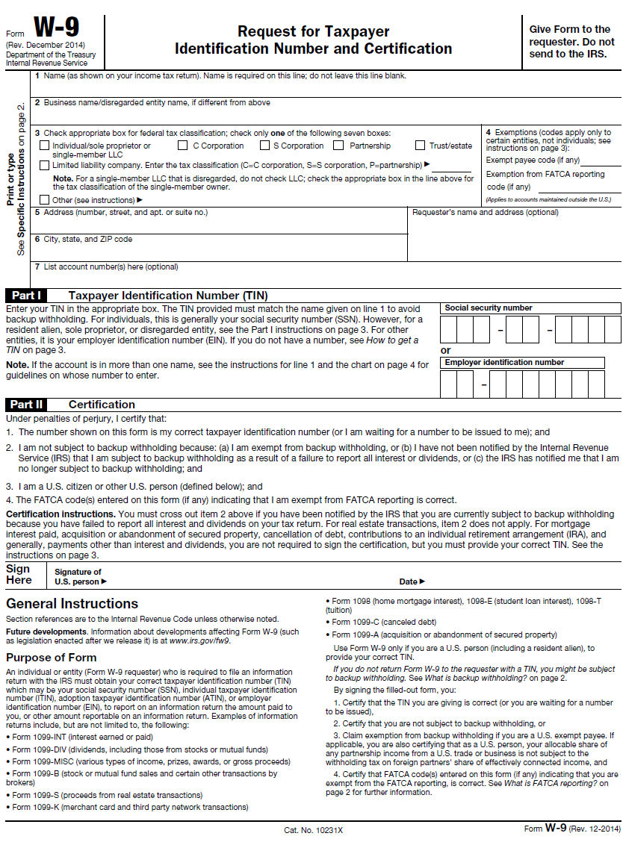
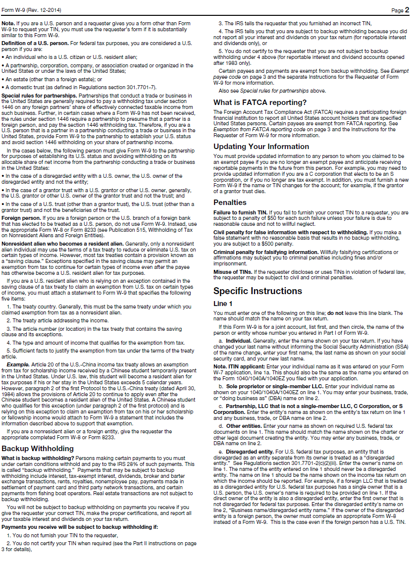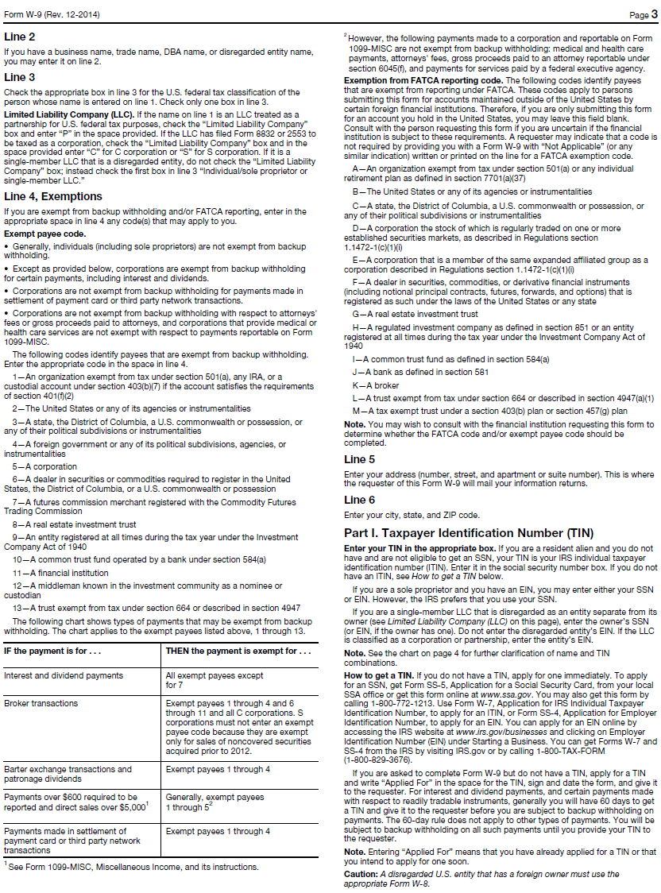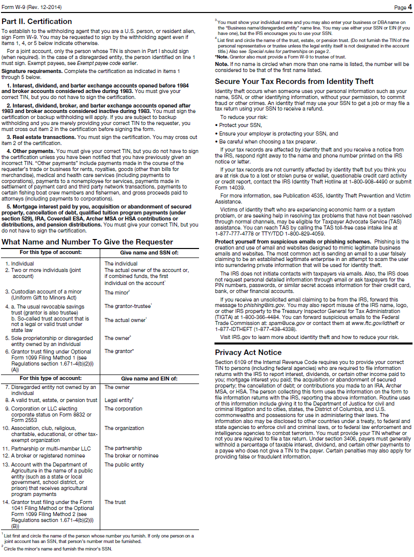
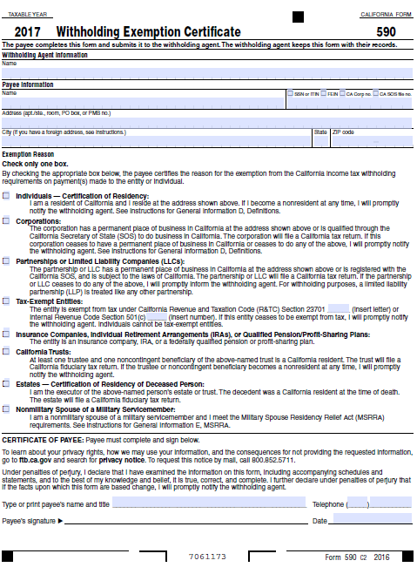
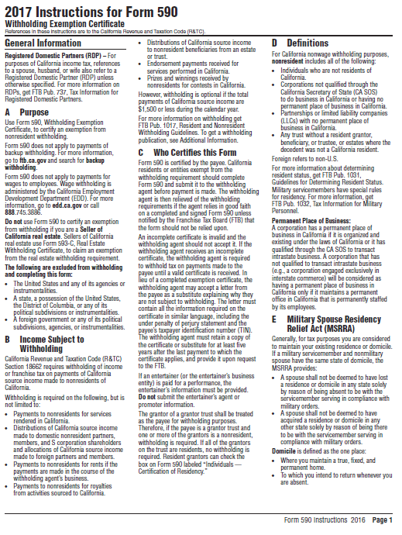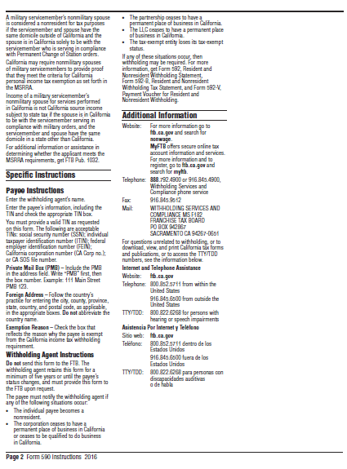
MSRC Prospective Contractor Information
- Contractor (Legal Name): __________________________________________________

- Brief Description of Project: ________________________________________________
- Did Contractor retain a consultant to help prepare the funding application?
Yes No If YES, identify consultant below and then sign and date the form. If NO, sign and date below.
Name of Consultant _____________________________

I declare the foregoing disclosure to be true and correct.
Name: _____________________________

Signature: _______________________

Title: _______________________

Date: _______________________
DISADVANTAGED BUSINESS CERTIFICATION

Federal guidance for utilization of disadvantaged business enterprises allows a vendor to be deemed a small business enterprise (SBE), minority
business enterprise (MBE) or women business enterprise (WBE) if it meets the criteria below.
- is certified by the Small Business Administration or
- is certified by a state or federal agency or
- is an independent MBE(s) or WBE(s) business concern which is at least 51 percent owned and controlled by minority group member(s) who are citizens of the United States.

Statements of certification:

As a prime contractor to the SCAQMD, (name of business) will engage in good faith efforts to achieve the fair share in accordance with 40 CFR Section 33.301, and will follow the six affirmative steps listed below for contracts or purchase orders funded in whole or in part by federal grants and contracts.

- Place qualified SBEs, MBEs, and WBEs on solicitation lists.
- Assure that SBEs, MBEs, and WBEs are solicited whenever possible.
- When economically feasible, divide total requirements into small tasks or quantities to permit greater participation by SBEs, MBEs, and WBEs.
- Establish delivery schedules, if possible, to encourage participation by SBEs, MBEs, and WBEs.
- Use services of Small Business Administration, Minority Business Development Agency of the Department of Commerce, and/or any agency authorized as a clearinghouse for SBEs, MBEs, and WBEs.
- If subcontracts are to be let, take the above affirmative steps.

Self-Certification Verification: Also for use in awarding additional points, as applicable, in accordance with SCAQMD Procurement Policy and Procedure:

Check all that apply:

Small Business Enterprise/Small Business Joint Venture Women-owned Business Enterprise
Local business Disabled Veteran-owned Business Enterprise/DVBE Joint Venture
Minority-owned Business Enterprise

Percent of ownership: %

Name of Qualifying Owner(s):

State of California Public Works Contractor Registration No. ______________________. MUST BE INCLUDED IF BID PROPOSAL IS FOR PUBLIC WORKS PROJECT, AS APPLICABLE.

I, the undersigned, hereby declare that to the best of my knowledge the above information is accurate. Upon penalty of perjury, I certify information submitted is factual.

NAME TITLE

TELEPHONE NUMBER DATE

Definitions

Disabled Veteran-Owned Business Enterprise means a business that meets all of the following criteria:
- is a sole proprietorship or partnership of which is at least 51 percent owned by one or more disabled veterans, or in the case of any business whose stock is publicly held, at least 51 percent of the stock is owned by one or more disabled veterans; a subsidiary which is wholly owned by a parent corporation but only if at least 51 percent of the voting stock of the parent corporation is owned by one or more disabled veterans; or a joint venture in which at least 51 percent of the joint venture’s management and control and earnings are held by one or more disabled veterans.
- the management and control of the daily business operations are by one or more disabled veterans. The disabled veterans who exercise management and control are not required to be the same disabled veterans as the owners of the business.
- is a sole proprietorship, corporation, partnership, or joint venture with its primary headquarters office located in the United States and which is not a branch or subsidiary of a foreign corporation, firm, or other foreign-based business.

Joint Venture means that one party to the joint venture is a DVBE and owns at least 51 percent of the joint venture. In the case of a joint venture formed for a single project this means that DVBE will receive at least 51 percent of the project dollars.

Local Business means a business that meets all of the following criteria:

- has an ongoing business within the boundary of the SCAQMD at the time of bid application.
- performs 90 percent of the work within SCAQMD’s jurisdiction.

Minority-Owned Business Enterprise means a business that meets all of the following criteria:

- is at least 51 percent owned by one or more minority persons or in the case of any business whose stock is publicly held, at least 51 percent of the stock is owned by one or more minority persons.
- is a business whose management and daily business operations are controlled or owned by one or more minority person.
- is a business which is a sole proprietorship, corporation, partnership, joint venture, an association, or a cooperative with its primary headquarters office located in the United States, which is not a branch or subsidiary of a foreign corporation, foreign firm, or other foreign business.

“Minority” person means a Black American, Hispanic American, Native American (including American Indian, Eskimo, Aleut, and Native Hawaiian), Asian-Indian American (including a person whose origins are from India, Pakistan, or Bangladesh), Asian-Pacific American (including a person whose origins are from Japan, China, the Philippines, Vietnam, Korea, Samoa, Guam, the United States Trust Territories of the Pacific, Northern Marianas, Laos, Cambodia, or Taiwan).

Small Business Enterprise means a business that meets the following criteria:

- 1) an independently owned and operated business; 2) not dominant in its field of operation; 3) together with affiliates is either:

- A service, construction, or non-manufacturer with 100 or fewer employees, and average annual gross receipts of ten million dollars ($10,000,000) or less over the previous three years, or

- A manufacturer with 100 or fewer employees.

- Manufacturer means a business that is both of the following:

- Primarily engaged in the chemical or mechanical transformation of raw materials or processed substances into new products.

- Classified between Codes 311000 to 339000, inclusive, of the North American Industrial Classification System (NAICS) Manual published by the United States Office of Management and Budget, 2007 edition.

Small Business Joint Venture means that one party to the joint venture is a Small Business and owns at least 51 percent of the joint venture. In the case of a joint venture formed for a single project this means that the Small Business will receive at least 51 percent of the project dollars.

Women-Owned Business Enterprise means a business that meets all of the following criteria:

- is at least 51 percent owned by one or more women or in the case of any business whose stock is publicly held, at least 51 percent of the stock is owned by one or more women.
- is a business whose management and daily business operations are controlled or owned by one or more women.
- is a business which is a sole proprietorship, corporation, partnership, or a joint venture, with its primary headquarters office located in the United States, which is not a branch or subsidiary of a foreign corporation, foreign firm, or other foreign business.
CAMPAIGN CONTRIBUTIONS DISCLOSURE

In accordance with California law, bidders and contracting parties are required to disclose, at the time the application is filed, information relating to any campaign contributions made to Board Members or members/alternates of the MSRC, including: the name of the party making the contribution (which includes any parent, subsidiary or otherwise related business entity, as defined below), the amount of the contribution, and the date the contribution was made. 2 C.C.R. §18438.8(b).

California law prohibits a party, or an agent, from making campaign contributions to SCAQMD Governing Board Members or members/alternates of the Mobile Source Air Pollution Reduction Review Committee (MSRC) of more than $250 while their contract or permit is pending before the SCAQMD; and further prohibits a campaign contribution from being made for three (3) months following the date of the final decision by the Governing Board or the MSRC on a donor’s contract or permit. Gov’t Code §84308(d). For purposes of reaching the $250 limit, the campaign contributions of the bidder or contractor plus contributions by its parents, affiliates, and related companies of the contractor or bidder are added together. 2 C.C.R. §18438.5.

In addition, Board Members or members/alternates of the MSRC must abstain from voting on a contract or permit if they have received a campaign contribution from a party or participant to the proceeding, or agent, totaling more than $250 in the 12-month period prior to the consideration of the item by the Governing Board or the MSRC. Gov’t Code §84308(c).

The list of current SCAQMD Governing Board Members can be found at the SCAQMD website (www.aqmd.gov). The list of current MSRC members/alternates can be found at the MSRC website (http://www.cleantransportationfunding.org).

SECTION I.
Contractor (Legal Name):

- DBA, Name , County Filed in
Corporation, ID No.
LLC/LLP, ID No.

List any parent, subsidiaries, or otherwise affiliated business entities of Contractor:
(See definition below).

SECTION II.

Has Contractor and/or any parent, subsidiary, or affiliated company, or agent thereof, made a campaign contribution(s) totaling $250 or more in the aggregate to a current member of the South Coast Air Quality Management Governing Board or member/alternate of the MSRC in the 12 months preceding the date of execution of this disclosure?

Yes No If YES, complete Section II below and then sign and date the form.
If NO, sign and date below. Include this form with your submittal.

Campaign Contributions Disclosure, continued:

Name of Contributor

Governing Board Member or MSRC Member/Alternate Amount of Contribution Date of Contribution

Name of Contributor

Governing Board Member or MSRC Member/Alternate Amount of Contribution Date of Contribution

Name of Contributor

Governing Board Member or MSRC Member/Alternate Amount of Contribution Date of Contribution

Name of Contributor

Governing Board Member or MSRC Member/Alternate Amount of Contribution Date of Contribution

I declare the foregoing disclosures to be true and correct.

By:

Title:

Date:

DEFINITIONS

Parent, Subsidiary, or Otherwise Related Business Entity (2 Cal. Code of Regs., §18703.1(d).)

(1) Parent subsidiary. A parent subsidiary relationship exists when one corporation directly or indirectly owns shares possessing more than 50 percent of the voting power of another corporation.

(2) Otherwise related business entity. Business entities, including corporations, partnerships, joint ventures and any other organizations and enterprises operated for profit, which do not have a parent subsidiary relationship are otherwise related if any one of the following three tests is met:
(A) One business entity has a controlling ownership interest in the other business entity.
(B) There is shared management and control between the entities. In determining whether there is shared management and control, consideration should be given to the following factors:
- The same person or substantially the same person owns and manages the two entities;
- There are common or commingled funds or assets;
- The business entities share the use of the same offices or employees, or otherwise share activities, resources or personnel on a regular basis;
- There is otherwise a regular and close working relationship between the entities; or
(C) A controlling owner (50% or greater interest as a shareholder or as a general partner) in one entity also is a controlling owner in the other entity.

