MAjor Event Center Transportation Programs

Funding for the Implementation of Zero & Near-Zero Emissions Transportation for Major Event Center Destinations in the South Coast Air Quality Management District

2021 - 2024 Edition

Program Announcement

PA2022-04

May 6, 2022

SECTION 1 - INTRODUCTION

The Mobile Source Air Pollution Reduction Review Committee (MSRC) Major Event Center Transportation Program first debuted in 2010, and over the past twelve years the MSRC has co-funded numerous programs that provided convenient, low-cost transportation alternatives for accessing major sports and entertainment venues throughout the South Coast region. The purpose of this Program Announcement is to again offer event center transportation co-funding, but with an important caveat; the MSRC intends this offering to be the final funding under this Program.
A primary goal of Major Event Center Transportation Program remains the same: seek cost-effective opportunities to reduce a significant number of automobile trips and their associated air pollutant emissions by shifting attendees of major event center functions out of their personal automobile and onto zero and near-zero emission transportation alternatives. This final edition carries with it an additional but equally important objective – to successfully transition our long-time transportation partners to ongoing, sustainable event center transportation. This will ensure the MSRC’s decade-long investment continues to pay dividends to the communities that bear the air pollution and traffic congestion burden, the oftentimes unrecognized byproducts of major entertainment venues.
The past decade has brought significant advancements in automotive technology. Low-emitting gasoline vehicles, hybrid electric vehicles, and a rapidly increasing number of zero-emission electric vehicles have resulted in an overall cleaner fleet of personal automobiles. As a result of this fleet modernization, the overall automobile fleet emissions in the South Coast region are about 77% lower than when the Event Center Program began in 2010. To ensure this final Event Center program achieves cost-effective air quality benefits, a primary focus of this funding opportunity is to align major event centers with operators of the cleanest vehicles, giving priority to those entities who commit to a zero-emission transportation option for event attendees.
The MSRC has allocated a total of $3.0M in Clean Transportation Funding™ for this Program. As discussed in subsequent sections of this Program Announcement, proposals will be accepted beginning on May 6, 2022, through October 28, 2022. This funding opportunity has at its core the following goals and objectives:
- Partner with Major Event Center venues and transportation providers who have previously implemented - and successfully demonstrated - event center transportation services, and assist those partners in transitioning to ongoing, sustainable event center transportation. This includes the identification of funding sources or revenue to support future transportation services beyond this MSRC funding opportunity;
- Seek out additional major event center venues located within the South Coast AQMD jurisdiction that experience high levels of traffic congestion during scheduled events and are not served by, or are insufficiently served by, regular public transit services;
- Partner with transportation providers and event center venues to develop and implement new or expanded programs to attract patrons to transit services that are tailored to each venue’s scheduled events;
- Utilize the cleanest commercially available vehicles to implement event center transportation service, with a preference for zero-emission vehicles. At a minimum, event center transportation vehicles must be 90% lower emitting than the current heavy-duty emissions standards;
This final Event Center Transportation Program funding opportunity spans three fiscal years – FYs 2021/’22 through 2023/’24. As noted herein, applicants may propose transportation services for a maximum of two consecutive event seasons, with an obligation to perform transportation service for an additional two (2) consecutive event seasons.
While many of the features of the previous event center programs are retained in this funding opportunity, several major changes should be noted:
- All on-road transportation performing Event Center transportation services under this Program must be zero emission or near-zero emission. This means that the vehicle drive system must be certified by the California Air Resources Board (CARB) as a zero-emission vehicle or meet CARB’s Optional Low-NOx Standard of 0.02 grams per brake horsepower – hour (g/bhp-hr).
- Applicants are eligible to propose a maximum of two (2) consecutive event “seasons”, wherein a “season” consists of multiple events or an event that spans multiple days.
- All events receiving MSRC Clean Transportation Funding™ under this Program Announcement must be held no later than December 31, 2025.
- Event transportation for the mandatory two additional consecutive years or consecutive event seasons must be completed no later than December 31, 2027.
The following Sections describe the eligibility requirements to participate in the MSRC Major Event Center Transportation Services Program and guidelines for proposal preparation. It is important to recognize that the MSRC must ensure that the use of Clean Transportation funds will result in direct, tangible, and quantifiable air quality benefits. To this end, this Program Announcement stipulates specific performance thresholds and participation obligations that must be met in order to be deemed eligible for an MSRC funding award. Projects submitted for funding consideration will be scrutinized to ensure they meet the minimum eligibility requirements described herein.
MSRC staff members are available to answer questions and provide technical and programmatic guidance as appropriate. Please refer to Section 6 of this document for a list of MSRC Staff contacts.

Available Funding - The total amount of MSRC Clean Transportation Funding™ allocated for the Major Event Center Transportation Program is $3.0M. This funding level is a targeted amount – should meritorious projects be received totaling greater than $3.0M, the MSRC reserves the right to increase the amount of total funding available.
Also, should the MSRC receive proposals with total requests less than the amount allocated, or if proposals are deemed non-meritorious, the MSRC reserves the right to reduce the total funding available and reallocate funds to other Work Program categories. The MSRC also reserves the right to not fund any of the proposals received, irrespective of the merits of the proposals submitted.
Please note that the source of MSRC Clean Transportation Funding™ for projects submitted in response to this solicitation is motor vehicle registration fees collected by the California Department of Motor Vehicles (DMV) in accordance with the California Health and Safety Code. Thus, the availability of MSRC Clean Transportation Funding™ is contingent upon the timely receipt of funds from the DMV. Neither the MSRC nor South Coast AQMD can guarantee the collection or remittance of registration fees by the DMV.
SECTION 2 – ELIGIBILITY REQUIREMENTS

This Program Announcement seeks to facilitate the reduction of automobile trips and mitigate traffic congestion by shifting event attendees out of their personal automobiles and onto zero and near-zero emission transportation at major event centers that are not currently served by adequate, regularly scheduled transit or shuttle service prior to, during, and following the venue’s events.
For the purpose of this Program Announcement, the following eligibility requirements apply:
- Major Event Center – a Major Event Center is defined as a publicly or privately-owned, publicly accessible venue located within the geographical jurisdiction of the South Coast Air Quality Management District that possesses the following attributes, at a minimum:
  - Occupancy capacity of at least 7,500 people;
  - Average event attendance of at least 5,000 people;
  - Dedicated parking lot or structure co -located with the event center.
- Traffic Impacted Event – A scheduled event held at a Major Event Center that results in recurrent traffic congestion prior to, during, or after the scheduled event whose impact on surrounding roadways, arterials, intersections, or freeways exceeds design capacity;
- Transportation Provider – includes but is not necessarily limited to a) public transit agencies, including regional and municipal transit agencies and authorities; b) private transit operators, including subcontractor service providers to public transit agencies; and c) paratransit providers and other licensed, private transportation and shuttle providers;
- Qualifying Transportation Vehicles – vehicles proposed for use in Event Center Transportation Services must conform to the following minimum requirements:
On-Road Bus and Shuttle Vehicles:
  - All on-road vehicles performing Event Center transportation services under this Program must be certified by the California Air Resources Board as zero-emission vehicles or be equipped with an engine that is certified at CARB’s Optional Low-NOx emission standard of 0.02 g/bhp-hr;
  - Vehicle Seating Capacity – vehicles must have a minimum seated position capacity of twenty-two (22) occupants;
  - Vehicles must meet all Americans with Disabilities Act (ADA), US Department of Transportation (DOT), California Department of Motor Vehicles (DMV), and other applicable regulatory agency.

- Transportation Deficient – the Event Center must be Transportation Deficient. This is defined as an Event Center that is not served by regularly scheduled public transit or private shuttle service sufficient to entice patrons to attend the event using public transit rather than private automobile, or is served by public and/or private transportation services that are operating at maximum capacity. Please note that this Program Announcement is NOT intended to subsidize ongoing public or private transportation services.

The MSRC seeks the formation of partnerships between traffic-impacted, transportation-deficient major event centers and transportation providers who operate qualifying vehicles. The following Sections define who is eligible to submit a proposal to the MSRC, who is eligible to enter in to a contract for event center transportation services, and what transportation costs are eligible for reimbursement by the MSRC:
- Who can submit a proposal in response to this Program Announcement? Either a qualifying major event center, a qualifying transportation provider, or a County Transportation Commission may respond to this Program Announcement and submit a proposal for MSRC consideration. Proposals may also be submitted from a joint County Transportation Commission/event center/transportation provider partnership. Please note that the following conditions apply:
  - A proposal submitted by qualifying Major Event Centers must identify what Transportation Provider(s) will provide the event center service. The proposal must include a Memorandum of Understanding (MOU) or letter of support between the event center and transportation provider(s) stating their mutual intent to implement and operate event center transit service in accordance with Program requirements in the event the MSRC provides a funding award;
  - A proposal submitted by a qualifying Transportation Provider must identify which Major Event Center(s) will be served in the Program. The proposal must include an MOU or letter of support between the transportation provider and event center(s) stating their mutual intent to implement and operate event center transit service in accordance with Program requirements in the event the MSRC provides a funding award;
  - A proposal submitted by a County Transportation Commission must identify which Major Event Center(s) will be served in the Program and identify what Transportation Provider(s) will provide the event center service. The proposal must include an MOU or letter of support between the County Transportation Commission and transportation provider and/or event center(s) stating their mutual intent to implement and operate event center transit service in accordance with Program requirements in the event the MSRC provides a funding award;
  - A proposal submitted jointly by a County Transportation Commission in partnership with an event center and transportation provider(s) must also include an MOU or letter of support, as above.

- Who is eligible to receive an award of MSRC Clean Transportation Funding™ under this Program Announcement? While either a County Transportation Commission, major event center or qualifying transportation provider are eligible to submit a proposal, only the qualifying transportation provider or County Transportation Commission is eligible to enter into a contract on behalf of the proposed event center transportation service partnership. The rationale for this restriction is that only transportation service costs (including transit program and traffic control costs) are eligible for reimbursement under this Program. Thus, it makes sense that the service provider who incurs direct expenses in providing transportation services be the party to the contract that provides reimbursement. Please note that the MSRC does not enter into three-party agreements.

In summary, major event centers that meet the above eligibility requirements and transportation providers that meet qualifying requirements are eligible to participate in this MSRC Program. Both Event Centers and Transportation Providers are eligible to submit a proposal; however, each party must be identified by name in the proposal, accompanied by a MOU between the named participants. Only the transportation provider can be the MSRC funding recipient and contract signatory.

SECTION 3 - PARTICIPATION GUIDELINES, CONDITIONS, & RESTRICTIONS

The following guidelines, requirements, and conditions have been established and apply to all Proposals:

- Program Scope – The primary objective of this Program is to eliminate automobile trips, reduce automobile vehicle miles traveled (VMT), and reduce traffic congestion in the vicinity of a major event center prior to, during, and following an event, resulting in a reduction in air pollutant emissions. Automobile trip reduction and traffic congestion mitigation are achieved by shifting the travel mode of event attendees from their personal automobile and onto new or expanded zero or near-zero emission transportation service or dedicated zero/near-zero emission shuttle event center feeder service. MSRC Clean Transportation Funding™ is available to co-fund the cost of implementing new or expanded transportation programs. Only direct costs of transportation programs are eligible for reimbursement under this Program. Proposals submitted in response to this Program Announcement must include as named participants the major event center where new or expanded transit or shuttle service will be operated, as well as the transportation provider who will implement the event center transportation program.
- Geographical Funding Minimum - The MSRC has established a Geographical Funding Minimum for each county within the SCAQMD. The geographical funding minimum amount has been set at $250,000 per county. This funding set-aside guarantees a minimum level of funding for each county to implement Event Center Transportation projects. At the end of the application submittal period, October 28, 2022, if any county has funds remaining in its geographical minimum, these funds will be made available to qualifying projects from any other county in order of receipt.
- All events receiving MSRC Clean Transportation Funding™ under this Program Announcement must be held prior to December 31, 2025.
- Applicants are eligible to propose a maximum of two (2) consecutive event “seasons”, wherein a “season” consists of multiple events or an event that spans multiple days. There is an obligation to perform event transportation services for an additional two consecutive event seasons at the completion of the MSRC-funded season(s). Note that the requirement to perform transportation service for two additional event seasons is irrespective of whether MSRC funding is requested for one or two event seasons under this Program Announcement.
- In all cases, acceptance of an MSRC funding award and execution of a binding agreement obligates the funding recipient to implement two (2) additional consecutive event seasons at recipients’ expense, with transportation services fully implemented no later than December 31, 2027. Should the recipient not provide one or more of these additional seasons of service, they will be obligated to pay back twenty-five percent (25%) of the funds previously reimbursed for each season of service not provided.
- Eligible Uses of MSRC Funds – MSRC funds may be used to offset direct operating costs associated with event center transportation programs. These include transportation operations and traffic control costs as defined below:
- Transportation Operations – Direct costs associated with operations of event center transportation vehicle and/or rail operations subject to the requirements and conditions outlined in Section 2, Eligibility Requirements;
- Event Center Traffic Control/Bus Priority – Costs associated with providing traffic control to provide participating transportation vehicles event center ingress and egress priority may also be proposed as project co-funding. This includes, but is not necessarily limited to: special lane designation for transit vehicles, including cones, lane striping, etc.; traffic control personnel to direct traffic and grant participating vehicles faster entry and exit; designation of areas for drop off and pickup of event center patrons who utilize the transportation service, including directional signage, markings and placards, etc.
- Transportation Programs Advertising, Outreach, Marketing, and Promotion – All event center transportation programs projects that receive an MSRC Clean Transportation Funding™ award must include advertising and promotion of the availability of the service as a project element. This is a mandatory component of any MSRC-funded event center transportation programs project. Advertising and promotion may include, but is not limited to:
- Radio, television, newspaper, or specialty publication advertisements;
- Print materials;
- Materials developed for incorporation into a website, electronic media, etc.;
- Transportation program kickoff events, ribbon cuttings, or news conferences, etc.
- Program Co-Funding Requirements – Major event center projects funded by the MSRC are required to provide minimum project co-funding. Co-funding must be greater than or equal to 60% of the total project cost, i.e., a maximum of 40% of total project costs to be co-funded by the MSRC.
Eligible project co-funding includes the following:
- Direct Cost Share – Cash, direct labor, and equipment use contributions from the transportation provider may be accounted for as co-funding;
- Fare box Revenue – Fare box revenue collected to augment MSRC-funded transportation program may be documented and applied as co-funding;
- Transportation Programs Outreach, Marketing, and Promotion – Direct costs associated with advertising the availability of event center transportation programs may be applied as co-funding. Appropriate outreach may include, but is not limited to, radio, television, newspaper, or specialty publication advertisements, printed materials, materials developed for incorporation into a website, electronic media, transportation program kickoff events, ribbon cuttings, or news conferences, etc.
- Event Center Traffic Control/Bus Priority – Direct costs associated with providing traffic control to provide participating transportation vehicles event center ingress and egress priority may also be proposed as project co-funding.

- Funding Restrictions – MSRC funds may only be applied to direct operating costs associated with event center transportation programs. These include transportation operations and traffic control costs only. MSRC funds cannot be used:
- To fund capital acquisition costs associated with transportation vehicle purchase;
- To recoup lost parking lot revenue.

- MSRC Funds Remitted on a Reimbursement Basis - MSRC funds will be distributed on a reimbursement basis only upon completion of approved project milestones and submission of all required reports and invoices. Both an Interim and a Final Report will be required. Note that five percent (5%) will initially be withheld from all reimbursements. Of this amount, $25,000 or 5% of the total amount reimbursed, whichever is less, will be retained pending submission and approval of a Final Report covering both the MSRC-funded and additional two seasons of operation. The difference, if any, will be released following submission and approval of the Interim Report covering the MSRC-funded season(s) of operation.

- Additional Conditions on MSRC Funding
- MSRC projects are funded on a “site-specific” basis; that is, each project is evaluated with respect to the proposed event center’s unique location, traffic congestion, availability of other transportation options, etc. Thus, proposals that result in an award of MSRC funds are not allowed to change the event center venue under any circumstances. In the event the proposed venue becomes unavailable, nonviable, or no longer cost-effective, either contract negotiations will terminate or the contract will terminate, as applicable;
- All projects must include an advertising, marketing, and outreach component. Acceptable outreach strategies are described in the previous section;
- Conflict of Interest – Proposers must identify possible conflicts of interest with other clients affected by actions performed by the firm on behalf of the MSRC. Although the bidder will not be automatically disqualified by reason of work performed for such firms, the MSRC reserves the right to consider the nature and extent of such work in evaluating the proposal;
- Certifications – All Proposers must complete and submit the included Attachment G forms as an element of their Proposal (unless specifically exempted below):
- Internal Revenue Service Form W-9 – Request for Taxpayer Identification Number and Certification, and Franchise Tax Board Form 590 – Withholding Exemption Certificate. If you are selected for an award, you cannot be established as a vendor without this information.
- Campaign Contributions Disclosure. This information must be provided at the time of application in accordance with California law. You may be asked for an update when awards are considered.
- Certification Regarding Debarment, Suspension and Other Responsibility Matters – The SCAQMD needs this information for their vendor database.
- Disadvantaged Business Certification. The SCAQMD needs this information for their vendor database. It will not be considered in the determination of your MSRC funding award. Governmental entities do not need to complete this form.
- Finally, in accordance with state law, all projects awarded MSRC Clean Transportation Funding™ are subject to audit. The provisions of the audit are discussed in the Sample Contact, included as Section 9 of this Program Announcement. It is highly recommended that bidders employ government accepted accounting practices when administering their MSRC co-funded project.

SECTION 4 – PROGRAM ANNOUNCEMENT TIMETABLE
The MSRC understands that developing an event center transportation programs project is a complex undertaking. The MSRC also appreciates that events scheduled at a major venue are firm; thus, the MSRC Program is designed to afford potential proposers as much flexibility as possible to allow development of outstanding event center transportation projects.
Table 4-1 - Key Event Center Transportation Programs Program Dates
Program Event | Date
Program Announcement Release | May 6, 2022
Application Submittal Period | May 6, 2022 – October 28, 2022
Latest Date/Time for Electronic Application Submittal | October 28, 2022 @ 11:59 p.m.

SECTION 5 - Proposal Preparation & submittal instructions

An Event Center Transportation Project Proposal must be completed and submitted for funding consideration under this Program. Proposals must be prepared and submitted in accordance with the instructions outlined below.

- Proposal Preparation – The following information must be included in all Proposals seeking MSRC Clean Transportation Funding™ under the Major Event Center Transportation Programs Program:

- Attachments A-G - Proposals must include the following completed Attachments, including all required supporting documentation as requested. Proposal Templates and Instructions are included in Section 8 of this Program Announcement:
- Attachment A: Proposer and Project Participant Information
- Attachment B: Project Description
- Attachment C: Project Cost Breakdown
- Attachment D: Project Implementation Schedule
- Attachment E: Memorandum of Understanding/letter of support between Event Center(s) and Transportation Services Provider(s) (as applicable)
- Attachment F: Transportation Service Ridership Estimates
- Attachment G: Certifications

- Electronic Application Submittal Process – To reduce the need to photocopy, package, and physically submit paper applications, the Major Event Center Transportation Program requires that applications be submitted electronically in PDF format using the MSRC Website. We believe this benefits the applicant, the MSRC staff, and the environment.

The application that will be submitted as a PDF document is comprised of seven (7) primary sections – these correspond to the application Attachments A-G as described in the preceding section. Thus, a complete application will be comprised of the following elements:

- Attachment A: Proposer and Project Participant Information
- Attachment B: Project Description, including Service Continuation Plan to ensure sustainable, ongoing event center transportation operations
- Attachment C: Project Cost Breakdown
- Attachment D: Project Implementation Schedule
- Attachment E: Memorandum of Understanding/letter of support between Event Center(s) and Transportation Services Provider(s) (as applicable)
- Attachment F: Transportation Service Ridership Estimates
- Attachment G: Certifications
  - Disadvantaged Business Certification Form
  - IRS Form W-9
  - California Form 590 Withholding Exemption Certificate
  - Certification Regarding Debarment, Suspension, and Other Responsibility Matters
  - Campaign Contribution Disclosure Form
  - Direct Deposit Authorization
These seven sections, including Attachment G certifications, are to be compiled into a single PDF document for submittal to the MSRC Clean Transportation Funding Website. Please note that ONLY PDF format can be accepted. Microsoft Word documents cannot be accepted by the MSRC Website. Applicants will need to register on the MSRC Clean Transportation Funding website.

Please note that the latest date and time to apply is OCTOBER 28, 2022 at 11:59 pm!
- Addenda – The Mobile Source Air Pollution Reduction Review Committee may modify the Program Announcement and/or issue supplementary information or guidelines relating to the Program Announcement during the Proposal preparation and acceptance period of May 6, 2022 to October 28, 2022. Amendments will be posted on the MSRC website at www.cleantransportationfunding.org.
- Proposal Modifications - Once submitted, Proposals cannot be altered without the prior written consent of the Mobile Source Air Pollution Reduction Review Committee.
5. Certificates of Insurance - Upon notification of an MSRC funding award, a certificate(s) of insurance naming the South Coast Air Quality Management District (SCAQMD) as an additional insured will be required within forty-five (45) days. Entities that are self-insured will be required to provide proof of self-insurance prior to contract execution.
SECTION 6 - IF YOU NEED HELP…
This Program Announcement can be obtained by accessing the MSRC web site at www.cleantransportationfunding.org. MSRC staff members are available to answer questions during the Proposal acceptance period. In order to help expedite assistance, please direct your inquiries to the applicable staff person, as follows:

- For General or Technical Assistance, please contact:
Ray Gorski
MSRC Technical Advisor
Phone: 909-396-2479
E-mail: Ray@CleanTransportationFunding.org

- For Administrative Assistance, please contact:
Cynthia Ravenstein
MSRC Contracts Administrator
Phone: 909-396-3269
E-mail: Cynthia@CleanTransportationFunding.org

- For Contractual Assistance, please contact:
Dean Hughbanks
SCAQMD Procurement Manager
Phone: 909-396-2808
E-mail: dhughbanks@aqmd.gov

sECTION 7 - Proposal Evaluation and Approval Process
MSRC staff members will screen proposals upon receipt to ensure compliance with all mandatory Program Announcement requirements. In the event a proposal is deemed noncompliant, MSRC Staff will notify the proposer of the issues and corrective actions required. Note that a noncompliant proposal is not considered “received” and will not undergo further evaluation until all proposal deficiencies are remedied.
Proposals deemed compliant will be forwarded to an Evaluation Subcommittee comprised of members of the MSRC Technical Advisory Committee (MSRC-TAC). Proposals will be evaluated in order of receipt using criteria established by the MSRC; these criteria are listed below. Proposals will be recommended for funding based upon their conformance with the established criteria. It is possible that all funding allocated to this Program could be fully expended prior to the close of the proposal submittal period, October 28, 2022.
Evaluation Criteria – Proposals will be evaluated using a two-step process. The first step (Step 1) consists of a technical analysis to ensure that the project has a high probability of achieving a net air quality benefit. Only proposals that are determined to result in a net reduction in mobile source air pollution will undergo further evaluation (Step 2). MSRC Staff may request additional information from the project applicant to assist in this determination.
Step 2 continues the assessment of the merits of a proposed Event Center project. The specific criteria to be evaluated are outlined below. Each project will be assessed individually against the evaluation criteria. A maximum of 100 points is available – only projects that receive greater than 70 points will be considered for an MSRC funding award. Projects scoring less than 70 points will not be eligible for an MSRC funding award.

EVALUATION STEP 1:
POTENTIAL TO ACHIEVE QUANTIFIABLE AIR POLLUTANT REDUCTIONS - Each project will be analyzed to estimate its potential to achieve motor vehicle air pollution reductions, emphasizing reductions in oxides of nitrogen and particulate matter pollution. Factors to be evaluated include, but are not limited to:
- The types, quantity, emissions profile, and proposed utilization of the vehicles proposed to implement the event center transportation services;
- Event center transportation service ridership estimates based on previous documented event center project results, surveys or focus groups conducted to estimate potential transportation service utilization, etc.;
- The event center location, population density, and location relative to major arterial roadways and freeways;
- Availability of existing transportation options other than personal automobile;
- The number of events scheduled or planned for the event center during the proposed period of program; and
- The average venue attendance.

EVALUATION STEP 2:

- SUCCESSFUL PARTICIPATION IN PAST EVENT CENTER TRANSPORTATION PROGRAMS (0 – 15 Points).

- PROGRAM CONTINUATION PLAN (0 – 50 Points). As discussed, MSRC funding is not intended to serve as an ongoing funding source for event venues. Event Center project applicants are required to develop a plan to demonstrate how the proposed service will continue beyond the MSRC funding period, including the sources of internal and external revenue that will be pursued to augment and ultimately replace MSRC funding. Projects that have a definitive plan for continuing transportation programs well beyond the MSRC funding period will be awarded a higher point allocation.
- EVENT CENTER PROJECT COST-EFFECTIVENESS (0 – 20 Points). Cost-effectiveness is a measure of a proposed project’s potential for reducing mobile source air pollution relative to the MSRC funding amount sought. This is typically presented in units of “dollars per pound of air pollution reduced”. The results of Step 1 will be evaluated in the context of the MSRC funding request. Points will be awarded in accordance with the following cost-effectiveness (CE) matrix:

CE ($/Lb.) | POINTS
< $500/Lb. | 25
$500 - $1,499/Lb. | 20
$1,500 - $2,499/Lb. | 15
$2,500 - 3,499/Lb. | 10
$3,500 - $4,499/Lb. | 5
> $4,500/Lb. | 0

- ZERO-EMISSION TRANSPORTATION BONUS (0 or 5 points). Applicants who utilize zero-emission vehicles to perform event center transportation are eligible to receive additional points. Applicants who commit to use zero-emission vehicles to perform a minimum of 25% of event center service trips will receive five (5) additional points. This commitment will be included in any subsequent MSRC funding agreement with the applicant.

- NEXUS TO OTHER PUBLIC TRANSIT SERVICES (0 - 10 Points). MSRC experience over the past nine years has shown that vent Center projects that are ultimately most successful have a high degree of connectivity with other existing public transit services. This criterion evaluates the probability of successfully integrating the proposed transportation program with other existing public transportation services, including connectivity with existing regional or municipal bus service, Metrolink, light rail, transit centers, etc. Proposers should clearly outline the proposed Event Center transportation connectivity with other existing public transit services in their proposal.

Proposals deemed meritorious by the MSRC-TAC will be forwarded to the MSRC for evaluation, review, and potential funding approval. Please note that the MSRC retains full discretion and authority as it pertains to a potential award of Clean Transportation Funding™. The decision to award funding, or not award funding, will be based on the proposed project’s potential to achieve direct and tangible emission reductions. Thus, it is anticipated that not all projects submitted for funding consideration will receive an MSRC award.

SECTION 8 - Proposal ATTACHMENTS

Attachment A: Proposal CONTACT Information

- Please provide the following Proposer information in the space provided (This is information about the entity submitting the proposal):
Business Name
Division of:
Subsidiary of:
Website Address
Type of Business  Check One: | - Individual  - DBA, Name _______________, County Filed in _______________  - Corporation, ID No. ________________  - LLC/LLP, ID No. _______________  - Other _______________

REMITTING ADDRESS INFORMATION
Address
City
State |  | Zip
Phone | ( ) - Ext | Fax | ( ) -
Contact Name |  | Title
E-mail Address
Payment Name if Different

- Funding Request Summary:
MSRC Clean Transportation Funding™ Requested: $____________________
Other Co-Funding Applied to Project: $____________________
Total Project Cost: $____________________

- Please provide the following information about the Event Center in the space provided below:
Event Center Name
Website Address
Type of Venue

Address
City
State |  | Zip
Phone | ( ) - Ext | Fax | ( ) -
Venue Contact Name |  | Title
E-mail Address
Payment Name if Different

- Please provide the following information about the Transportation Service Provider in the space provided (If this information was provided in Section 8.A, simply type “See Above”):
Business Name
Division of:
Subsidiary of:
Website Address
Type of Business

Address
City/Town
State/Province |  | Zip
Phone | ( ) - Ext | Fax | ( ) -
Contact Name |  | Title
E-mail Address
Payment Name if Different

Attachment B: project Description

- Event Center Description - Please provide a detailed description of the major event center. At a minimum, provide the following information:
- General Characteristics of the Event Center, including type of venue, facility physical size, occupancy capacity, parking lot capacity, etc.;
- Average number of events held annually or during a full season of operation;
- Average attendance at a regularly scheduled event; peak attendance at special events;
- Traffic conditions in proximity to event center prior to, during, and following a regularly scheduled event. If possible, provide a statement from the City or County Traffic Engineering Department verifying that traffic volumes on adjacent roadways and intersections prior to and following a scheduled event exceed roadway and intersection capacity.
- Proposed Transportation Program Description – Provide a detailed description of the proposed event center transportation program. This should include, at a minimum:
- A description of the vehicles proposed to perform transportation services, including the make and model, model year, engine model and year, alternative fuel type if required, seating positions, and total capacity (seated and standing) for each vehicle proposed to be utilized in event center transportation services.
- The estimated number of events for which transportation program will be implemented. Include event schedules, dates, etc. to the extent feasible.
- A description of how the transportation program services will be conducted, including passenger pickup locations, passenger drop-off locations, anticipated headways, hours of operation, etc.
- For circulator-type transportation services, please include a map of the vehicle route(s) that graphically illustrates vehicle routing, passenger pickup and drop-off locations, etc.
- Event Transportation Continuation Plan – Please describe what efforts will be made by the event center/transportation provider partnership to identify and secure necessary resources to continue event center transportation program beyond the MSRC funding period. IMPORTANT: This plan will comprise up to 50% of all points awarded under Section 7, Proposal Evaluation and Approval Process.
- Connectivity with Other Public Transit Service - Please discuss potential connectivity with other public transit services, including but not limited to potential connectivity with existing regional or municipal bus lines, Metrolink, light rail, transit centers, park and ride lots, etc.
- Advertising, Marketing, Outreach, and Promotion of Event Center Transportation Program – Please describe the plan for conducting outreach and promotion of the availability of event center transportation programs. This may include, but is not limited to, radio, television, newspaper, or specialty publication advertisements; other printed materials; materials developed for incorporation into a website, electronic media, etc., transportation program kickoff events, ribbon cuttings, or news conferences, etc. Please note that outreach and promotion is a mandatory element of any event center transportation program project funded by the MSRC and may be accounted for as an in-kind co-funding contribution.
Attachment C: Cost Breakdown
Please provide a detailed cost breakdown of the proposed project. Please note that MSRC Clean Transportation Funding™ is intended to help offset the cost of transportation program, and cannot be applied to capital equipment purchases or used to offset lost parking facility revenues. The MSRC reserves the right to exclude cost elements deemed unallowable, as well as award funding in an amount less than the requested amount.

Attachment D: PROJECT IMPLEMENTATION SCHEDULE
Please provide a Milestone Schedule for your proposed event center transportation program project. This should include, at a minimum, the anticipated date event center transportation program will commence, as well as any additional information regarding scheduled events to be supported by transportation services.

Attachment E: Memorandum of Understanding/Letter of support Between transportation service provider (proposed Contractor) and event center Site
For projects seeking MSRC Clean Transportation Funding™ for implementation or expansion of an event center transportation program, a fully executed Memorandum of Understanding (MOU) or letter of support must be submitted as an element of the proposal package.
The MOU/Letter of Support must be provided at the time of Proposal Submittal and must contain the following essential elements, at a minimum:
- The parties to the MOU/Letter of Support, including the transportation service provider(s) and event center site owner or authorized representative;
- The term of the MOU/Letter of Support;
- The specific location of where transportation services will be provided;
- Anticipated dates of transportation service start of operation and completion;
- Executed signatures by individuals authorized on behalf of the parties to the MOU/Letter of Support.
If the proposal package contains a letter of support, an MOU may be required prior to execution of a contract.
Attachment F: transportation PROGRAM Ridership Estimates
Please provide an estimate of the anticipated utilization of the event center transportation program if implemented as proposed. Please include any empirical information used to generate ridership estimates, including but not limited to survey results, focus group results, etc.
Please note that as a condition of funding award, the contractor will be required to survey, document, or otherwise quantify the patronage of the event center transportation program in order for the MSRC to quantify motor vehicle emission reductions achieved by the transportation program.
Attachment G: CERTIFICATIONS
BUSINESS STATUS CERTIFICATIONS

Federal guidance for utilization of disadvantaged business enterprises allows a vendor to be deemed a small business enterprise (SBE), minority business enterprise (MBE) or women business enterprise (WBE) if it meets the criteria below.
- is certified by the Small Business Administration or
- is certified by a state or federal agency or
- is an independent MBE(s) or WBE(s) business concern which is at least 51 percent owned and controlled by minority group member(s) who are citizens of the United States.

Statements of certification:

As a prime contractor to South Coast AQMD, (name of business) will engage in good faith efforts to achieve the fair share in accordance with 40 CFR Section 33.301, and will follow the six affirmative steps listed below for contracts or purchase orders funded in whole or in part by federal grants and contracts.

- Place qualified SBEs, MBEs, and WBEs on solicitation lists.
- Assure that SBEs, MBEs, and WBEs are solicited whenever possible.
- When economically feasible, divide total requirements into small tasks or quantities to permit greater participation by SBEs, MBEs, and WBEs.
- Establish delivery schedules, if possible, to encourage participation by SBEs, MBEs, and WBEs.
- Use services of Small Business Administration, Minority Business Development Agency of the Department of Commerce, and/or any agency authorized as a clearinghouse for SBEs, MBEs, and WBEs.
- If subcontracts are to be let, take the above affirmative steps.

Self-Certification Verification: Also for use in awarding additional points, as applicable, in accordance with South Coast AQMD Procurement Policy and Procedure:

Check all that apply:

Small Business Enterprise/Small Business Joint Venture Women-owned Business Enterprise
Local business Disabled Veteran-owned Business Enterprise/DVBE Joint Venture
Minority-owned Business Enterprise Most Favored Customer Pricing Certification

Percent of ownership: %

Name of Qualifying Owner(s):

State of California Public Works Contractor Registration No. ______________________. MUST BE INCLUDED IF BID PROPOSAL IS FOR PUBLIC WORKS PROJECT.

I, the undersigned, hereby declare that to the best of my knowledge the above information is accurate. Upon penalty of perjury, I certify information submitted is factual.

NAME TITLE

TELEPHONE NUMBER DATE

Definitions

Disabled Veteran-Owned Business Enterprise means a business that meets all of the following criteria:
- is a sole proprietorship or partnership of which is at least 51 percent owned by one or more disabled veterans, or in the case of any business whose stock is publicly held, at least 51 percent of the stock is owned by one or more disabled veterans; a subsidiary which is wholly owned by a parent corporation but only if at least 51 percent of the voting stock of the parent corporation is owned by one or more disabled veterans; or a joint venture in which at least 51 percent of the joint venture’s management and control and earnings are held by one or more disabled veterans.
- the management and control of the daily business operations are by one or more disabled veterans. The disabled veterans who exercise management and control are not required to be the same disabled veterans as the owners of the business.
- is a sole proprietorship, corporation, partnership, or joint venture with its primary headquarters office located in the United States and which is not a branch or subsidiary of a foreign corporation, firm, or other foreign-based business.

Joint Venture means that one party to the joint venture is a DVBE and owns at least 51 percent of the joint venture. In the case of a joint venture formed for a single project this means that DVBE will receive at least 51 percent of the project dollars.

Local Business means a business that meets all of the following criteria:

- has an ongoing business within the boundary of South Coast AQMD at the time of bid application.
- performs 90 percent of the work within South Coast AQMD’s jurisdiction.

Minority-Owned Business Enterprise means a business that meets all of the following criteria:

- is at least 51 percent owned by one or more minority persons or in the case of any business whose stock is publicly held, at least 51 percent of the stock is owned by one or more minority persons.
- is a business whose management and daily business operations are controlled or owned by one or more minority person.
- is a business which is a sole proprietorship, corporation, partnership, joint venture, an association, or a cooperative with its primary headquarters office located in the United States, which is not a branch or subsidiary of a foreign corporation, foreign firm, or other foreign business.

“Minority” person means a Black American, Hispanic American, Native American (including American Indian, Eskimo, Aleut, and Native Hawaiian), Asian-Indian American (including a person whose origins are from India, Pakistan, or Bangladesh), Asian-Pacific American (including a person whose origins are from Japan, China, the Philippines, Vietnam, Korea, Samoa, Guam, the United States Trust Territories of the Pacific, Northern Marianas, Laos, Cambodia, or Taiwan).

Small Business Enterprise means a business that meets the following criteria:

- 1) an independently owned and operated business; 2) not dominant in its field of operation; 3) together with affiliates is either:

- A service, construction, or non-manufacturer with 100 or fewer employees, and average annual gross receipts of ten million dollars ($10,000,000) or less over the previous three years, or

- A manufacturer with 100 or fewer employees.

- Manufacturer means a business that is both of the following:

- Primarily engaged in the chemical or mechanical transformation of raw materials or processed substances into new products.

- Classified between Codes 311000 to 339000, inclusive, of the North American Industrial Classification System (NAICS) Manual published by the United States Office of Management and Budget, 2007 edition.

Small Business Joint Venture means that one party to the joint venture is a Small Business and owns at least 51 percent of the joint venture. In the case of a joint venture formed for a single project this means that the Small Business will receive at least 51 percent of the project dollars.

Women-Owned Business Enterprise means a business that meets all of the following criteria:

- is at least 51 percent owned by one or more women or in the case of any business whose stock is publicly held, at least 51 percent of the stock is owned by one or more women.
- is a business whose management and daily business operations are controlled or owned by one or more women.
- is a business which is a sole proprietorship, corporation, partnership, or a joint venture, with its primary headquarters office located in the United States, which is not a branch or subsidiary of a foreign corporation, foreign firm, or other foreign business.

Most Favored Customer as used in this policy means that the South Coast AQMD will receive at least as favorable pricing, warranties, conditions, benefits and terms as other customers or clients making similar purchases or receiving similar services.

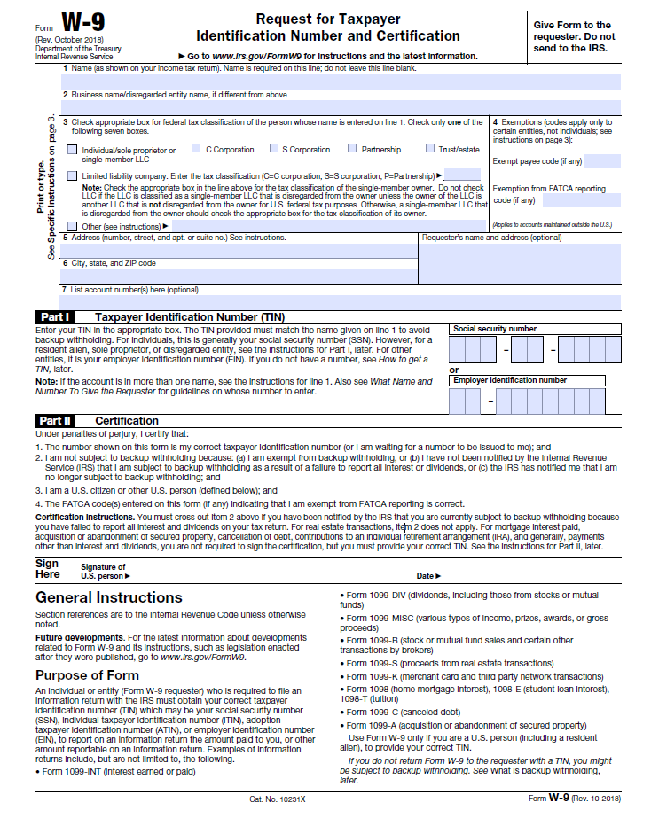
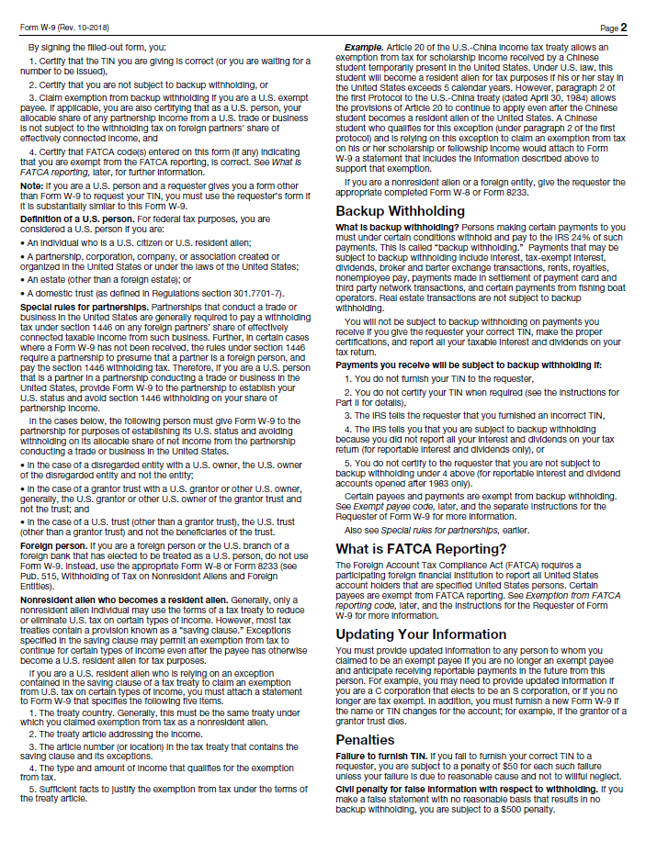
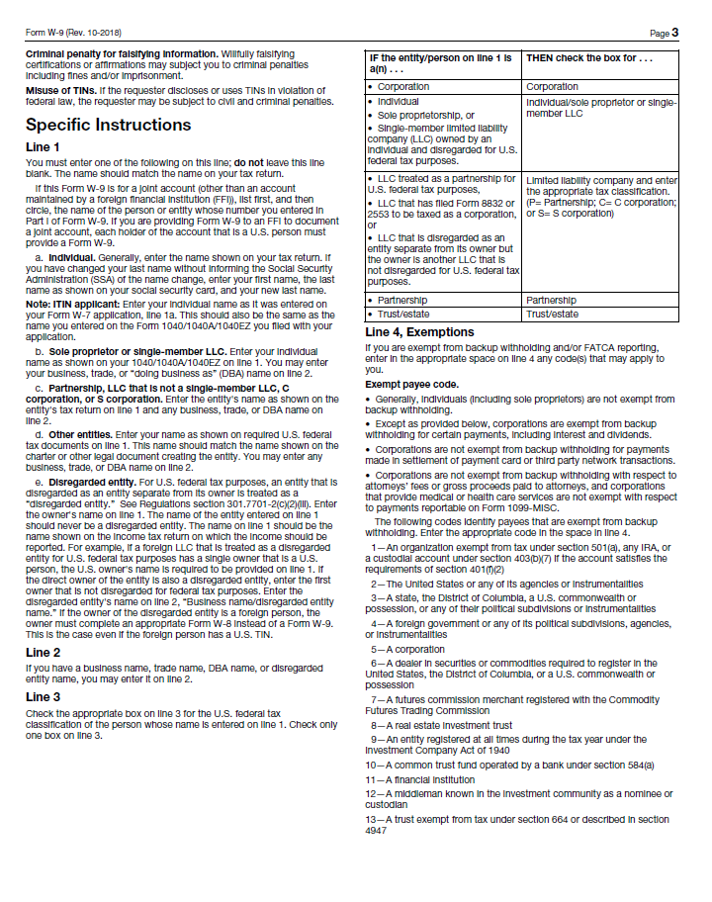

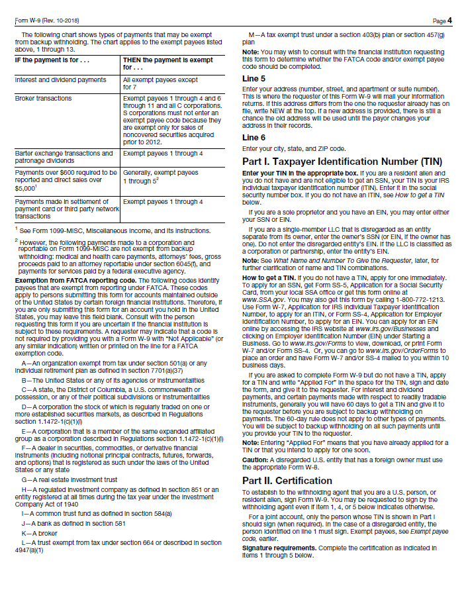
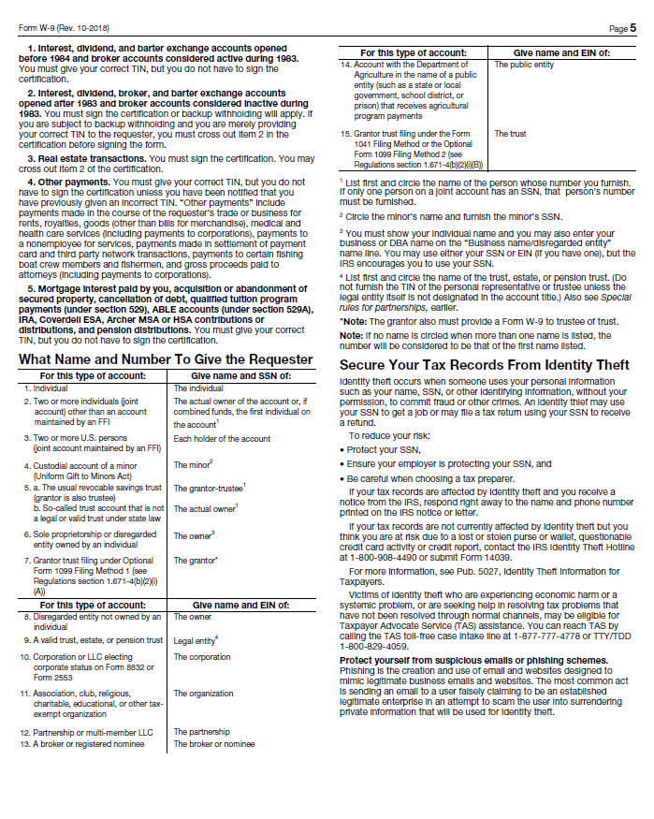

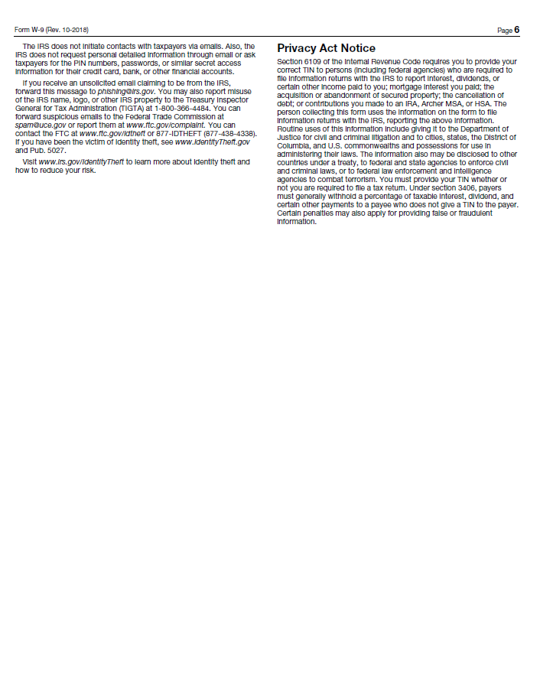
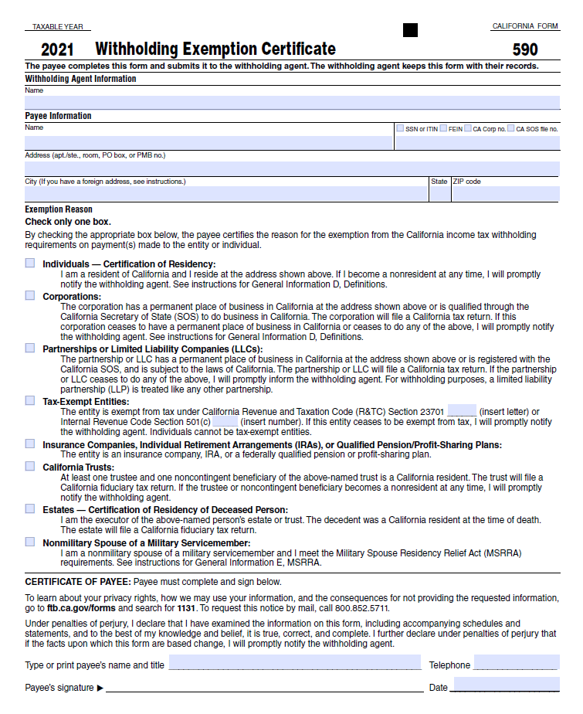

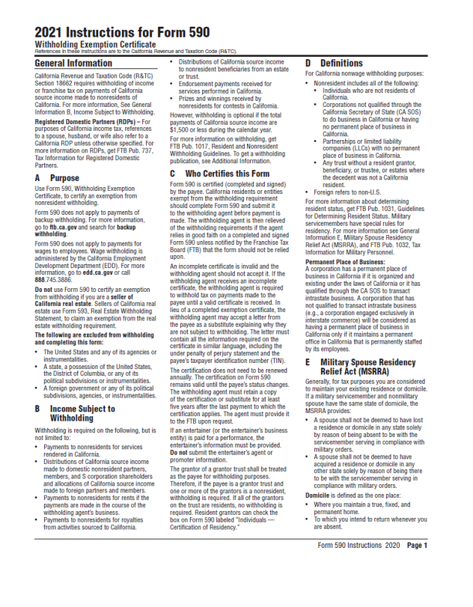

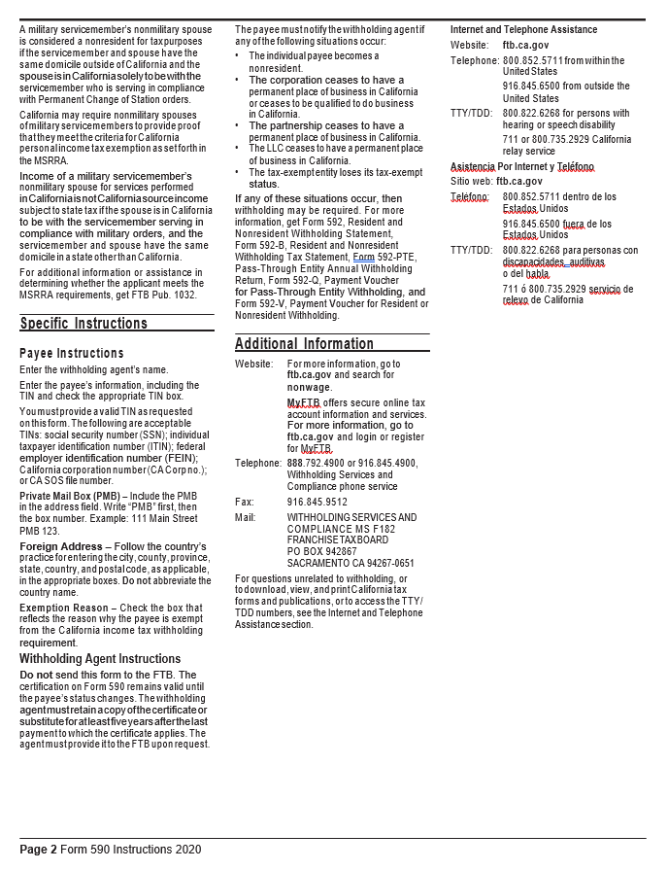

Certification Regarding
Debarment, Suspension, and Other Responsibility Matters

The prospective participant certifies to the best of its knowledge and belief that it and the principals:
- Are not presently debarred, suspended, proposed for debarment, declared ineligible, or voluntarily excluded from covered transactions by any Federal department or agency;
- Have not within a three year period preceding this proposal been convicted of or had a civil judgement rendered against them or commission of fraud or a criminal offense in connection with obtaining, attempting to obtain, or performing a public (Federal, State, or local) transaction or contract under a public transaction: violation of Federal or State antitrust statute or commission of embezzlement, theft, forgery, bribery, falsification or destruction of records, making false statements, or receiving stolen property:
- Are not presently indicted for or otherwise criminally or civilly charged by a government entity (Federal, State, or local) with commission of any of the offenses enumerated in paragraph (b) of this certification; and
- Have not within a three-year period preceding this application/proposal had one or more public transactions (Federal, State, or local) terminated for cause or default.

I understand that a false statement on this certification may be grounds for rejection of this proposal or termination of the award. In addition, under 18 USC Sec. 1001, a false statement may result in a fine of up to $10,000 or imprisonment for up to 5 years, or both.

________________________________________________________________________
Typed Name & Title of Authorized Representative

________________________________________________________________________
Signature of Authorized Representative Date

I am unable to certify to the above statements. My explanation is attached.

CAMPAIGN CONTRIBUTIONS DISCLOSURE

In accordance with California law, bidders and contracting parties are required to disclose, at the time the application is filed, information relating to any campaign contributions made to South Coast Air Quality Management District (SCAQMD) Board Members or members/alternates of the MSRC, including: the name of the party making the contribution (which includes any parent, subsidiary or otherwise related business entity, as defined below), the amount of the contribution, and the date the contribution was made. 2 C.C.R. §18438.8(b). Where a proposed rule or proposed amended rule impacts three or fewer facilities, those facilities will be treated in much the same manner as contracting parties and so must also complete this form, disclosing information relating to any campaign contributions made to any SCAQMD Board Members. See Quadri Advice Letter (2002) A-02.096.1 In the event that a qualifying campaign contribution is made, the Board Member to whom it was made may be disqualified from participating in the actions involving that donor.

California law prohibits a party, or an agent, from making campaign contributions to SCAQMD Governing Board Members or members/alternates of the Mobile Source Air Pollution Reduction Review Committee (MSRC) of more than $250 while their contract or permit is pending before the SCAQMD; and further prohibits a campaign contribution from being made for three (3) months following the date of the final decision by the Governing Board or the MSRC on a donor’s contract or permit. Gov’t Code §84308(d). For purposes of reaching the $250 limit, the campaign contributions of the bidder or contractor plus contributions by its parents, affiliates, and related companies of the contractor or bidder are added together. 2 C.C.R. §18438.5.

In addition, SCAQMD Board Members or members/alternates of the MSRC must abstain from voting on a contract or permit if they have received a campaign contribution from a party or participant to the proceeding, or agent, totaling more than $250 in the 12-month period prior to the consideration of the item by the Governing Board or the MSRC. Gov’t Code §84308(c).

The list of current SCAQMD Governing Board Members can be found at the SCAQMD website (www.aqmd.gov). The list of current MSRC members/alternates can be found at the MSRC website (http://www.cleantransportationfunding.org).

SECTION I.
Contractor (Legal Name):
-

DBA, Name , County Filed in
Corporation, ID No. LLC/LLP, ID No.

List any parent, subsidiaries, or otherwise affiliated business entities of Contractor:
(See definition below).

SECTION II.

Has Contractor and/or any parent, subsidiary, or affiliated company, or agent thereof, made a campaign contribution(s) totaling $250 or more in the aggregate to a current member of the

1 The information provided on this form does not, and is not intended to, constitute legal advice. To the extent that you may have questions regarding any case law, citations, or legal interpretations provided above please seek the guidance of your own independent counsel.

South Coast Air Quality Management Governing Board or member/alternate of the MSRC in the 12 months preceding the date of execution of this disclosure?

Yes No If YES, complete Section II below and then sign and date the form.
If NO, sign and date below. Include this form with your submittal. Campaign Contributions Disclosure, continued:

Name of Contributor

Governing Board Member or MSRC Member/Alternate Amount of Contribution Date of Contribution

Name of Contributor

Governing Board Member or MSRC Member/Alternate Amount of Contribution Date of Contribution

Name of Contributor

Governing Board Member or MSRC Member/Alternate Amount of Contribution Date of Contribution

Name of Contributor

Governing Board Member or MSRC Member/Alternate Amount of Contribution Date of Contribution

I declare the foregoing disclosures to be true and correct.

By:

Title:

Date:

DEFINITIONS

Parent, Subsidiary, or Otherwise Related Business Entity (2 Cal. Code of Regs., §18703.1(d).)

- Parent subsidiary. A parent subsidiary relationship exists when one corporation directly or indirectly owns shares possessing more than 50 percent of the voting power of another corporation.

- Otherwise related business entity. Business entities, including corporations, partnerships, joint ventures and any other organizations and enterprises operated for profit, which do not have a parent subsidiary relationship are otherwise related if any one of the following three tests is met:
  - One business entity has a controlling ownership interest in the other business entity.
  - There is shared management and control between the entities. In determining whether there is shared management and control, consideration should be given to the following factors:
    - The same person or substantially the same person owns and manages the two entities;
    - There are common or commingled funds or assets;
    - The business entities share the use of the same offices or employees, or otherwise share activities, resources or personnel on a regular basis;
    - There is otherwise a regular and close working relationship between the entities; or
  - A controlling owner (50% or greater interest as a shareholder or as a general partner) in one entity also is a controlling owner in the other entity.
South Coast
Air Quality Management District
21865 Copley Drive, Diamond Bar, CA 91765-4178
(909) 396-2000 • www.aqmd.gov

Direct Deposit Authorization

STEP 1: Please check all the appropriate boxes
Individual (Employee, Governing Board Member) New Request
Vendor/Contractor Cancel Direct Deposit
Changed Information

STEP 2: Payee Information
Last Name | First Name |  |  | Middle Initial |  | Title
Vendor/Contractor Business Name (if applicable)
Address |  |  |  | Apartment or P.O. Box Number
City |  |  | State | Zip |  |  | Country
Taxpayer ID Number |  | Telephone Number |  |  | Email Address

Authorization
- I authorize South Coast Air Quality Management District (South Coast AQMD) to direct deposit funds to my account in the financial institution as indicated below. I understand that the authorization may be rejected or discontinued by South Coast AQMD at any time. If any of the above information changes, I will promptly complete a new authorization agreement. If the direct deposit is not stopped before closing an account, funds payable to me will be returned to South Coast AQMD for distribution. This will delay my payment.
- This authorization remains in effect until South Coast AQMD receives written notification of changes or cancellation from you.
- I hereby release and hold harmless South Coast AQMD for any claims or liability to pay for any losses or costs related to insufficient fund transactions that result from failure within the Automated Clearing House network to correctly and timely deposit monies into my account.

STEP 3:
You must verify that your bank is a member of an Automated Clearing House (ACH). Failure to do so could delay the processing of your payment. You must attach a voided check or have your bank complete the bank information and the account holder must sign below.

To be Completed by your Bank
Staple Voided Check Here | Name of Bank/Institution
 | Account Holder Name(s)
 | Saving Checking |  | Account Number |  |  | Routing Number
 | Bank Representative Printed Name |  |  | Bank Representative Signature |  |  |  | Date
 |  |  |  |  |  |  |  | Date
 | ACCOUNT HOLDER SIGNATURE:
For South Coast AQMD Use Only |  | Input By |  |  |  |  | Date

